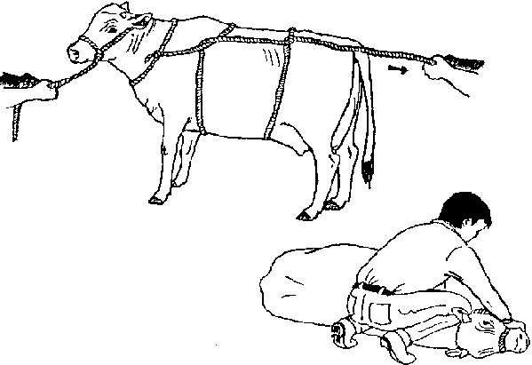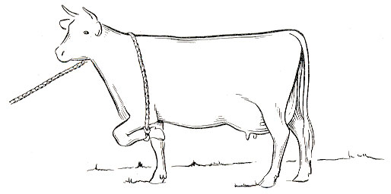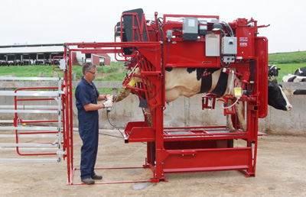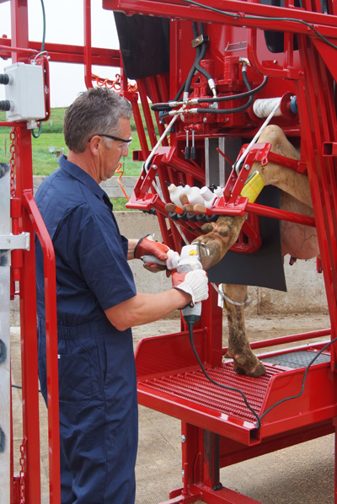

**RESTRAINT**

The animal may be cast into lateral recumbence as seen in image 1.

A rope may be used (as seen in image 2) to elevate the leg for easier access. Note, the animal should be harnessed and tied or placed in a crush or a chute.

One of the newly designed “comfort chutes” for cattle hoof care being demonstrated in images 3 & 4.

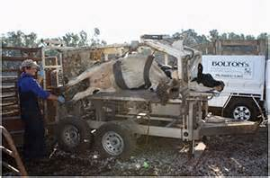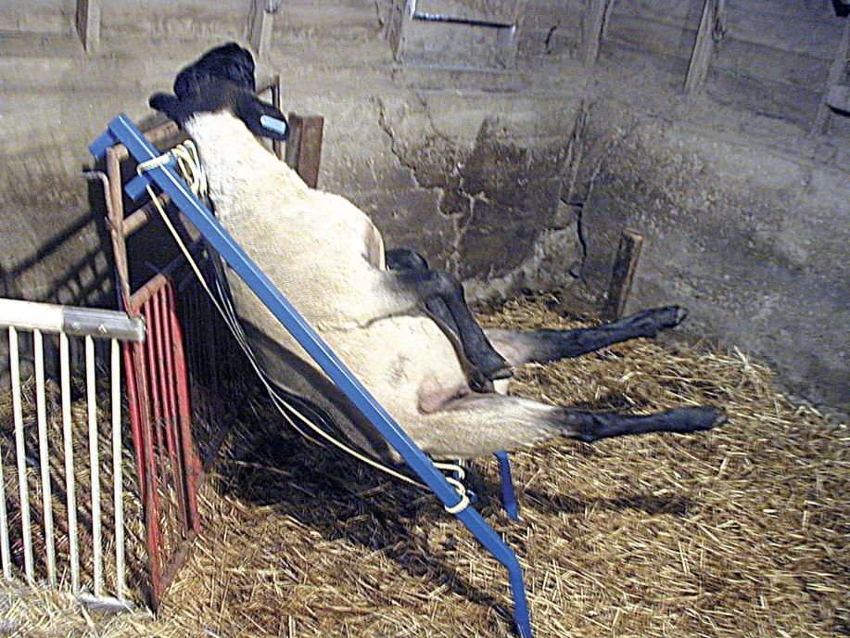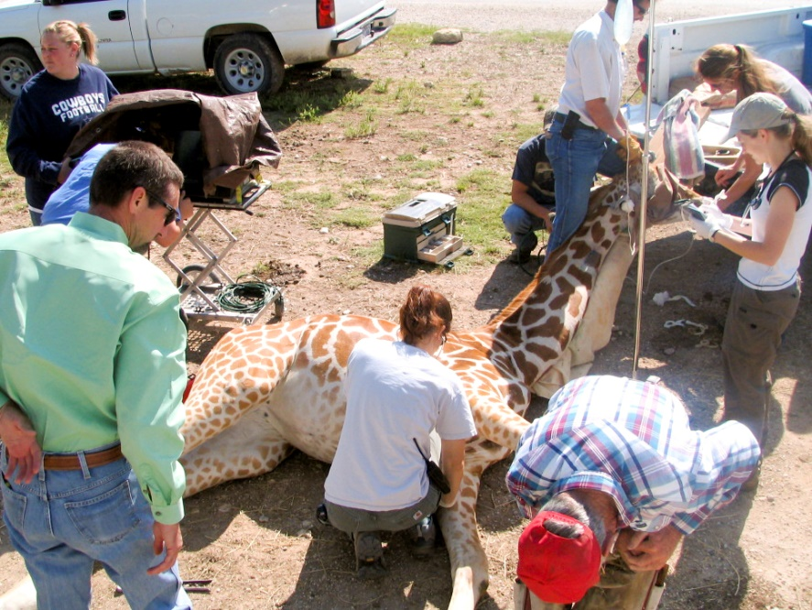

Image 5 shows a chute which can be rotated laterally to keep all four limbs off the ground and allow for easier access by the trimmer.

Image 6 shows a device made just for sheep called a heavy duty sheep chair which is fully adjustable and supposedly comfortable for sheep and ideal for hoof trimming.

Image 7 shows that even wildlife need their hooves checked. This animal has been sedated and the long neck is resting on a padded plank which has been elevated at one end by resting it on a truck bed.

**Restraint**