**Small Hernias** - These pigs have hernias that do not touch the ground, do not impede movement and are not open or bleeding.

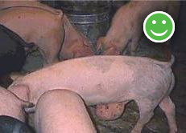 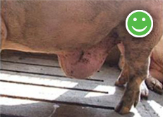

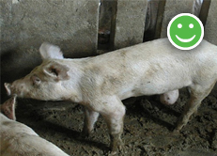

**Larger Hernias -** These hernias should have been addressed sooner. The pigs must be promptly and humanely destroyed on the farm.

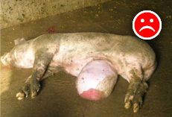 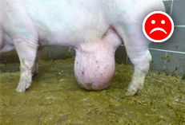

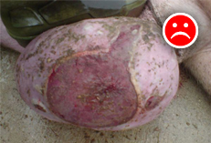

Source: <http://www.omafra.gov.on.ca/english/livestock/swine/facts/13-075.htm>.