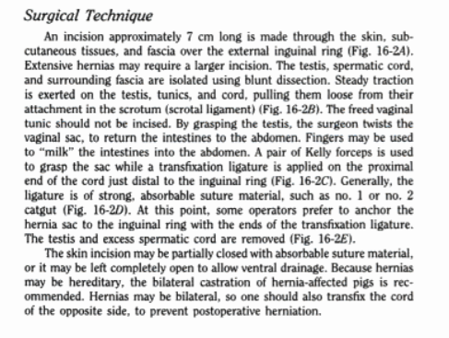**Inguinal Herniorrhaphy**