Local Anaesthesia of teats in Ruminants
Anaesthesia of all or part of the teat, used for surgical operations on the teat.
Teat cistern infusion:
To provides anaesthesia of the mucosa and submucosa of the teat cistern.
- Under adequate physical restraint and sedation, milk out the teat cistern.
- Cleanse the teat orifice thoroughly using alcohol.
- Place a tourniquet (e.g. narrow gauze bandage or suture material) at the base of the teat. This prevents milk from entering the teat cistern and diluting the local anaesthetic.
- Place a teat cannula in the teat and through this infuse 8 to 10 ml of local anaesthetic solution (2% lidocaine) through the streak canal into the teat cistern.
- Analgesia of the mucosa of the teat cistern should occur in five to ten minutes.
- Milk out the local anaesthetic solution once time has been allowed for analgesia to develop.
- Remove the tourniquet.
- Analgesia should remain for about 90 minutes.
- The muscularis and skin layers of the teat are not anaesthetised by this procedure.
- 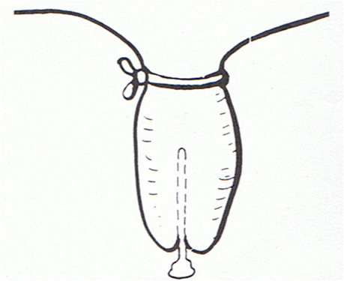
Ring block:
- Thoroughly cleanse the whole teat and teat base.
- Ensure appropriate restraint of the cow.
- Place an elastic band around the base of the teat if desired, to prevent diffusion of local anaesthetic into the udder.
  - Do not place a tourniquet if a supernumerary teat is being removed.
- Insert a 2.5 cm 25 gauge needle into the skin and muscularis layer of the teat, transverse to the direction of the teat, dorsal to the area at which analgesia is required; at the junction of the teat and the udder.
- Inject local anaesthetic solution in a ring pattern around the teat.
  - Each insertion of the needle should take place through an area which has already been desensitized.
  - Inject a total of 4 to 6 ml 2% lidocaine ; a volume of 10 ml 2% lidocaine should be sufficient.
- Following injection, massage the solution into the tissue.
- Analgesia develops distal to the tourniquet in about 10 minutes and lasts for about two hours.
- Appropriate for most procedures carried out on the teat e.g. repair of lacerations or fistulas, removal of warts, teat removal associated with gangrenous mastitis, opening of obstructed teats, removal of fistuli and supernumerary teats.
- Simple to perform.
- Does not interfere with healing. 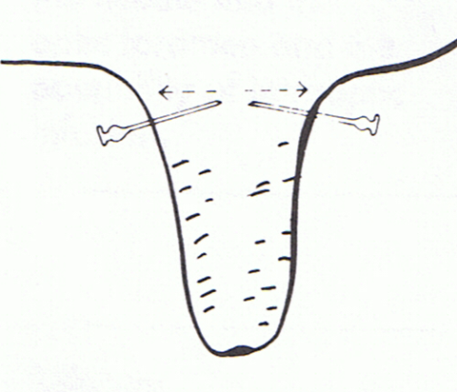
Inverted V-block:
- Thoroughly cleanse the whole teat and teat base.
- Insert a 2.5 cm 25 gauge needle into the skin and muscularis layer of the teat dorsal to the area at which analgesia is required. ; 1.5 cm 25 gauge needle
- Inject a total of 4 to 6 ml of 2% lidocaine in an inverted V-shape enclosing the area in which analgesia is required (e.g. site of a laceration).
- Surgical procedures on the teat such as repair of lacerations or fistulas, or wart removal.
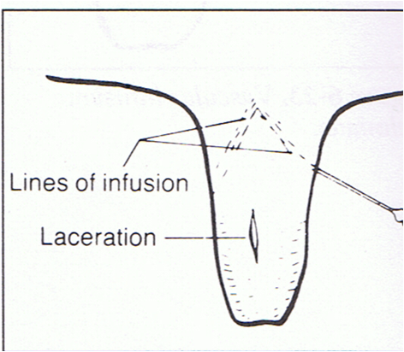
Intravenous regional anaesthesia of the teat:
- Restrain the cow, preferably recumbent.
- Place a tourniquet (e.g. narrow gauze bandage or suture material) around the base of the teat.
- Into any superficial vein distal to the tourniquet, using a 2.5 cm 22 to 25 gauge needle, inject 5 to 7 ml of 2% lidocaine.
- Provide digital pressure and gentle massage over the injection site to prevent formation of a haematoma.
- Analgesia develops in the area distal to the tourniquet within three to five minutes.
- Analgesia persists until the tourniquet is removed.
- Remove the tourniquet once the operation is completed; sensation returns in five to ten minutes once the tourniquet has been removed. For most surgical procedures on the teat.
- Adequate restraint, preferably with the animal recumbent, is essential.
- Aseptic technique is essential.

Regional nerve blocks may also be used:
Perineal nerve block:
- Restrain the cow.
- At the ischial arch, about 2.0 to 2.5 cm lateral to the midline on both sides, inject 5.0 to 7.0 mL of 2% lidocaine solution into the subcutaneous and subfascial tissues.

