Instructional Design
5th Grade Math- Fractions as Division

Gina Murphy
Bowling Green State University
EDTL 7100
Spring 2015

Rationale

When put into a real world situation involving math, people often reach for their calculator, smart phone, or tablet to help find a solution. Our world has become so dependent on finding quick resolutions to problems, that common math sense is being lost. Fractions are a mathematical concept that can be found in everyday life. People use fractions to bake, measure distances, and build houses. However, more often than not, a technological aid is present in reaching an answer. While I would support using these devices to check your work, it is essential that people build a strong math foundation so they do not rely solely on technology to do the work for them. This reliance results in a loss of cognitive ability and capability to problem solve in unexpected situations.
According to Bloom’s taxonomy, by the time students reach middle school they have built a basic foundation of learning through spending time on recall and comprehension and are ready to begin higher stages of thinking in the levels of analysis, synthesis, and evaluation (Chiarelott, 2006, p. 60). This instructional design will focus on the first of three units in the Curriculum Design of 5th Grade Math Fractions, requiring students to tap into higher levels of problem solving. The strong focus on problem solving, use of both individual and group work, and authenticity of the lessons fall in line with a problem based instructional model of learning (Chiarelott, 2006, p. 93). The first year in school when students spend a plentiful amount of time studying fractions is in fifth grade. This curriculum unit on fractions will build strongly on the students’ experiences through the use of contextualized learning. As argued by Dewey, “learning emerges from experience, and one’s interpretation of experience is always contextual” (Chiarelott, 2006, p. 7). The most effective way for students to retain information is the ability to relate what they are learning to their own lives. Everyone has used a measuring cup, went on a bike ride, or split the last piece of cake with a friend. These are instances where fractions are used, and it is necessary to have an understanding of what they are and how they work.
In order to teach fractions effectively, the rigor of the curriculum needs to be on par with the necessity of the topic. Fractions surround us, and therefore students need to be held to high standards during the unit. One strong focus will be on learning the vocabulary that coincides with the unit. Massey and Riley (2013) explain how math textbooks differ from the typical narrative style students see in other content areas such as language arts, science, and social studies, and go on further to explain that math texts rely heavily on technical vocabulary (p. 577). There are a lot of vocabulary terms surrounding the concept of fractions. Students will begin with basic recall of each term, but will then be expected to apply what they have learned in context, to something they can easily relate.
The success and availability of technology is brilliant. It has helped our society reach great heights and allows us to cure disease, communicate with people across the globe, and enhance our students’ learning experiences in the classroom. While there are many benefits of technology, as educators we need to enable our students to become independent problem solvers, and not answer getters. Fractions are an essential factor of everyday life that some students may not even realize they have been using. This unit will take the prior knowledge students have of fractions and apply it to problem solving, all while enhancing their confidence in their math ability.

Unit Outcomes
This instructional design focuses on fractions as division, listed below as Unit 1. Outcomes for units 2 and 3 are also included to provide the big picture.

Unit 1: Fractions as Division
- Students will interpret a fraction as a division problem. (comprehension)
- Students will write mixed numbers as improper fractions, and improper fractions as mixed numbers. (comprehension)
- Students will find the greatest common factor of a set of numbers. (application)
- Students will write fractions in simplest form to create equivalent fractions. (application)
- Students will find the least common multiple of a set of numbers. (application)
- Students will compare fractions using the least common denominator. (analysis)
- Students will compare fractions by graphing them on a number line. (analysis)
- Students will use models to show fraction equivalents. (synthesis)
- Students will write fractions as decimals. (application)
- Students will write fractions as percents. (application)

Unit 2: Add and Subtract Fractions
- Students will add and subtract like fractions. (application)
- Students will add and subtract unlike fractions. (application, analysis)
- Students will use models to add and subtract fractions. (synthesis)
- Students will estimate the sums and differences of fractions, using the benchmark fractions of 0, $\frac{1}{2}$, and 1. (analysis)
- Students will write improper fractions as mixed numbers. (application)
- Students will add and subtract mixed numbers. (application)
- Students will subtract fractions using renaming. (synthesis)

Unit 3: Multiply and Divide Fractions
- Students will estimate products of fractions by using compatible numbers and rounding. (application)
- Students will multiply whole numbers with fractions. (application, synthesis)
- Students will multiply fractions with fractions. (application)
- Students will multiply mixed numbers with fractions. (application, synthesis)
- Students will multiply mixed numbers with mixed numbers. (application)
- Students will interpret multiplication as scaling. (analysis, synthesis)
- Students will divide whole numbers by unit fractions. (application)
- Students will model fraction division. (synthesis)
- Students will use bar diagrams to divide fractions and whole numbers. (synthesis)

Pre-Assessment

The pre-assessment will be used to determine what prior knowledge students have on the topic of fractions. According to Ohio’s New Learning Standards (2010), one of the major learning goals for students in fourth grade is “developing an understanding of fraction equivalence” (p. 26). In this fifth grade unit, the focus is on recognizing fractions as division, what fractions represent, and how to interpret them. To properly design lessons geared toward student achievement, the pre-assessment will be based largely on the previous fraction knowledge and skills students learned in fourth grade. Students will not delve into solving problems with fraction operations (add, subtract, multiply, divide) until this unit is complete. Therefore, a strong understanding of fractions as division and what fractions represent is essential to moving on to units 2 and 3 of the larger picture.
If students have a strong understanding of any specific portion of fractions as division, as seen through the pre-assessment results, less time will spent on learning those topics in class. For questions where a majority of students do not score well, more time will be spent mastering those topics in class. At the end of the unit, students will be given the opportunity to take the pre-assessment again. This is an essential part of closing the unit, as it allows to students to see their growth. They can compare their initial score with the new score, and even answering one more questions correctly can be considered an improvement. A sample pre-assessment follows.

Pre-Assessment

Name: ____________________________________________ Date: _____________

Directions: Answer each question below. Show your work when necessary.

- A fraction represents the operation of __________________.

  - Addition

  - Subtraction

  - Multiplication

  - Division

- List the factors of 12 and 18. Circle all of the factors they have in common.

12: _____________________________

18: _____________________________

- List the first 5 multiples of the numbers below. Circle the Least Common Multiple.

4: _____, _____, _____, _____, _____

6: _____, _____, _____, _____, _____

- Circle all of the fractions that are equivalent to $\frac{6}{30}$?

  - $\frac{6}{3}$ B. $\frac{2}{10}$ C. $\frac{1}{5}$ D. $\frac{3}{10}$

- Write the fraction $\frac{3}{7}$ as an addition sentence using unit fractions.

- Solve. $\frac{5}{9}+ \frac{3}{9}=$

- Solve. $\frac{14}{20}- \frac{4}{20}=$

- Write the fraction $\frac{6}{10}$ as a decimal.

- Write the decimal 0.48 as a fraction.

Compare the fractions below using <, >, or =.

- $\frac{1}{9}$ $\frac{1}{5}$

- $\frac{8}{16}$ $\frac{1}{2}$

- $\frac{3}{12}$ $\frac{5}{24}$
Lesson Plans
These lesson plans are created with the pretense that students have a math journal to glue in notes and practice pages, a binder to put all of their papers in, or some sort of other tool in which to compile all of the information from class. My students have interactive math journals with notes, foldables, practice problems, and more to exhibit their skills and reach students with various learning styles and multiple intelligences. In line with the problem-based instructional model, these lessons are very process oriented with a focus on problem solving through reasoning (Chiarelott, 2006, p. 93). Students will be given well defined tasks to complete along with the opportunity for individual, partner, and whole group instruction.
Every lesson builds on the previous lesson as well as prior knowledge students have from their year in 4th grade math. Included after the description of each lesson plan are sample student handouts including note sheets, practice pages, and interactive games. Some of the materials listed can be found as attachments in the Curriculum Map under the corresponding topic.

Lesson 1: What Are Fractions?

Materials Needed | Fraction Circles  Student Notes  Magnetic Pizza Model  Scrap Paper
Length of Lesson | 45 minutes
Lesson Outcomes | Students will interpret a fraction as a division problem.
Essential Question | When have you used fractions as division during one of your own life experiences?

Common Core State Standard:
5.NF.3 Interpret a fraction as division of the numerator by the denominator. Solve word problems involving division of whole numbers leading to answers in the form of fractions or mixed numbers, e.g., by using visual fraction models or equations to represent the problem.

Procedures:

- Opening (15 minutes): Place students in pairs and give each pair a set of fraction circles. Ask the students the following questions:

  - Build a model that represents one whole. What pieces did you use? What does “one whole” look like?

  - Now build one whole using $\frac{1}{2}$ pieces. How many halves does it take to build one whole?

  - Build one whole using only $\frac{1}{3}$ pieces. How many thirds does it take to build one whole? Do you notice any patterns?

As an alternate option, students can use online manipulative fraction circles if the technology is available in your classroom!

- Guided Instruction (10 minutes):

  - Pass out a copy of the “Fractions and Division” notes to each student. Have students glue the notes into their math journal. Together, read through the notes and answer the sample questions.

  - You can use a magnetic fraction pizza model to represent the problem visually, and create similar scenarios for students to discuss.

- Independent Practice (15 minutes):

  - Have students pair up with a different partner and pass out the fraction circles again.

  - On scrap paper, have them answer the following addition problems, prove their answer using a model, and discuss different ways to solve the problems.

    - $\frac{1}{4}+\frac{2}{4}=$

    - $\frac{3}{5}+\frac{1}{5}=$

    - $\frac{2}{3}+\frac{1}{3}=$

  - As a class, discuss possible solutions to the problems above.

- Summary/Evaluation (5 minutes):

  - Have students answer the essential question in the form of a word problem on a piece of scrap paper. Students should write the solution to their word problem and turn it in as an exit slip for the lesson.

  - Use the data to determine if students are ready to move on to Lesson 2, or if Lesson 1 needs to be reviewed tomorrow. By making the exit slip question authentic to the learners own lives, there will be a stronger focus on problem solving.

Fractions and Division

- A ____________________ is a number that names equal parts of a whole.

- A fraction represents _________________ of the numerator by the denominator.

$\frac{1}{3}$ = $\frac{numerator}{denominator}$ = 1 ÷ 3

Example:

Dylan, Drake, and Jade are sharing 2 small pizzas equally after their lacrosse game. How much does each person get?

- Model two pizzas divided among three people:

- Write a number sentence: ______________________

- Write the division sentence as a fraction: _________

- Your answer will be between what two whole numbers: ______ and ______

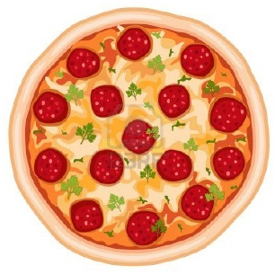
Lesson 2: Mixed Numbers and Improper Fractions

Materials Needed | Computer with Projector  Foldable Notes (print double sided)  Dry Erase Boards  Markers  I Have Who Has Game Pieces  Scrap Paper
Length of Lesson | 45 minutes
Lesson Outcomes | Students will write mixed numbers as improper fractions, and improper fractions as mixed numbers.
Essential Question | When do we use mixed numbers? When do we use improper fractions?

Common Core State Standard:
5.NF.3 Interpret a fraction as division of the numerator by the denominator. Solve word problems involving division of whole numbers leading to answers in the form of fractions or mixed numbers, e.g., by using visual fraction models or equations to represent the problem.

Procedures:

- Opening (5 minutes): Show the Brain Pop video “Mixed Numbers.” https://www.brainpop.com/math/numbersandoperations/mixednumbers/preview.weml

- Guided Instruction (10-15 minutes):

  - Pass out a “Mixed Numbers and Improper Fractions” foldable to each student.

  - Have students fold the sheet in half horizontally and cut along the dotted line, creating two flaps. Then, students can glue the notes into their math journal.

  - Read through the step-by-step instructions and fill in the notes as a class.

- Independent Practice (15-20 minutes):

  - Pass out a dry erase board and marker to each student.

  - Give each student a game piece to play “I have who has” with improper fractions and mixed numbers.

  - Game can be purchased from: https://www.teacherspayteachers.com/Product/Mixed-Numbers-and-Improper-Fractions-Spiral-Card-Game-472102
- Summary/Evaluation (5 minutes):

  - Have students answer the following questions on a piece of scrap paper and collect them.

    - Write $8\frac{3}{6}$ as an improper fraction.

    - Write $\frac{27}{4}$ as a mixed number.

  - Use the data to determine if students are ready to move on to Lesson 3, or if Lesson 2 needs to be reviewed tomorrow.

Mixed Numbers and Improper Fractions

Mixed Number Improper Fraction

Improper Fraction Mixed Number

Step 1: Multiply the whole number by Step 1: Divide the numerator
the denominator. by the denominator.
Step 2: Add the numerator to your Step 2: Your whole number answer
answer from Step 1. becomes the whole number
Step 3: Keep your denominator the in your mixed number.
same. Step 3: The remainder is your
numerator.
Step 4: Keep your denominator the
same.

$6\frac{2}{3}$ $\frac{33}{5}$

Improper Fraction Mixed Number

Model: Model:

Lesson 3: Equivalent Fractions

Materials Needed | #1 Handout  Student Notes  Fraction Modeling Worksheet
Length of Lesson | 45 minutes
Lesson Outcomes | Students will use models to show fraction equivalents.
Essential Question | Why can’t you add fractions with unlike denominators?

Common Core State Standard:
5.NF.3 Interpret a fraction as division of the numerator by the denominator. Solve word problems involving division of whole numbers leading to answers in the form of fractions or mixed numbers, e.g., by using visual fraction models or equations to represent the problem.

Procedures:

- Opening (10 minutes):

  - Pass a #1 sheet to each student. Students can cut out the one and glue it into their math journal.

  - Instruct students to write five different forms of 1 inside of the 1. For example, $\frac{7}{7}, \frac{4}{4},$and $\frac{12}{12}$ are all different forms of 1. Students will need this essential knowledge to write equivalent fractions.

  - Allow students to decorate their “1.”

- Guided Instruction (15 minutes):

  - Pass out the “Equivalent Fractions” notes to each student. Have students glue the notes into their math journal and fill them in as a class.

- Independent Practice (10 minutes):

  - Independently, have students complete the “Fraction Modeling” worksheet.

  - Give students 5 minutes to share their answers with the person sitting next to them and have students volunteer to model their answers on the board.

- Summary/Evaluation (5 minutes):

  - Ask students to look at the #1 handout from the beginning of class.
  - Discuss the essential question and expand on it by asking why you need common denominators to add or subtract fractions.

  - See if students can use the models on their worksheets to support their answers.

  - Use the discussion data to determine if students are ready to move on to Lesson 4, or if Lesson 3 needs to be reviewed tomorrow.

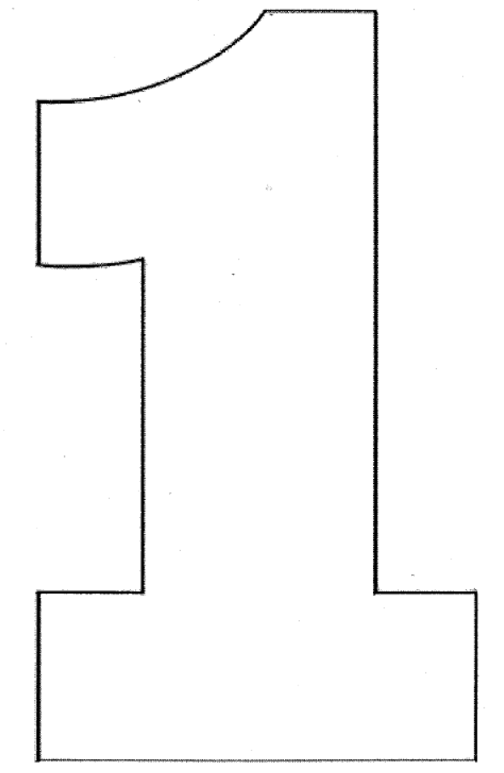
Remember:
Equivalent fractions name the same number!
Equivalent Fractions

Shade in the models to see if $\frac{4}{10}= \frac{2}{5}$

$\frac{4}{10}$

$\frac{2}{5}$

Practice

Write an equivalent fraction to $\frac{2}{3}$ ______________

Write an equivalent fraction to $\frac{12}{18}$ ______________

Are $\frac{10}{15}$ and $\frac{3}{5}$ equivalent fractions? ______________

Are $\frac{16}{18}$ and $\frac{48}{54}$ equivalent fractions? ______________

Name: _______________________________________ Fraction Modeling

Shade in the models to decide whether or not the fractions are equivalent.

- Are $\frac{2}{5}$ and $\frac{5}{8}$ equivalent fractions? ______________
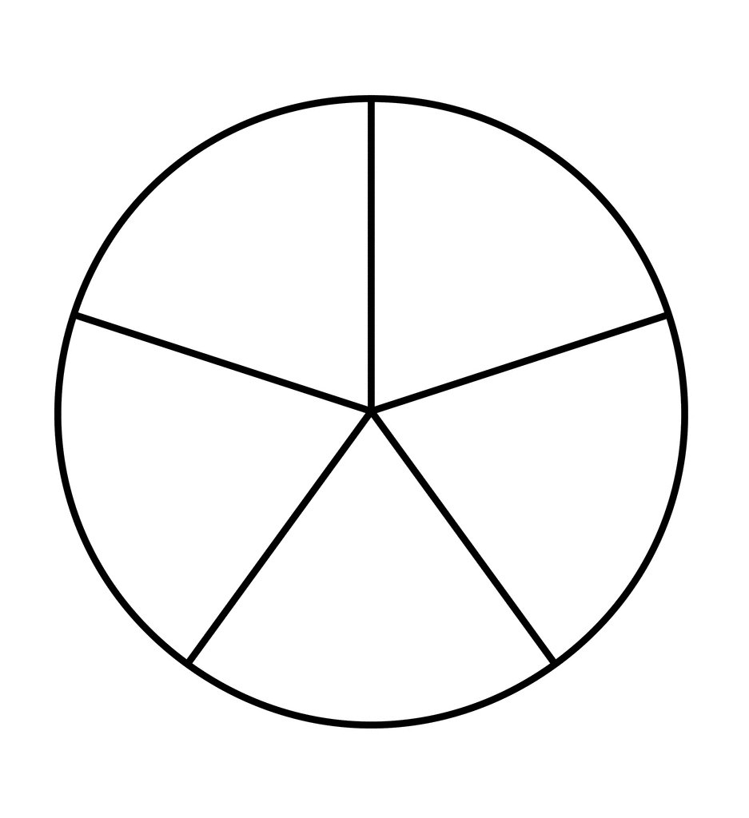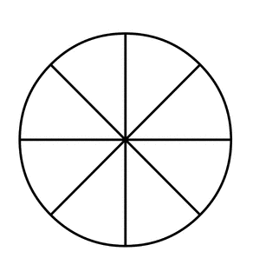

- Are $\frac{3}{4}$ and $\frac{6}{8}$ equivalent fractions? ______________

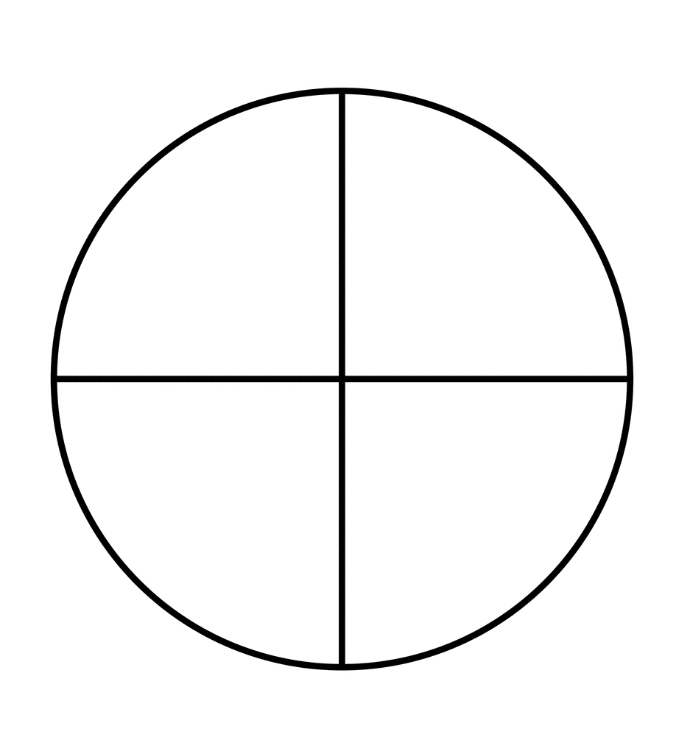

- Are $\frac{3}{4}$ and $\frac{4}{6}$ equivalent fractions? ______________

- Write two fractions are equivalent. Then, draw a model to prove it.

_____________ _____________

- Write two fractions are not equivalent. Then, draw a model to prove it.

_____________ _____________

Lesson 4: Simplest Form

Materials Needed | Students Notes  5 Rules Reference Sheet  Computer with Projector  Simplest Form Worksheet
Length of Lesson | 45 minutes
Lesson Outcomes | Students will write fractions in simplest form to create equivalent fractions.
Essential Question | What is the purpose of finding equivalent fractions? Give a real world example.

Common Core State Standard:
5.NF.3 Interpret a fraction as division of the numerator by the denominator. Solve word problems involving division of whole numbers leading to answers in the form of fractions or mixed numbers, e.g., by using visual fraction models or equations to represent the problem.

Procedures:

- Opening (5 minutes):

  - Go to the Study Jams video, “Simplest Form.” http://studyjams.scholastic.com/studyjams/jams/math/fractions/simplest-form.htm

  - Have students watch and listen to the step-by-step process as an introduction to writing fractions in simplest form.

- Guided Instruction (20-25 minutes):

  - Pass out a copy of the “Simplest Form” notes to each student. After students glue the notes into their journal, discuss and fill them in as a class.

    - Note: Students should have background knowledge of Greatest Common Factor (GCF). This can be confirmed through the pre-assessment.

  - Next, pass out a copy of the “5 Rules of Simplest Form” reference sheet. Have students glue this into their math journal.

  - Discuss the 5 Rules of Simplest Form by going through the Power Point (attached in C-Map) and watch the included videos.

- Independent Practice (10 minutes):

  - Students will complete the “Simplest Form” worksheet independently.
  - This sheet can be collected and used in place of an exit slip.

- Summary/Evaluation (5 minutes):

  - Revisit the essential question from the beginning of the lesson.

  - Have students think of their own responses, share with a partner, then share as a whole class.

  - Use the data to determine if students are ready to move on to the next lesson, or if Lesson 4 needs to be reviewed tomorrow.

Simplest Form

- A fraction is written in simplest form when the __________ of the numerator and denominator is ________.

- _________________________ _________________ are fractions that name the same number.

- To write a fraction in simplest form, use the steps below:

  - Find the _________ of the numerator and denominator.

  - _______________ both the numerator and denominator by the GCF.

Practice

Write each fraction in simplest form.

1. $\frac{4}{6}$ 2. $\frac{2}{12}$ 3. $\frac{18}{30}$

4. Angie has a vertical jump height of 12 inches, and Holly has a vertical jump height of 22 inches. So, Angie’s vertical jump is $\frac{12}{22}$ of the vertical jump of Holly. Write the fraction in simplest form.

5 Rules for Simplest Form

- One Direction Rule: If the numerator is 1, then your fraction is in simplest form.

2. One Foot in Front of the Other Rule: If your numerator and denominator are one number apart, then your fraction is in simplest form.

- UP Rule: If the numerator and denominator are odd, USUALLY your fraction is in simplest form.

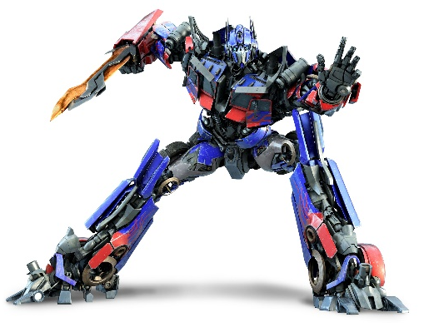

- Optimus Prime Rule: If the denominator is a prime number, the fraction is in simplest form.

- Survivor Rule: If you cannot divide your numerator and denominator by a common factor, then your fraction is in simplest form.

Name: _____________________________________________ Simplest Form

Write each fraction in simplest form. If the fraction is already in simplest form, write “simplified” on the line.

1. $\frac{3}{9}$ = __________ 2. $\frac{8}{32}$ = __________

3. $\frac{14}{42}$ = __________ 4. $\frac{27}{45}$ = __________

5. $\frac{18}{38}$ = __________ 6. $\frac{40}{56}$ = __________

7. Colleen bought 20 donuts for her friends to eat for breakfast at her sleepover. Twelve of the donuts had sprinkles on them. What fraction of the donuts had sprinkles? Be sure to write your answer in simplest form.

8. Brad was practicing his foul shots for his team’s championship game on Saturday. If Brad made 18 shots out of 24, what fraction of the foul shots did he miss? Be sure to write your fraction in simplest form.

Post-Assessment
The post-assessment will be used to determine if students have reached the mastery level of the content covered in Unit 1 of the fractions course. The focus of the assessment questions will be derived from Ohio’s New Learning Standards (2010) for fifth grade mathematics. Where the pre-assessment focused largely on seeing what fraction information students recalled from fourth grade, the post-assessment will now provide data as to whether or not students have taken their knowledge of fractions to the next level of learning. Rather than solving questions in the memory/recall and comprehension stages of Bloom’s Taxonomy, students will expected to advance to the application and analysis stages (Chiarelott, 2006, p. 60). They will be presented with authentic problems relevant to real word tasks. The post-assessment covers material for the entire Unit 1. The lessons provided do not cover all of the material contained in the post-assessment.
Students will be scored on a scale with a possible four levels of achievement; emerging, progressing, proficient, and mastery. Raw assessment scores may be converted to a scale of 5 to determine the level of student mastery. Students who don’t achieve in the proficient or mastery levels will be given the opportunity to take a re-assessment. The belief here is that not all students learn at the same pace. If a student does not score well the first time around, they are provided with extra study tools and alternate methods of learning the material before they attempt a re-assessment of the content. A sample post-assessment follows.

Post-Assessment

Name: ____________________________________ Fractions Assessment: Unit 1

Standard 5.NF.3 – I can interpret a fraction as a division problem.

- Fill in the missing value to create equivalent fractions.

- $\frac{4}{16}$ = $\frac{}{4}$

- Shade in the area models below to show the equivalence from above.

=
=

- Diane wanted to find all the fractions that are equivalent to $\frac{6}{15}$ . Help her decide which two to choose.

A. $\frac{12}{21}$ B. $\frac{2}{5}$ C. $\frac{24}{60}$ D. $\frac{22}{45}$

- Graph the following fractions on the number line below: $\frac{1}{8}$ , $\frac{5}{9}$ , $\frac{7}{6}$

0 1 2
- Interpret the following picture as an improper fraction and a mixed number.

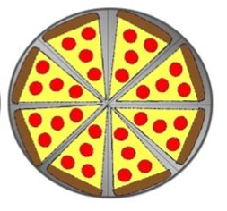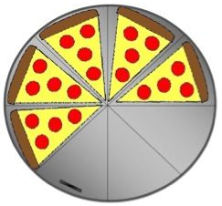

- Write it as an improper fraction:

- Write it as a mixed number:

- Graph the following fractions on the number line below: $\frac{1}{4}$ , $\frac{1}{2}$ , $\frac{1}{9}$

0 1 2
- George sold 9 pounds of candy to his neighbors for a school fundraiser. He made sales to 4 different people.

  - If each neighbor received an equal amount from George,
how much did each person get? __________________

  - Between what two whole numbers does the answer lie? ________ and ________

- Doug, Julie, Leigh, Meredith, Eddie and Gina are sharing 5 pepperoni pizzas.

  - How much does each person get to eat?

  - Between what two whole numbers does the answer lie? ________ and ________

- Which fraction is not equivalent to $\frac{8}{12}$ ?

  - $\frac{16}{24}$ B. $\frac{2}{3}$ C. $\frac{18}{22}$ D. $\frac{32}{48}$

- Kris and Hunter are carpenters. Both are known for hanging drywall. Kris likes to hang $\frac{3}{4}$ inch drywall, but Hunter likes to hang $\frac{5}{8}$ inch drywall. Which of the two hangs the thicker drywall? Use <, > or = to compare the two amounts.

Kris’s Drywall
$$\frac{3}{4}$$
Hunter’s Drywall
$$\frac{5}{8}$$

- Caroline is making her special banana pudding recipe. She is looking for her one cup
measure, but can only find her one third cup measure.

A. How many third cups does she need for the vanilla pudding mix?

B. Draw a picture to illustrate your solution.

- Tammie and Angela are each making cookies for their dads. Both girls are using recipes that call for flour. Tammie needs to use 3 $\frac{3}{4}$ cups of flour; Angela needs to use $\frac{11}{4}$ cups of flour.

  - Which of the two girls uses less flour? _______________________

  - Use pictures, numbers, or words explain your answer in the box below.

- Nora, Anne, and Cathy are comparing their fingernails. The information about each girls’ nails is in the table below.

Name | Nail Color | Nail Length  (in centimeters)
Nora | Pink | $$\frac{5}{11}$$
Anne | Rose | $$\frac{1}{2}$$
Cathy | Purple | $$\frac{4}{9}$$

List the girls in order of shortest to longest fingernail.

_________________________________________________________________________________________________________________________________________________________

Summative Assessment Rubric: Fractions Unit 1

Math Learning Goals | Question # | Correct?

Standard 5.NF.3: I can interpret a fraction as a division problem.

1 A
1 B
2
3
4 A
4 B
5
6 A
6 B
7 A
7 B
8
9
10 A
10 B
11 A
11 B
12

Score

Unit level of
Mastery

Conversion  Scale | 5.00 – 4.50  Mastery | 4.49 – 4.00  Proficient | 3.99 – 3.00  Progressing | 2.99 – 0.00  Emerging

References
Chiarelott, L. (2006). Curriculum in context. Belmont, CA: Wadsworth.
Fractional Fun. (2012). Mixed numbers and improper fractions spiral card game. Retrieved from https://www.teacherspayteachers.com/Product/Mixed-Numbers-and-Improper-Fractions-Spiral-Card-Game-472102

Massey, D., & Riley, L. (2013). Reading math textbooks: An algebra teacher’s patterns of thinking. Journal of Adolescent & Adult Literacy, 56 (7), 577-586. Retrieved from http://ezproxy.bgsu.edu:2065/ehost/pdfviewer/pdfviewer?sid=23c5081f-f3a7-4efc-bfa8-258d1b22fbbd%40sessionmgr4001&vid=1&hid=4212

Ohio Department of Education. (2010). Ohio’s new learning standards: Mathematics standards. Retrieved from http://education.ohio.gov/getattachment/Topics/Ohio-s-New-Learning-Standards/Mathematics/Math-Standards.pdf.aspx

