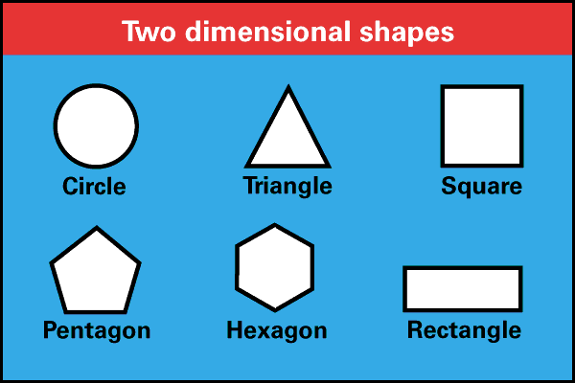
Rationale
With the new PARCC tests that are being implemented, it is my goal to find anything and everything that will help students better understand the material I am teaching. I have come to learn that students learn best when they are experiencing hands-on lessons that deal with the material being taught. When they can see what we are talking about, they are able to better understand what is going on and it seems to stick with them longer. The material is more rigorous than ever, and if I can find a way to help make that information stick in their brains, I will have exceeded my expectations.
The unit I have created contains lesson plans based on the Basic Lesson Plan model outlined in Leigh Chiarleott’s, Curriculum in Context. Creating the lesson plans this way allows a layout that will help myself and anyone else who may be evaluating the lesson an easy guide for what should be occurring in the classroom. Each lesson includes the objective of the lesson, materials needed, introductory activity, developmental activity, and closure activity, along with an assessment of what the children did that day. The assessments will help me form my unit, as they will let me know if I am able to continue on with the unit as planned or if I need to re-teach something. These lesson plans also provide structure and a good flow for the lesson within my classroom, which will help me quickly transition from one thing to the next throughout my lesson. While there are several different things going on in the lesson and a lot of hands-on student learning, with this model everything will come together nicely.
My classroom will represent an inductive learning environment. As described in Chirarleott’s text: “inductive thinking was the way humans naturally formed concepts by working from specific examples and then drawing conclusions (part-to-whole thinking)” (113). My lessons include activities that have the students working with me instructing them in class and giving specific examples for them to follow, and then having them discover further what they have found on their own. They are given part of the information they need and they have to make sense of it as a whole. By completing these hands on activities as a class and then on their own to discover more, the students are taking responsibility for their learning. This will help them become better learners, and understand the material better as they move through it.
Subunit Learner Outcomes

Geometry
- The students will be able to categorize two dimensional figures. (analysis)

Pre-Assessment
Match the prefix to the appropriate number it represents.
Hepta Six (6)
Quad Seven (7)
Tri Four (4)
Octa Ten (10)
Hexa Eight (8)
Nona Five (5)
Deca Nine (9)
Penta Three (3)
What makes a polygon a regular polygon?

Check the box under each quadrilateral that applies to the statement listed on the left.
 | Rhombus | Parallelogram | Square | Rectangle | Trapezoid
I have four sides and four angles.
I have opposite sides that are parallel.
I have four right angles.
All of my sides are congruent.
I have one pair of parallel sides.
I am a parallelogram.

Check the box under each type of triangle that applies to the statement listed on the left.
 | Scalene | Isosceles | Equilateral | Right | Acute | Obtuse
I have three different angle measures.
I have three congruent sides.
I have two congruent angles.
I have one 90º angle.
I have three congruent angles.
I have two congruent sides.
I have one angle over 90º.
I have one angle less than 90º.

Lesson Plan #1 – Introduction to Two Dimensional Shapes

Unit Outcomes:
- The students will be able to categorize two dimensional figures. (analysis)
Time Period Objectives:
- The students will be able to classify vocabulary words into three categories: Polygons, Triangles, and Quadrilaterals.

Materials Needed:
- Pretest
- Pencils
- Computer
- Projector
- InFocus Pen
- Category Papers
- Subunit Vocabulary Words

Procedures:
Before the Lesson: (15 minutes)
- Students will complete the pretest for the subunit of two dimensional shapes.

Introductory Activity: (5 minutes)
- I will put up the name of the three types of two-dimensional figures we will be going into more depth over on the board: Polygons, Triangles, and Quadrilaterals.

- We will have a short discussion about these three types of figures and the students will tell me what they know or think they know about each thing already. This could include names of specific shapes, ideas, what the shape includes, etc. **I will write the things they say as they tell me.**
Developmental Activity: (20 minutes)
- I will divide the students up into small groups and each group will receive the three category papers (attached, and will need cut out) and two sets of vocabulary words (attached and will need cut out).

- The students will then work together to categorize the vocabulary words under the correct category of Polygon, Triangle, or Quadrilateral. The words will sometimes be in multiple categories. The students will not use every word more than once, and will therefore have some leftover words.

- When the group is finished, they will compare their categories with another group and discuss why they chose the category they did.

- When the groups have met with at least one other group, we will come back to a whole class discussion. We will go over the correct category each vocabulary word should be under.
Key Questions:
- What qualifies as a triangle?
- What qualifies as a quadrilateral?
- What qualifies as a polygon?

Summary/Closure/Evaluation:
Closure Activity/ Assessment: (5 minutes)
- The students will discuss in their groups what they see significant about the words in each category. Why were the words put into this category together? Why are some words in more than one category? What is significant about a polygon, quadrilateral, and triangle?

Lesson Plan #2 – Polygons

Unit Outcomes:
- The students will be able to categorize two dimensional figures. (analysis)
Time Period Objectives:
- Students will be able to classify the first ten polygons based on their understanding of the prefix of each word.

Materials Needed:
- White Board & Markers
- Computer
- Projector
- InFocus Pen
- Worksheets
- Pencil
- Construction Paper
- Scissors
- Baggies
- Markers
- Exit Slips
- Notebook Paper

Procedures:
Introductory Activity: (10 minutes)
- Students will be given a piece of construction paper and asked to create their favorite shape. They will draw, cut out, and color their shape.

- While the students are creating their shape, I will walk around and ask them why they are creating the shapes they are.

- When each student is done with their shape, we will have a brief discussion about why students chose their shape. I will ask things such as: “Why did you cut the shape you did? What do they believe is significant about the shape? What do they notice about the shape?”

- We will then discuss how the number of sides they created in their shape can help determine the name of the shape. “Shapes that are classified by the number of sides they have are called polygons. We are going to discuss polygons with three up to ten sides. Some of your shapes may fit into one of these categories.”
Developmental Activity: (30 minutes)
- Each student will receive a worksheet (attached) that has each polygon from triangle all the way to decagon. The name of each polygon will not be included on the worksheet, because we will fill them in as we discuss their prefixes and how those fit with the number of sides on each polygon. **As we are working I will have the worksheet projected on the white board so the students can visually see what I add to mine, so they can add it to theirs as well.**

- With the worksheet presented on the board I will begin by asking the students if they remember what a prefix is from language arts class. Once we have discussed that a prefix is the beginning of a word, I will ask the students if they know the prefixes to represent the numbers three through ten. I will explain that they should think about different things in the world that have that many of something.

- On the white board I will write the numbers 3-10 and the students will write this on a separate sheet of notebook paper as we come up with the prefixes, I will write them next to the correct number. (I will provide them with hints if they cannot figure some out.)

- We will then discuss that the prefixes we just came up with will help the students in naming each of the polygons present on their worksheet. In the case of polygons, the prefix tells the number of sides, vertices, and angles that each has.

- In small groups, they will come up with the prefix that goes with each polygon and write it under the word, leaving room for the root word we will add later.

- Once they have matched the prefixes to each shape, we will discuss and add the root words that go with each will generally be gon with represents the number of sides. However, triangles and quadrilaterals are the exception and we will discuss that triangle means three angles and quadrilateral means four sides with latus being the root word for side in this case.

- We will also discuss that if all of the sides and all of the angles in a polygon are equal, then it is known as a regular polygon.

- The students will then cut out the boxes from their worksheets, and they will now be used as flash cards. On the back of the boxes they will write the number of sides and angles each polygon has.
Key Questions:
- What are two ways we can classify shapes?
- What does the prefix of a polygon tell us?
- What makes a polygon a regular polygon?
Summary/Closure/Evaluation:
Closure Activity/Assessment:(5 minutes)
- We will discuss the new things students learned about shapes and if their favorite shape fell under any of the new shapes (polygons) we learned that day.

- The students will then complete an exit slip covering what they learned in this lesson. This will help me see if I can move on or not. I will be able to see how well the students understand what we discussed.(attached)

Types of Polygons
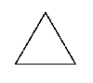

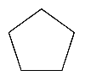 | 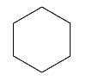
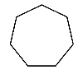 | 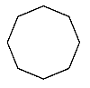

Exit Slip
- How many sides does a pentagon have?

- The prefix of a shape tells how many what it has? (3 possible answers)

- How many wheels does a tricycle have? How do you know this?

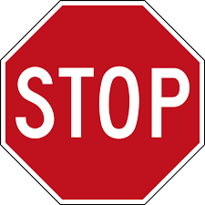
- What is this shape?

- Is there anything you’re confused about?
Lesson Plan #3 – Triangles

Unit Outcomes:
- The students will be able to categorize two dimensional figures. (analysis)
Time Period Objectives:
- Students will be able to classify the six different types of triangles based on their angles and sides.

Materials Needed:
- http://www.mathplayground.com/geoboard.html
- Computers
- White Board and Markers
- Tape
- Projector
- InFocus Pen
- Dot Paper (printablepaper.net)
- Pencils
- Scissors
- Notebook Paper
- Exit Slips

Procedures:
Introductory Activity: (5 minutes)
- We will have a class discussion about the different types of triangles. The students should come up with all six types before moving on to the Developmental Activity. Clues will be given if necessary.

Developmental Activity: (35 minutes)
- Students will each be given a computer and will log on using their school username and password. They will then go to Google Chrome and type in: http://www.mathplayground.com/geoboard.html.

- While the students are logging on and opening the Geoboard, I will put one up on the board from my computer in order to demonstrate everything to the students.

- The students will be instructed to create triangles on their Geoboards given prompts that I read to them. After they have created the triangle on the computer they will create it on the dot paper provided (attached). These should be large enough for them to cut out and used later.
  - Create a triangle that has one right angle.
  - Create a triangle that has two equal sides.
  - Create a triangle that has three different sides.
  - Create a triangle that has at three acute angles.
  - Create a triangle that has one obtuse angle.
  - Create a triangle that has three equal sides.

- After we have gone through all of the prompts and the students have drawn all of their triangles, they will then cut them out.

- The students will then use tape, and under each category on the white board (I will have written all six types of triangles on the board) they will put each triangle where they think it fits best.

- After all of the students have placed their triangles, we will discuss the properties for each type. The students will write this on notebook paper.
Key Questions:
- What type of triangle has three different sides?
- What type of triangle has two different sides?
- What type of triangle has all equal sides?
- What type of triangle has one right angle?
- What type of triangle has an angle greater than 90º?
- What type of triangle has an angle less than 90º?

Summary/Closure/Evaluation:
Closure Activity/Assessment: (5 minutes)
- We will then make sure each triangle is in the correct category and fix them if necessary. We will also discuss if there is more than one category a triangle could go under.

- The students will complete an exit slip (attached) over what they learned in class today in order to help me make sure they understand the material.
Exit Slip
- How many different categories of triangles are there?

- Triangles can be classified by what two things?

- What type(s) of triangles might have three angles less than 90º?

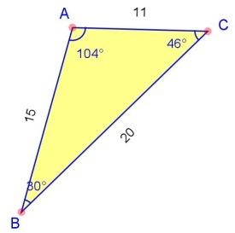
- What type(s) of triangle is this a picture of?

- Do you have any other questions or concerns about triangles?
Lesson Plan #4 – Quadrilaterals

Unit Outcomes:
- The students will be able to categorize two dimensional figures. (analysis)
Time Period Objectives:
- Students will be able to classify the five different types of quadrilaterals and show how they relate to one another.

Materials Needed:
- http://www.mathplayground.com/geoboard.html
- Computers
- White Board and Markers
- Tape
- Projector
- InFocus Pen
- Dot Paper (printablepaper.net)
- Pencils
- Scissors
- Notebook Paper
- Venn Diagram Worksheet (http://cindywhitebcms.blogspot.com/2012/03/quadrilaterals-classwork-homework.html)

Procedures:
Introductory Activity: (5 minutes)
- We will have a class discussion about the different types of quadrilaterals. The students should come up with all five types before moving on to the Developmental Activity. Clues will be given if necessary.

Developmental Activity: (30 minutes)
- Students will each be given a computer and will log on using their school username and password. They will then go to Google Chrome and type in: http://www.mathplayground.com/geoboard.html.

- While the students are logging on and opening the Geoboard, I will put one up on the board from my computer in order to demonstrate everything to the students.

- The students will be instructed to create triangles on their Geoboards given prompts that I read to them. After they have created the quadrilateral on the computer they will create it on the dot paper provided (attached). These should be large enough for them to cut out and used later.
  - Create a quadrilateral that has four right angles and all equal sides.
  - Create a quadrilateral with opposite sides equal and four right angles.
  - Create a quadrilateral with exactly two parallel sides.
  - Create a quadrilateral that has no sides parallel or perpendicular.
  - Create a quadrilateral with two pairs of sides that are equal and no parallel sides.

- After we have gone through all of the prompts and the students have drawn all of their quadrilaterals, they will then cut them out.

- The students will then use tape, and under each category on the white board (I will have written all five types of quadrilaterals on the board) they will put each quadrilateral where they think it fits best.

- After all of the students have placed their quadrilaterals, we will discuss the properties for each type. The students will write this on notebook paper.
Key Questions:
- What type of quadrilateral has four equal sides and four right angles?
- What type of quadrilateral has opposite sides equal and four right angles?
- What type of quadrilateral has exactly two parallel sides?
- What type of quadrilateral that has no sides parallel or perpendicular?
- What type of quadrilateral has two pairs of sides that are equal and no parallel sides?

Summary/Closure/Evaluation:
Closure Activity/Assessment: (10 minutes)
- We will then make sure each quadrilateral is in the correct category and fix them if necessary. We will also discuss if there is more than one category a quadrilateral could go under.

- We will fill in the Venn Diagram (attached) to show how quadrilaterals relate to one another. It should look like this:
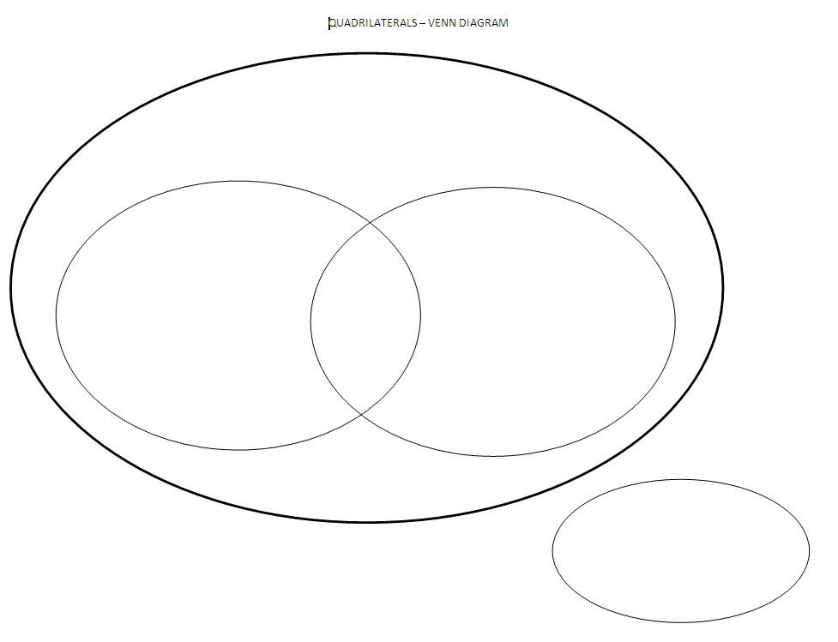
Square
Rectangle
Rhombus
Trapezoids
Parallelograms

Post Assessment

Fill in the blank with the correct vocabulary word.

- A closed, plane figure with all sides and angles congruent is called a ____________________________.
- A polygon with eight sides and eight angles is called a _______________________________.
- A triangle with three different side lengths is called a _________________________________ triangle.
- A quadrilateral with one set of parallel sides and no right angles is called a ____________________________.
- Another name for equal sides are _________________________________ sides.
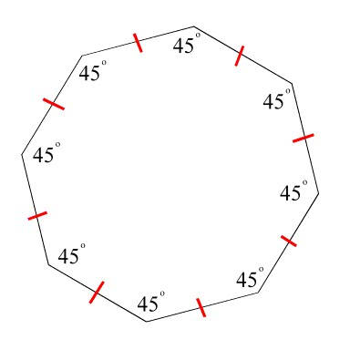
Classify each of the polygons below. Then write Regular or Not Regular on the second line.
- 7. 8.

________________________ ________________________ ________________________

________________________ ________________________ ________________________

Classify each of the triangles below. Each should have two classifications. First write Obtuse, Acute, or Right and then write Equilateral, Isosceles, or Scalene.
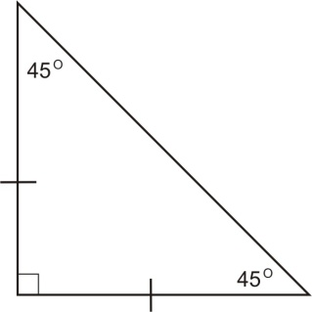
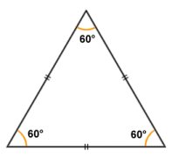
9. 10. 11.
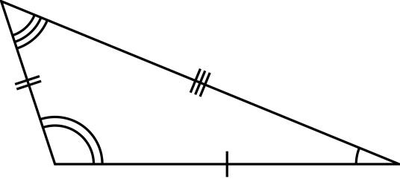

________________________ ________________________ ________________________

________________________ ________________________ ________________________
Classify each of the quadrilaterals below in as many ways as possible. Write Quadrilateral, Parallelogram, Rhombus, Square, Rectangle, or Trapezoid. You may have up to 5 answers. You may not use all lines.
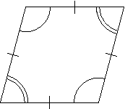
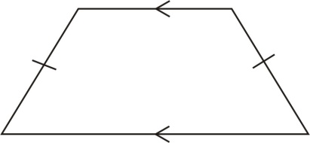
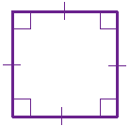
- 13. 14.

________________________ ________________________ ________________________

________________________ ________________________ ________________________

________________________ ________________________ ________________________

________________________ ________________________ ________________________

________________________ ________________________ ________________________

References

Chiarelott, L. (2006). Curriculum in Context. Belmont, CA: Wadsworth.

