Caudal Epidural Procedure in bovine
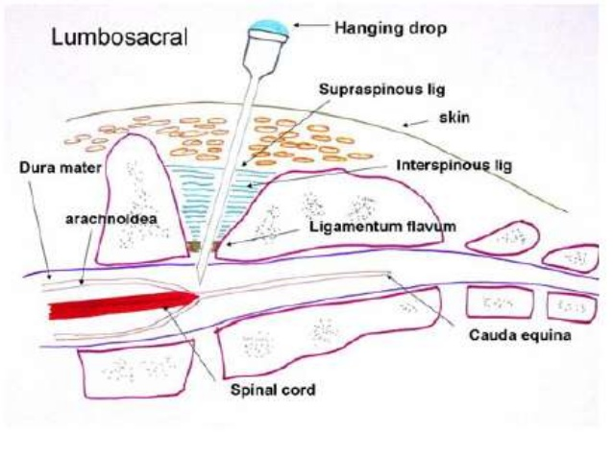
Hang drop method
• In the ox, the spinal cord ends in the region of the last lumbar vertebra, but the meningeal
sac goes to the 3rd/4th sacral segments.
• For caudal epidural anesthesia the injection site used was between coccygeal C1 and
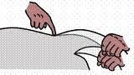
C2 (located by raising tail in “pump handle” fashion, the first obvious articulation behind
the sacrum being C1 /C2).
- Using your less dominant hand as a guide, place your thumb just above the depression
- Using your more dominant hand to hold the needle, the needle is inserted at a 45ᵒ angle distal to the thumb at the depression.
- It is advanced until it comes into contact with the floor of the vertebral canal and then withdrawn 0.5cm
- A drop of lidocaine is then placed at the hub and if it is drawn it we are at the epidural space, if not the needle is redirected until the drop moves
- At this point the syringe is applied and the remainder of lidocaine is administered
.

