Steps to perform an IV regional (Forelimb Block)
- 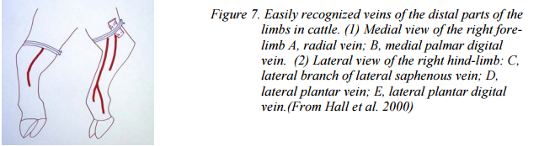Clip and disinfect over a convenient prominent superficial limb vein distal to where the tourniquet will be placed.
- The lateral digital vein immediately proximal to the fetlock may be used. In this case the radial vein or median palmar digital vein may be used on the forelimb with consideration that the lateral branch of the lateral saphenous vein, or the lateral plantar vein, or the lateral plantar digital vein may be used on the hind limb as well
(If an Esmarch bandage is to be applied to exsanguinate the limb, place a needle (19 gauge) or butterfly needle into an appropriate superficial vein before applying the Esmarch bandage and tourniquet. Keep the needle patent using heparin-saline solution)
- Place a rubber tube tourniquet or wide flat rubber band around the limb.
- Flat rubber appears to cause less discomfort than rubber tubing and thus the animal is less likely to be restless during the procedure. (The band or tubing may be placed in the proximal metatarsal or proximal metacarpal region or above the hock or carpus.)
- If applying above the hock, place 15cm ( six inch) rolls of bandage in the medial and lateral depressions anterior to the Achilles tendon before placing the tourniquet, to ensure that all blood vessels are occluded.
- The tourniquet must be applied tightly.
- Insert a needle (22 gauge (1.1 mm external diameter) 3.6cm long into the vein, directed distally.
- Aspirate blood to confirm that the needle is properly positioned within a vein. If not in the vein oull back and redirect. Aspirate again, continue till in the lateral vein.
- Inject an appropriate amount of local anaesthetic solution, 7 ml of 2% lidocaine hydrochloride for adult cattle.
- Withdraw the needle and massage the injection site for a few seconds to prevent haematoma formation.
- Anaesthesia should be complete in five minutes and persist for 1-2 hours if the tourniquet is left in place.
- Analgesia should be in effect after ten minutes.
- Analgesia develops in 15-20 minutes.
- Check after ten minutes whether full analgesia has been achieved: it is important to check the state of analgesia in the deep tissues prior to beginning a surgical procedure involving these tissues (e.g. digit amputation).
(It is particularly important to confirm that the caudal aspects of the interdigital cleft are insensitive as this is often the last area to become fully anaesthetised. Sometimes the skin between the digits is not fully anaesthetised; in such cases inject 5 ml of 2% lidocaine midline on the dorsal aspect of the fetlock and 5 ml midline on the caudal aspect between the dew claws. )
Analgesia remains until the tourniquet is removed. Following surgery (up to 45 minutes) release the tourniquet slowly over about ten seconds. Release should not cause any problems if at least ten minutes have elapsed between injection and release of the tourniquet. The tourniquet may be left in place for up to1.5 hours without ill effect.

Potential problems are:
o Difficulty in finding the vein once the limb is exsanguinated (this is why it’s best to have a catheter in place first).
o Cardiac arrhythmias or even arrest. This is due to an inadequate tourniquet (in man there have been more problems when bupivicaine was used than were found with lidocaine).
o Failure to take effect. Common reasons are inadequate tourniquet, inadequate time, and lack of exsanguination (it does work without exsanguination but not so well).
o Collapse when tourniquet is removed. This is because of anoxic waste products re-entering circulation. It is preferable if the animal is recumbent at this time.
o Damage as a result of the tourniquet being left on too long. This is rare. It can be left on for 1-1.5 hours on the limb of cattle and dogs.
Common use:
- Intravenous regional anesthesia is commonly used in cattle for amputation of a digit.
- It is use in lameness test for cattle and horses.

