Both physical and chemical restraint is essential for the safety of the bull and surgeon. As chemical restraint, Xylazine is used due to its sedative properties.

The first line of physical restraint is the halter. This is tied to a barrier using a quick release knot. After the administration of the Xylazine, the bull laid on the ground due to the ataxia. For even better restraint the back legs were tied using a Tom Fool’s Knot in an attempt to prevent the animal from kicking. Also to give even greater restraint people kneeled in the animal’s neck to prevent the animal from getting up and potentially falling and damaging itself or anyone around the animal.

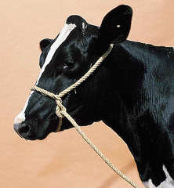

**Example of bull halter**

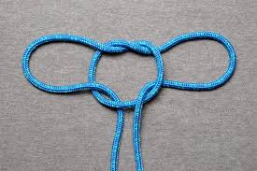

**Tom’s Fool Knot**