Hot Iron Dehorning
Hot iron dehorners are available in versions heated by a furnace or fire, 12-volt battery, 120-volt electricity, power packs (e.g., Buddex™) or LP gas (Figure 4). The head of the iron is a hollow circle and it fits over the horn bud. Proper application of the hot iron will destroy the horn-producing skin at the base of the horn. This technique works well for calves up to 12 weeks old. There are several sizes of dehorning irons. The proper size is one where the burner makes a complete ring around the base of the horn. For electric irons, use a short extension cord as voltage drops with a long cord, limiting the amount of heat generated by the dehorner.

Technique
Administer sedation, analgesia and local anaesthetic.
Shave around the base of the horns
Preheat the dehorning iron to a red colour. Both electric and gas irons work best when they are "red" hot.
apply good restraint. Ensure the calf's ear is out of the way to keep it from being burned.
Place the tip of the burner over the horn and apply slight pressure. When the burning hair begins to smoke, slowly rotate the dehorner by twisting your wrist.
Continue the application of heat for 10-15 seconds. Do not leave the dehorner in place for much longer, especially in young calves. Heat can be transferred through the thin bones of the skull and damage the calf's brain.
Dehorning is complete when there is a copper-coloured ring all the way around the base of the horn.
The horn bud or button will slough off in 4 to 6 weeks.
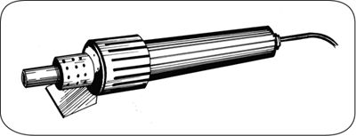
An electric hot-iron dehorner will destroy the horn-producing skin at the base of the horn bud.

