**Dehorning Spoon or Tube**

Dehorning spoons or tubes provide a quick and efficient technique for removing horn buds in calves less than eight weeks of age (Figure 5). With this method, a sharpened metal tube cuts through and removes the horn-producing skin at the base of the horn bud. Use the proper size tube to remove the horn plus about 1/8 inch of skin around the entire horn bud.   
  
**Technique**

* Administer sedation, analgesia and local anaesthetic.
* Select the correct size tube (4 sizes available) to fit over the horn bud, and cover about 1/8 inch of skin around the horn base.
* Place the cutting edge straight down over the horn.
* Apply pressure to the tube; push and twist the tube until the skin has been cut through.
* Cut under the horn bud and remove it, using a scooping motion.
* Apply an antiseptic to the wound. Some bleeding may occur.
* Clean and disinfect the cutting edge of the tube between calves.

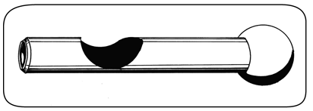

Figure 5. A dehorning spoon or tube is used to remove the horn bud plus the horn-producing skin at the base of the bud

**Advantages and Disadvantages**

* not bloodless
* useful for young calves
* risk of infection because of open wounds
* avoid use during fly season
* unreliable when done incorrectly, leads to scurs
* requires expertise - pain control, technique, control of bleeding

Reference;

1. Thebeefsitecom. 1. The Beef Site. [Online]. Available from: http://www.thebeefsite.com/articles/2261/dehorning-of-calves/ [Accessed 26 September 2015].

In-text citation: (1)