Technique for Disbander
1. Administer sedation, analgesia and local anaesthetic.
2. Close the handles together.
3. Place the jaws of the dehorner over the horn bud. The objective is to completely remove a ring of skin surrounding the horn base. Therefore, adjust the opening as needed .
4. Press the gouger gently against the head. Maintain the pressure and quickly spread the handles apart to bring the blades together to remove skin and the horn bud.
5. Control bleeding by pulling the artery with forceps or using a hot iron to cauterize the artery.
6. Clean and disinfect the jaws of the gouger between calves.
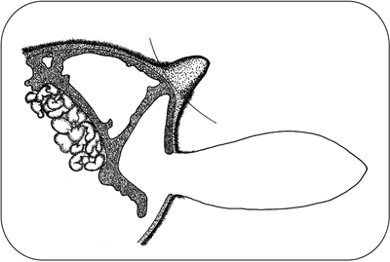
With young calves, the Barnes-type dehorner removes horn-producing skin but does not cut into the frontal sinus as shown by the arced line above. In older calves with the horn attached to the skull, the dehorner cuts into the frontal sinus.

