Cornual Nerve Block
Technique
Steps | Images
- Restrain the calf with a halter tied to a ring, a post, or the head gate of the chute. | 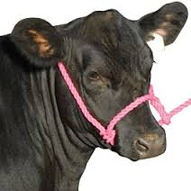
- Preferably, sedate the calf with an injection of an appropriate dose of a sedative and a non-steroidal anti-inflammatory drug as per label directions.

- Locate the injection site for the local anaesthetic by putting your thumb on the skin just beside the outside corner of the eye. You will feel a soft depression at this site. Now, move your thumb backwards toward the horn. You will feel a small groove that runs in the bone of the skull. The nerve runs along and under this groove. The injection site is in the upper third (closer to the horn bud) between the corner of the eye and the base of the horn. | 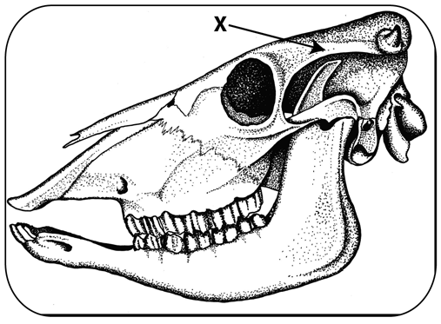
- Disinfect the site with an alcohol swab. Select appropriate size needle, syringe and calculate the volume of lidocaine to be administered.

- While holding the head steady and with the needle on the syringe, push the needle through the skin at the injection site. The needle should penetrate perpendicular to the skull at the site. Once you are through the skin, pull back on the plunger to be sure the needle is not in a blood vessel; then inject the calculated volume of lidocaine. | 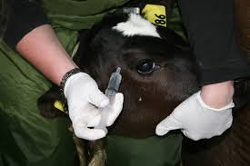
- Repeat on the other side of the head

