Nerve Blocks used for Enucleation

**Peterson’s Block**

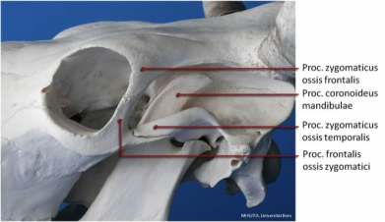

This block desensitizes the oculomotor, trochlear, abducens, and three branches of the trigeminal nerve (ophthalmic, maxillary, and mandible).

* The point of injection is the notch formed by the supraorbital process cranially, the zygomatic arch ventrally, and the coronoid process of the mandible caudally.
* A 10 cm, 18 gauge needle is inserted through a desensitized skin as far anterior and ventral as possible in the notch. The needle is directed horizontally and slightly posterior direction until it hits the coronoid process of the mandible.
* Gently manipulate the needle anteriorly until its point passes medially around the coronoid process, then advanced to the pterygopalatine fossa rostral to the solid bony plate that is in close proximity of the orbitorotundum foramen. Following aspiration, lidocaine (2%) is injected.
* Desensitization should occur in 10 – 15 minutes following injection.

**Auriculopalpebral Nerve block**

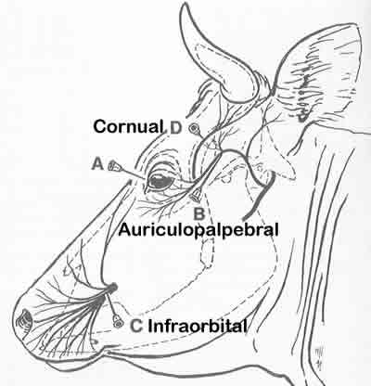

* This block paralyses the muscles of the eyelid. It is used to keep the eye open for procedures such as ophthalmic surgery. This is one of the most commonly used techniques to block the motor function of the upper eye lid for ophthalmic surgery. To prevent eyelid closure during examination of the eyeball   
  **Method**
* Auriculopalpebral nerve supplies motor fiber to the orbicularis oculi muscle.
* The needle is inserted in front of the base of the ear at the end of the zygomatic arch and is introduced until its point lies at the dorsal border of the arch. 2% lidocaine 10-15 ml at injection site.
* Onset of analgesia occurs 10-15 minutes and duration of analgesia is approximately one hour.

**Four Point Retrobulbar Nerve Block**

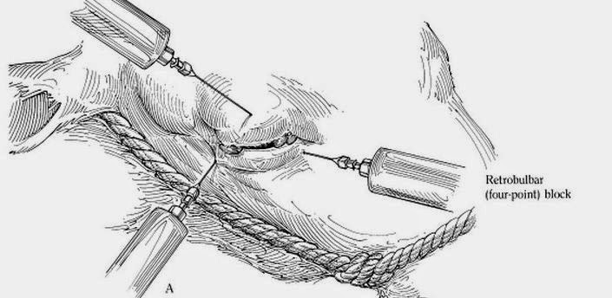

This can be done as an alternative to the Peterson eye block.

**Method**

* An 18 gauge, needle is introduced through the skin on the dorsal, lateral, ventral and medial aspects of the eye, at 12, 3, 6, and 9 o ́clock positions, respectively.
* Introduction of the needle through the conjunctiva should be avoided to reduce the occurrence of ocular contamination.
* The needle is directed behind the globe using the bony orbit as a guide. When the needle is introduced into retrobulbar sheath, the eye will move slightly with the tug of the needle.
* Aspirate and deposit 5-10 mls of lidocaine (2%) at each site.
* Mydriasis indicates a successful block.

**Ring Block**

This is used in conjunction with the other blocks. This is because the other blocks stated do not provide a complete analgesia of the eyelids. To perform this block 5-10mls of 2% lidocaine is injected subcutaneously 2.5cm from the eyelid margins.

**Important things to note:**

Before administering any of the lidocaine it is important to calculate the toxic dose for that weight of animal (especially smaller animals such as sheep and goat). If the amount of lidocaine needed for each site for the block to be successful exceeds the toxic dose, the amount needed for each site is halved and then diluted with sterile saline.