Step 2. Trim second claw to match trimmed claw - matched rather than measured
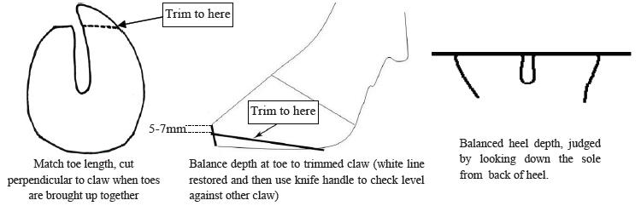
The outer hind claw has a longer natural toe length and so must not be measured to 7.5cm, but should be matched to the correctly trimmed inner claw. Step 2 corrects any obvious imbalances in weight bearing between inner and outer claws.
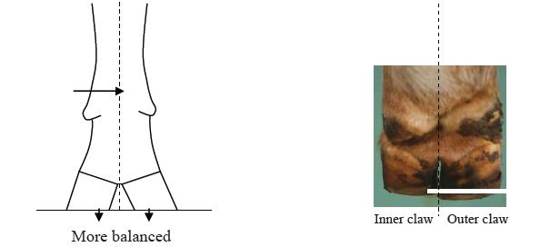
While equal weight bearing is probably ideal, for some animals a naturally shallow heel on the inner hind claw can leave the outer claw over-trimmed and exposed to bruising if completely equal weight bearing is attempted. Therefore, caution is advised when trimming down heels, with frequent checking of sole depth and slight imbalance preferred to thin soles in the heel of the outer hind claw.

Reference;
1. Nadisorguk. 1. Nadisorguk. [Online]. Available from: http://www.nadis.org.uk/bulletins/lameness-control-in-dairy-herds/part-1-practical-foot-trimming-(dutch-5-step-method).aspx [Accessed 11 October 2015].
In-text citation: (1)

