Step 4. Relieve weight off a painful claw - trim down the heel horn or fix a block to the healthy claw
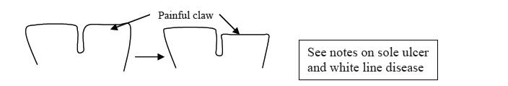
Relieving weight off a painful claw can be achieved in two ways. If there is a good depth of heel horn on the unaffected claw, then the heel horn on the painful claw can be trimmed down (red arrows below). Alternatively, a plastic, rubber or wooden block can be applied to the healthy claw for 6-8 weeks. However, in some cases, bruising or under-run horn may be present on the non-painful claw, making it unhealthy and unsuitable for blocking. These cases require a straw yard or nursing paddock to aid recovery. If in doubt about a case, always ask your vet for advice.
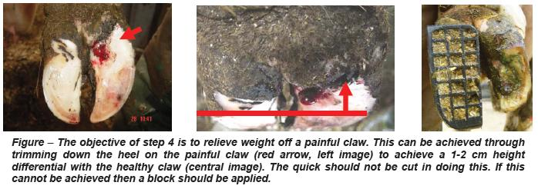

Reference,
1. Nadisorguk. 1. Nadisorguk. [Online]. Available from: http://www.nadis.org.uk/bulletins/lameness-control-in-dairy-herds/part-1-practical-foot-trimming-(dutch-5-step-method).aspx [Accessed 11 October 2015].
In-text citation: (1)

