Step 5. Remove loose/under-run horn and hard ridges
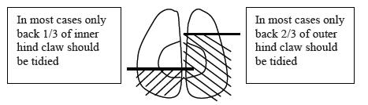

As little serious disease occurs in the front 2/3rd of the inner hind claw, and front 1/3rd in the outer claw, then tracts or under-run horn should not be pursued in these regions. Loose horn around the base of the sole ulcer, in the heel or around white line lesions should be removed (red arrows below). However, cutting into the "quick" should be avoided at all costs to prevent unnecessary pain, scarring and severe infections spreading to the deeper tissues. The final stage is to ensure there are no sharp ridges that could injure the teats or legs, checked by running the hand over the claw.
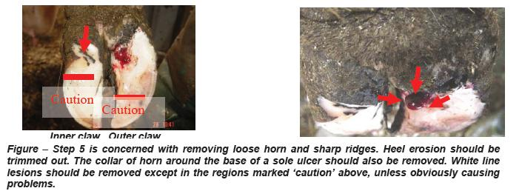

Reference,
1. Nadisorguk. 1. Nadisorguk. [Online]. Available from: http://www.nadis.org.uk/bulletins/lameness-control-in-dairy-herds/part-1-practical-foot-trimming-(dutch-5-step-method).aspx [Accessed 11 October 2015].
In-text citation: (1)

