Evaluation Strategy
Formative evaluation will be necessary to determine if a football has progressed and the players are responding to the teaching. The evaluation period will be based on what happens after a game is played. A game in every way represents a test to see if what I have tried to teach them has actually been learned by the player. Every single play will be graded to ensure an accurate depiction of where the player succeeded and where he made mistakes.
The evaluation strategy will come from a percentage system through 4 different sub units of evaluation. The sub units consist of Alignment, Assignment, and Execution (AE). Alignment and assignment determines whether or not the player executed where his defensive alignment, on the football field, was supposed to be against an offensive formation. After the player has aligned himself then the next part will be evaluating his assignment that he is instructed to do based on the defensive play that was called. Then execution will be whether the player did what was asked of him efficiently and in a timely manner.
The next sub unit will be Hustle and Pursuit (HP). Hustle and pursuit is literally in the sense that the player will be graded on his effort on the play. Did the player hustle to the opposing ball carrier? Did the player take the proper pursuit angle and play with proper leverage on the ball carrier?
The next sub unit is make the play (MP). Make the play is the based on whether the player made the play that was presented to him in the game. Did the player catch the ball? Did they player force a fumble on the opposing ball carrier? Did the player sack the Quarterback? Throughout a game, plays will present themselves to a player and with proper teaching he should “make the play.”
The last sub unit is tackle (T). This will be the easiest to decipher while evaluating a player. Did the player make the tackle or did the player miss the tackle?
While evaluating a player after a game for success on a sub unit the player will receive a plus or a minus. He will receive his evaluation back on two items. First item will be a play by play evaluation of all four subunits with comments on where he made mistakes.
Ex.
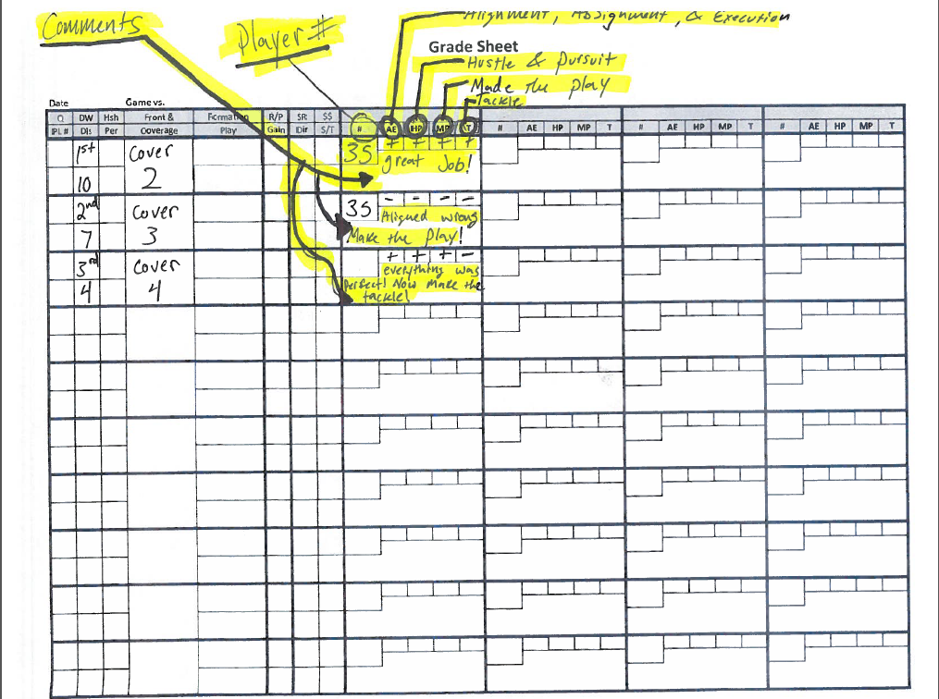

The next item a player will receive is a total grade for the game in which he played this will come from the total number of plays in which he received a plus or minus. The total and results will be very similar to that of a classroom grade
90-100%= Winning football
85-89%= Good Football
80-85%= Average Football
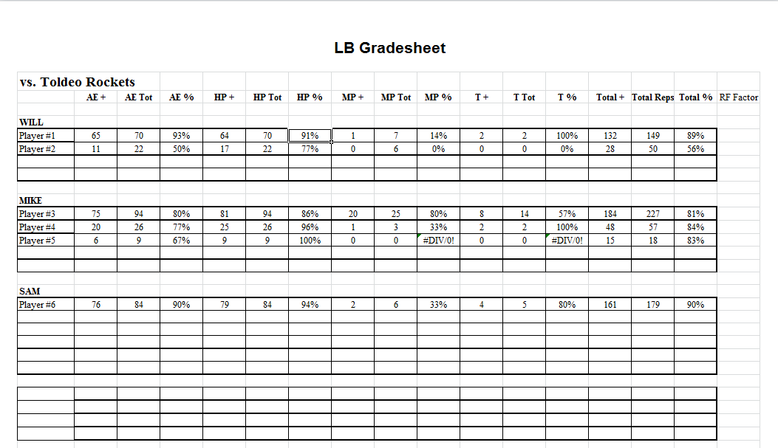
70-79%= under achieving football
>69%= Player should not be on field
Here is an example of a total evaluation grade sheet.

