All these lesions are very painful and the intervention provides immediate pain relief. The animal can remain standing, with the leg lifted up in the crush or in the milking parlour. The operation can also be done on the animal lying down, after sedation with xylazine.

Procedure:

1. After applying a tourniquet to the metatarsus or metacarpus, local intravenous anesthesia can be given.
2. The operation area should be washed, shaved and disinfected.
3. With a scalpel, a cut is made, starting in the interdigital space and ending in the middle of the second phalanx.
4. 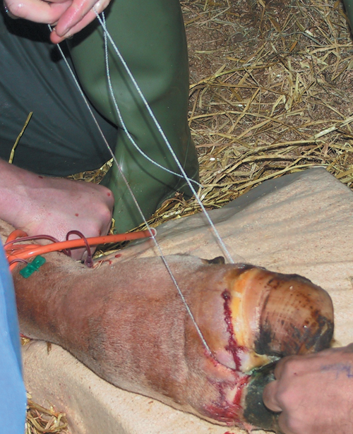A Gigli wire is used to cut through the bone, inserting it in the interdigital space and following the skin cut.

( Usually, it is not necessary to ligate the blood vessels, although the tourniquet should be loosened a little to check that there are no major hemorrhages. In case there are, we leave the tourniquet in place and administer coagulants to accelerate the coagulation process.)

1. To finish the operation, we sprinkle some antibiotic powder on the wound (oxytetracycline) and bandage the stump with a wad of cotton wool drenched in peroxide, held in place by elastic bandages (Vet- Flex). Or if possible, stitch the wound closed using a simple interrupted suture pattern.