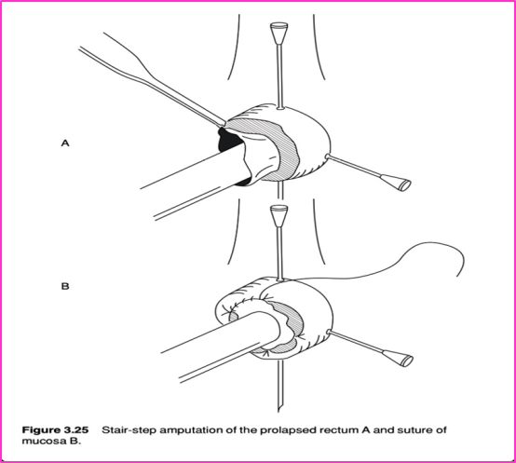
Rectal resection technique
Stairstep Method:
Isolating the rectum to be resected using a syringe and needles; the needles and make an X and stabalise the working area.
Amputate the prolapsed mucosa: cut right around
Free ends are anastomosed; an interrupted suture is placed at 12, 3, 6 and 9 oclock and a simple interrupted suture finishes the suture line.
Care is taken to ensure the sutures bites are taken 2mm apart and no further; to prevent leakage.
The needles and the syringe is then removed and the bowel is reinserted into the anus.

