**Anatomic Parts of a Hernia**

The hernia is composed of the sac, the covering of the sac and the contents of the sac.

The opening for the hernia could be due to an accidental opening of the abdominal wall due to things such as trauma; a persistent prenatal opening such as the umbilicus and it could also be a normal opening such as the inguinal canal.

The sac is the diverticulum of the peritoneum. The tissue layers include the skin, some muscle fibers, fibrous tissue and the parietal peritoneum. The parts of the sac include the mouth, neck and body.

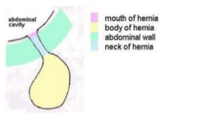

The hernial contents may be the loops of the intestines, the omentum, the stomach and the urinary bladder