UNIDAD 1
TALKING ABOUT PAST EVENTS AND EVENTS THAT WERE HAPPENING

Presentado por:
DORA INES TORRES DURAN
CODIGO 201022478

Presentado a:
LIC: HILDA ELENA PATIÑO

UNIVERSIDAD PEDAGÒGICA Y TECNÓLOGICA DE COLOMBIA
LICENCIATURA EN EDUCACIÒN BÀSICA
CREAD SOGAMOSO
2016

UNIDAD 1
TALKING ABOUT PAST EVENTS AND EVENTS THAT WERE HAPPENING

Presentado por:
DORA INES TORRES DURAN

COD:
20 1022478

UNIVERSIDAD PEDAGÒGICA Y TECNÓLOGICA DE COLOMBIA
LICENCIATURA EN EDUCACIÒN BÀSICA
CREAD SOGAMOSO
2016
INGLÉS PARA LA EDUCACIÓN BÁSICA SECUNDARIA
ACTIVIDADES:
- presente un texto con acción que pasaron y estuvieron pasando
- 10 yes/ no question y 10 wh questions y sus respuestas sobre el video anterior.
- Diseño de un plan de clase sobre, storytelling para grado septino

- Escribe un texto mínimo de dos párrafos donde describa el contenido hacienda uso del tiempo pasado simple.

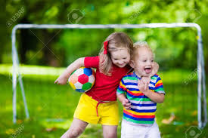
The children were happy scouts. The boy scout ran for the park. He was very surprised when he saw at the girl. The boy came home and hid. The girl gave a pin and he was very happy. They played in abandoned house all day. She visited in your house at night. She showed your adventure book. They got married in the church.
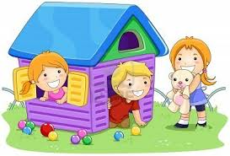They built a beautiful home in the city and bought two chairs. They did different daily activities. They danced in the room also cleaned his house. They explored in the park but she was sick and went home. They saw the heaven to imagine have a baby. She died and he was sad.
II) 10 YES/ NO QUESTION Y 10 WH QUESTIONS Y SUS RESPUESTAS SOBRE EL VIDEO DE MR BEAN.
1) what was Mr Bean washing with?
R. Mr Bean was washing the clothes with
2) where was he changing his clothen?
R. he was changing his clottes in the bathroom
3) what was Mr Bean getting in the laundry with?
R. he was getting in de laudry with a big
4) why was Mr Bean checking his pokets in the laundry?
R. Because Mr Bean was needing coins
5) who was Mr Bean sharing in de laundry with?
R. he was sharing with a bland man a Young woman
6) what was Mr Bean using for washing his clothes?
R) he was using bar soap for his clothes
7) which toys was Mr Bean closing for washing?
R. he was chosin a inflatable dragon deces and a teddy bear
8) how was Mr Bean walking in the laudry?
R he was walking in a strange way
9. why was Mr Bean wearing skirt?
R. Because he was looking for his pants
10) what was Mr Bean drinking in the laudry?
R. he was drinking liguid soap.
- ES/ NO QUESTION
1. Did he drink soap in the laundry?
R. no he did not he drank liquid soap in the laundry
2. did Mr Bean use a skirt that day?
R. yes, he wed a skirt that day
3. did he find his pants?
R. no, he never found his pants
4. did he wash his teddy bear?
R. yes, he washed his teddy bear in the washmachine?
5. did Mr Bean meet a friend in the laundry?
R. no, he didn`t meet any friend
6. did he waste a lot of money in the washmachine?
R. no, he didn`t use a lot of money
7. did the blond man think that Mr Bean was gay?
R. yes, the blond man thought that Mr Bean was gay
8. did the laundry have a coffe machine?
R. yes, It had a coffee machine
9. did the blond man change the soap by coffe?
R. no, he did not, Mr Bean changed the soap by coffee
10. did the washmachine damage Mr Bean stuff?
R. yes, the washmachine damaged Mr Bean stuff.

- UNIVERSIDAD PEDAGOGICA Y TECNOLOGICA DE COLOMBIA

INGLES PARA LA EDUCACIÓN SECUNDARIA

STORYTELLING GRADO SEPTIMO

SCHOOL: sugamuxi sede el sol (Sogamoso) GRADE: séptimo
DATE: the 01st and the 04th of march 2016 TIME: One hour to each grade (from 8:00 am to 9:00 am)
SCHOOL TEACHER: Irma Suarez TEACHER: Dora Ines Torres
Plan de clase:
TOPIC: The piper of Hamelín
AIM: I will be able to specify what I can do using five action verbs;The Storytelling aims to save cultural information, such as beliefs, social rules and developing the imagination. It opens the doors for the solution of problems, the taking decisions form and the exhibition of conflicts that call up emotions that allow clarifying feelings, It seems for me that this activity motivates to the reflection since the stories which affect the affective aspect.
In my opinion, the storytelling increases the vocabulary. The students enjoy studying the book and they learn to value it.
RESOURCES:
The video of the song.
http://www.virtualberks.com/spanishasasecondlanguage/cuentos.html

THE PIPER OF HAMELIN

In a little town named Hamelin, Everybody had mice ravaging all the inhabitants' food. This was caused by a very stingy Queen that guided Hamelin that did not want any expense to remedy the mice's invasion. This is terrible, they take my own food!
The queen, when she saw that mice had gotten to her palace, sent for a young fellow that had the reputation of making the rodents disappear with help of his flute.
I, Queen of Hamelin, I promise you a bag of gold if you manage to free me of those that eat cheese! I will do it! The small boy answered, sounding his flute. The mice, bewitched by the magic sound, followed him to the river nearby, where they all got on a raft and they receded into the distance. The piper, after having left Hamelin without any mice, went to the queen to receive his reward. But the queen, who was very greedy, did not want to live up to her promise.
I do not believe I owe you anything, get out of my kingdom!
You are very unjust and for that reason I will get revenge! the very angry gentleman said .
Then he sounded the flute and all children of the town followed him, listening to his sound.
He took them to a mountain and he locked them in a great cave, hidden to all the world. That way he had revenge on that deceptive and evil queen.
Several months went by and Hamelín turned into a sad town, without laughs and the joy of the children; until the flowers had the pale color of so much sadness.
All the parents of the children went together to the castle to complain to the Queen, requesting that she pay the piper the debt, because they didn't want to be left without their dear children.
The queen did not have more remedy than to pay the piper, and then all the children returned to their homes, bringing with them the happiness again to the kingdom.
From that moment, that queen always fulfilled her promises.

STORYTELLING
Christian Salmo says that: “It is the machine of making stories and promoting the minds”. Crawford and Brown affirm that: “It is form of communication and it is also used to transmit knowledge”. Through this method, students use different classes of narrative since myth, legend epic histories, and fairy tales until classic literature It is the art of using a story through a sensory language, presented in a way that transmits to the listeners the capacity of internalizing, understanding and creating a personal meaning of the topic.
I think that it is showy and useful for the education and learning process elusive to the use of stories for launching a reflection, Since my viewpoint this method is a way of knowing, remembering and dealing new concepts. Also, it wants to touch the child emotional part child to promote the active participation and to promote the cultural knowledge by means of the structure and organization of information and ideas.
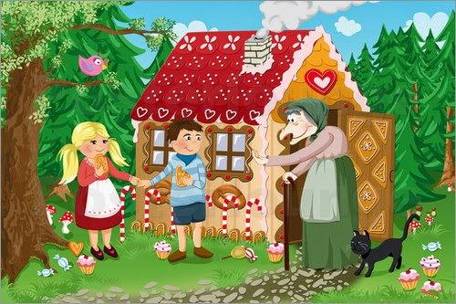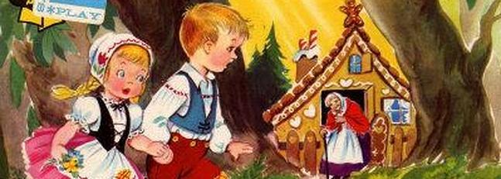
Example: https://www.google.com.co/search?q=cuentos+de+los+hermanos+grimm+en+ingles&rlz=1C1NHXL_esCO682CO682&espv=2&biw=1366&bih=667&source=lnms&tbm=isch&sa=X&ved=0ahUKEwirxr3lz8HLAhXHyyYKHcAPBtsQ_AUIBygC&dpr=1

CONCLUCIONES

This video shows a creative and interactive activity where students sing and dance while they are narrating the story. It uses keywords to support the students attentive; the previous activity is realized with simple words, and a marionette, which make the activity entertaining. The teacher changes the voice to represent the character. The scene is adapted. It has big and coloring images with the subject of the story. The teacher teaches all a choreography followed by a song that narrates the story of two children (hansel and Gretel).
The children realize the mime and actions according to the story. She sings to guide the students and shows happiness to motivate the children. Also, she interprets the character in different ways taking into account the speech of his friend, the witch and the children.

