Mesopotamia River Civilization

Introduction:
The Mesopotamian River Civilization was located where Iraq, Syria, Iran, Turkey, and part of Egypt are found today. Mesopotamia means “land between two rivers” and was in between the Tigris and Euphrates Rivers. It is the oldest river civilization and was formed between 3300-2500 BCE. The area around these two rivers was called the fertile crescent, making the soil very rich and easy to farm on. Mesopotamia was also called the “Cradle of Civilization” because they developed the first system of writing and were the first to use the concept of a city. The Mesopotamian river civilization is also responsible for inventing the wheel, the plow, base 60 unit of math, farming of animals and food, sails, irrigation system, and so much more. The people of Mesopotamia are also the first to domesticate animals. They also developed the first set of laws created by Hammurabi.

In this artifact box, you will find artifacts that represent movement, place, and human/environment interactions. More specifically, you will find a ziggurat, cuneiform writing, the wheel, Gilgamesh, checkers, and a clock. I feel that these six artifacts represent Mesopotamia as a whole, but so many more could have been included. Using these artifacts in a classroom would integrate Common Core because they would integrate using visual information into teaching.

Strands:
Geography
History

Themes:
Regions
People of the Eastern Hemisphere

Topics:
Early Civilization
Spatial Thinking and Skills
Places and Regions
Human Systems

Content Statements:
2. Early civilizations (India, Egypt, China and Mesopotamia) with unique governments, economic systems, social structures, religions, technologies and agricultural practices and products flourished as a result of favorable geographic characteristics. The cultural practices and products of these early civilizations can be used to help understand the Eastern Hemisphere today.
3. Globes and other geographic tools can be used to gather, process and report information about people, places and environments. Cartographers decide which information to include and how it is displayed.
5. Regions can be determined, classified and compared using various criteria (e.g., landform, climate, population, cultural, or economical).
6. Variations among physical environments within the Eastern Hemisphere influence human activities. Human activities also alter the physical environment.
8. Modern cultural practices and products show the influence of tradition and diffusion, including the impact of major world religions (Buddhism, Christianity, Hinduism, Islam, and Judaism).
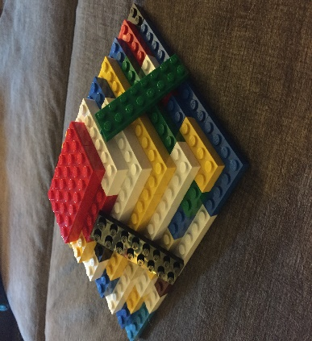
Ziggurat:
Artifact: Lego Ziggurat

A ziggurat is a temple that was built in the Mesopotamian river civilization. Ziggurats were made out of clay. They were built in the center of every town and were often referred to as “mountain of god” or “hill of heaven”. They were built extremely tall because ancient Sumerians believed that the closer the ziggurats were to the sky, the closer they were to the primary god of the city. Only priests were allowed in the ziggurat meaning that ziggurats were more of a house for gods verses a place to worship them.

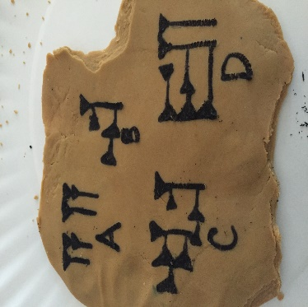
Cuneiform:
Artifact: Picture of Cuneiform alphabet

Cuneiform was the first developed form of writing. The Sumerians of Mesopotamia started using pictographs to represent simple nouns, but found that it was hard to make “sentences”, so they stated using triangles to represent sounds. Once they had sounds, they started to form words. Cuneiform was developed between 3500-3000 BCE.

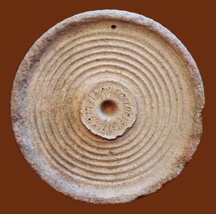
Wheel:
Artifact: Wheel

The wheel was invented by the Mesopotamians around 3500 B.C. It was not originally used for transportation but as a potter’s wheel. After this, they discovered that they could use wheels to move objects from place to place. Finally, using them on chariots.

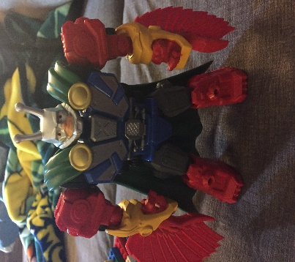
Gilgamesh:
Artifact: Superhero toy

Gilgamesh is a Mesopotamian hero. He is a demi-god who was said to have fought monsters, helped save people who were in need, and have many other “super hero” traits. There is still doubt that he ever actually existed, but he would have most likely been a king if he had. There have been many tales that have been written about him. In fact, The Epic of Gilgamesh, which was written in cuneiform, is one of the oldest recorded stories written.

Checkers:
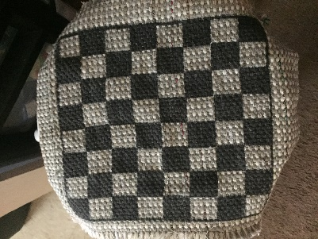
Artifact: Checker board

A checker’s board was discovered at a dig site in Ur, which was in southern Mesopotamia. It was dated back to 3000 B.C. The board is different than what we are used to today and only a partial set of rules have been found. No one really knows how the game was played. Historians assume that it was played with two sets of seven markers and three dice. It is also assumed that the game involved a race to be the winner.

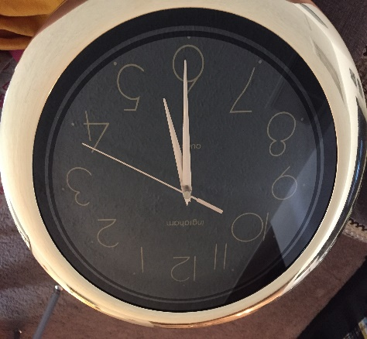
Base 60:
Artifact: Clock

Mesopotamians used a base 60 system for math, unlike the base 10 system we use today. They were the first ones to divide time into 60 separate units. (60 seconds in a minute and 60 minutes in an hour). They used different symbol to represent each number except for 1 and 60. They used the same symbol for both of these numbers. Because of this, historians often have to infer which number is being used.

Using Artifact in a Classroom:

All of the above artifacts can be used when teaching about Mesopotamia. As stated above, so many other artifacts could have been included but I felt these are all important to this river civilization. I feel that teaching about Mesopotamia using these artifacts can be interactive.

For example, after learning about a ziggurat, students can use resources, such as Legos, to build their own. They will take what they know and design one that is accurate based on pictures and descriptions. After they are build, the teacher could set them up around the classroom for everyone to compare and contrast the differences.

When teaching about people of Mesopotamia, students could draw or create their own “super hero”, such as the one I used of Gilgamesh. Even though there were already tales about him, students could pick someone from the time period and write a tale about them, using historical information that was learned throughout the unit. The teacher would use the Epic of Gilgamesh as an example for students to follow. After students have designed and written their tales, they could share them with the class.

As students learn about cuneiform, they could write letters to partners using cuneiform. After letters are exchanged the other person would have to try to determine what the letter says. Then, students could talk about struggles they faced and how cuneiform is different from using todays writing system.

After learning about base 60 number system, students could make up problems to solve using the symbols. They could also try to come up with other units to tell time and explain their reasoning behind it.

When teaching about the invention of the wheel, students could design their own wheel out of various materials. They could compare and contrast their wheels with other students. Then, students could design some type of vehicle and have a race using the wheels they created. Students could then write about why their wheel was or was not successful. Going one step further, students could then try to determine how and why the development of the wheel changed the way it did and write about how it could’ve been different then what we have today.

Finally, when teaching about the creation of checkers, students could use the facts that we know about it and try to determine how the game was originally played. They could then share their ideas and play their version of the game.

