Title of Today’s Lesson
Your Name | Angela Root | Date | 7/27/2016
Subject/ Course | Social Studies | Grade | 6th
ONLS Theme | Geography | # of Students | 25
ONLS Strand | Geography | Class Length | 60 minutes
ONLS Topic | Spacial Thinking and Skills | Day: 1 | of Day: 1
Central Focus/Concept, Essential Question, or Enduring Understanding
Central Focus: Thinking Geographically

Essential Question: How can geographic tools help find unknown locations?
Lesson Rationale and Summary
The purpose of this lesson is to familiarize students with geographic tools such as maps and a compass rose. Students will be using the mystery learning strategy through this lesson as they become geographers and find their way to a series of mystery locations. At each location, students will find a letter and a clue directing them to their next location. After visiting each mystery location, students will unscramble their letters to form the mystery word. Once students have found the mystery word, they will return to their teacher to check their answer.

This lesson requires students to use critical thinking and logic when finding mystery locations. These tasks require students to use higher order thinking skills throughout this lesson. In additon, this lesson is very engaging and interactive. Students are moving around outside of the school and working with classmates, which makes the lesson a developmentally responsive practice. By using writing, group work, an interactive activity, and class dicussions, many different multiple intelligence learning needs are addressed throughout this lesson. Students with a wide variety of learning needs and preferences will have the ability to interact with the content in several different ways.
ONLS Content Statement
3. Globes and other geographic tools can be used to gather, process, and report information about people, places, and environments. Cartographers decide which information to include and how it is displayed.
Learning Objectives
- SWBAT explain the purpose for using maps, compasses, and other geographic tools.
- SWBAT distinguish between the cardinal directions- North, South, East, and West.
- SWBAT use geographic tools in order to find an unknown location. .
Academic Language
- Compass Rose
- Cardinal Directions- North, South, East, West
- Geography
- Map
Planned Assessments
Indicate the types of assessments you plan to utilize in your lesson, & then indicate within your plan where each will be implemented. (Not all are needed in each lesson.) Be sure assessments are clearly aligned with lesson objectives. Consider these three types:
- Pre-Assessment: Students will be assessed informally through observation of class discussion at the beginning of class. Students will also complete a Before & After chart to assess their growth throughout the lesson.
- Formative Assessment: Students will be assessed throughout the lesson through teacher observation and teacher prompted discussion questions. Students who seem to be struggling will recieve extra teacher assistance during the activity and at a later time, if needed.
- Summative Assessment:: Students will be assessed on their ability to correctly use geographic tools to find mystery locations. If students correctly identify the mystery word, they have made their way to each of the mystery locatoins. Students will also complete the After section of their Before & After chart to see the amount of growth that has occured as a result of the lesson.

List Resources
- Notebook paper- 1 piece per student
- Map of school property- 1 per group
- Mystery word worksheet- 1 per group

THE LESSON PROCEDURES

1. READINESS (also called “Motivation” or the “Engage” segment) Allotted Time:___5_____
- Ask students to fold their piece of paper in half “hot dog style” to create 2 columns. Label the left column “before” and the right column “after”.
- In the “before” column, have students write down what they know about geographic tools: what are they, how are they used, what is the purpose of them, have they ever used one before, etc.
- Once students are finished, have them set their paper aside until the end of the lesson.
- Engage students in class discussion about maps, globes, and other geographic tools.
- Review the meaning of the term “cardinal directions” and what the cardinal directions are.

- ASSESSMENT: Students will be assessed informally on their prior knowledge of this topic by using the “before” chart, as well as observation of class discussion.

Now that we have begun thinking about different geographic resources, you now have a challenge. You are now geographers and will be going on a scavenger hunt to find a series of mystery locatons.

2. CENTRAL LESSON OR ACTIVITY (Explore, Explain, Extend) Allotted Time:____45____

- Divide students into teams of 3-4 and give each team a map of the school property (may be computer generated or hand drawn. For an extra challenge, have the class draw a map together the previous day and make copies for today’s activity).
- Explain the rules for the scavenger hunt:
  - Each group will be given a clue to their first location.
  - Use your clue, map, and compass rose find this location.
  - Once there, you will find an index card with a letter. Write the letter down on your Mystery Word worksheet.
  - Then, read the clue posted at that location and use your map and compass rose to find your next mystery location.
  - Follow his same procedure until you have visited all 10 stations. (The number of stations may be changed depending on how much time you have or what “mystery word” you want to use.)
- Once students have visited each mystery location they will return to a desinated area and unscramble the letters to determine the “mystery word”. They will check the word with the teacher to confirm that they have successfully completed the scavenger hunt. (Some teachers may elect to give students a small prize or “treasure” when they solve the mystery word.”

- ASSESSMENT: Students will be assessed by their ability to correctly use geographic tools to find mystery locations. Successfully finding the “mystery word” means that the team has located each of the stations using the geographic tools and clue provided for them.

3. CLOSURE Allotted Time:____10____
- Students will return to the classroom and have a brief discussion about the activity.
  - Discussion questions may include: “how did you use the geographic tools provided?”, “which tool did you find to be most useful?”, “what were some of the challenges that you faced?”

Homework: None

4. ASSESSMENT
- Students will then complete the “after” section of their before and after chart to reflect upon the lesson. Once again, have students write down what they know about geographic tools: what are they, how are they used, what is the purpose of them, etc.
- Ideally, students will show a more thorough understanding of geographic tools as a result of this lesson.

REFLECTION
Leave this blank for now, so that you can write in here at the end of each day you teach. After having taught it, include here a short paragraph about how things went, and what you would keep or do differently if you had to do it again. Or, if you did make changes as the day proceeded, note those changes.

Attach notes, handouts, etc., and save for the next year, so you can see what worked and what didn’t.

Sample School Grounds Map
For safety reasons, only complete this activity within a secure area where students are under adult supervision. For instance, the school playground and playing fields.

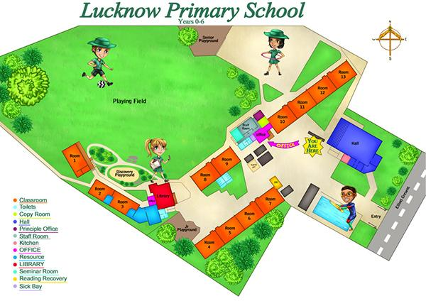

Group Members’ Names: __________________________________________________
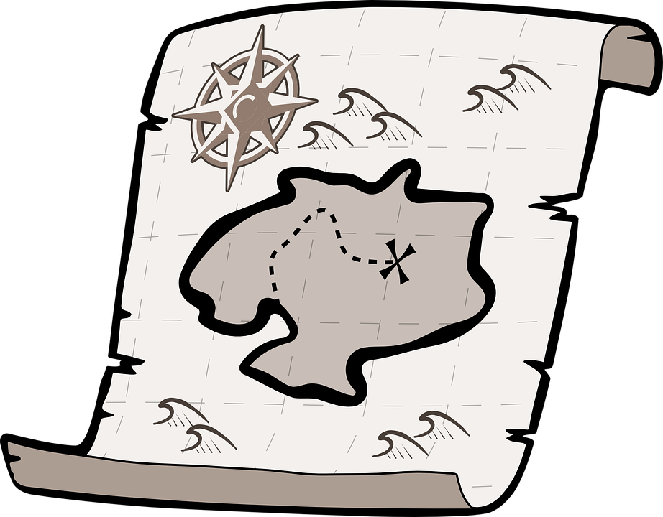
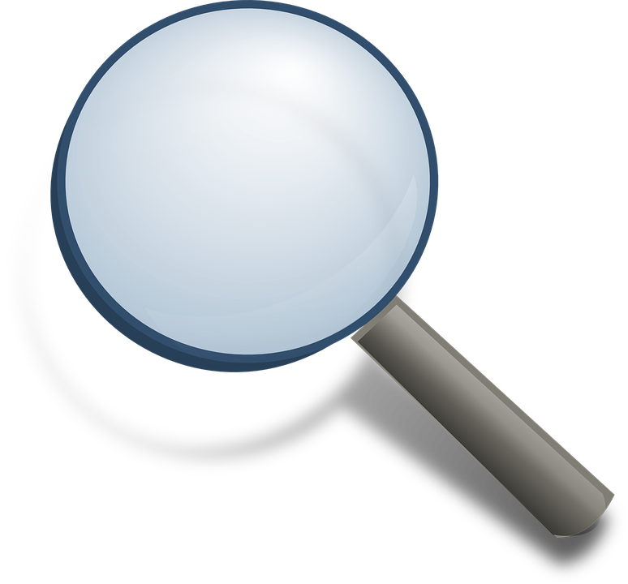
MYSTERY WORD SCAVENGER HUNT

At each mystery location you will find a letter and a clue. Write the letter below and then use the clue and your map to find the next mystery location.

Location | 1 | 2 | 3 | 4 | 5 | 6 | 7 | 8 | 9 | 10
Letter

When you have all 10 letters, unscramble them to discover the mystery word. Check your mystery word with your teacher to recieve a treasure.

Mystery Word: ________________________________

