Partners: Amy Hostetler and Vanessa Orahood
Ohio Social Studies Standard Grade 6
Strand: Economics.
Topic: Economic Decision Making and Skills Effective economic decision making requires students to be able to reason logically about key economic issues that affect their lives as consumers, producers, savers, investors and citizens. Economic decision making and skills engage students in the practice of analyzing costs and benefits, collecting and organizing economic evidence, and proposing alternatives to economic problems.
Content Statement 12. The choices people make have both present and future consequences. The evaluation of choices is relative and may differ across individuals and societies.
Analysis: In this mystery, students uncover the decline of made in the U.S.A. apparel since 1960, by focusing on a NPR produced documentary on the making of the t-shirt. Students read and analyze statistics from tables, charts, graphs and sentences about the fashion market, including wages, imports and exports, to draw conclusions on why apparel is no longer made in America.
Mystery Question: Why has the percent of clothing made in America changed so much over the past 50 years?

Time Needed: At least two 40 minute class periods to conduct the research. Day 3 to analyze and report the data to the class.

Prepare – Group students into multi-level groupings of 3 or 4. Assign group roles. Explain that today they will be solving an economic mystery.
Have t-shirts for groups to examine displayed around the room.

Step 1) Initial Data
Pass out the data cards first. Ask students to orally surmise what the mystery may be about.
Pass out the Mystery Clues Worksheet – Apparel Made in America. Explain that the students will be looking for clues to answer the question, “Why has the percent of clothing made in America changed so much over the past 50 years?” Explain what a hypothesis is, if needed.
Students look at Cards from 1960, 1970, 1980, 1990, 2000, and Today (2010) and then fill out the table and answer the questions on the Mystery Clues Worksheet.
Initial Hypothesis. Instruct students to stop after this step and make a hypothesis to the question “Why has the percent of clothing made in the America changed so much over the past 50 years?”
Guiding questions suggestions. Is there still a need for apparel? Has the number of clothes American’s wear increased or decreased? Why do you think the percent has gone down so much?

Step 2) Brief T-shirt history
Apparel is a big industry. It includes the clothes and shoes we wear. We are going to research one basic apparel item, the t-shirt.
Teacher – Read to the students the basic introduction to t-shirt history.
The name t-shirt comes from the basic design of a flat t-shirt, and the t-shape.
By 1920 the word t-shirt was entered into the Merriam-Webster Dictionary.
T-shirts were worn by American Navy men during the Spanish-American War of 1898.
The American t-shirt began in WWI from the European soldiers’ lightweight cotton undershirt. These cooler t-shirts replaced the wool undershirts American navy men had been wearing.
In World War I the Navy issued t-shirts as undergarments, replacing wool undershirts
By World War II, both the Navy and the Army included the t-shirt as standard issue underwear.
In 1951, Marlon Brando shocked Americans when his t-shirt was ripped off his body in the film “A Streetcar Named Desire”. In 1955, James Dean in the movie “Rebel Without a Cause” wore a t-shirt as clothing as a symbol of a rebellious youth.
In the 1960’s t-shirts were tie-dyed and screen printed and gained popularity as more colors and designs were introduced.
In the late 1960’s and 70’s rock and roll started to make lots of money selling t-shirts. People started using the t-shirt to say something about themselves.
Today t-shirts are popular with tourism. Most attractions sell t-shirts with their name on it.
Refer students to the Mystery Clues Worksheet Step 2 question: Are t-shirts popular in America?
Step 3) Have the students look at t-shirts displayed around the room.
Have each student group record data from the t-shirt labels. They will record the country where the t-shirts was made and record the material of the t-shirt from the labels. If they choose, students can look at the labels of the t-shirts they are wearing as well and include them in the data. Have each group report their findings and tally them together. Create a pie chart of the data. (Either teacher and students, or assign parts to each group to figure percentages.)
Step 4) Watch the 4 videos from NPR. This is the NPR Link http://apps.npr.org/tshirt/#/title
Instruct Students to read the questions for each video before watching. You may suggest that they read the questions for the video. Then watch the video once. Finally, answer the questions, pausing as needed, the second time through the video.
4a) Watch Video, COTTON: Planet Money Makes a T-shirt (Part I)
https://www.youtube.com/watch?v=QYa4zneKbeY
4b) Watch Video, MACHINES: Planet Money Makes a T-shirt (Part II)
https://www.youtube.com/watch?v=ZJOteam-zWw
4c) Watch Video, PEOPLE: Planet Money Makes a T-Shirt (Part III) https://www.youtube.com/watch?v=-6T1MvHyUic
Mystery Clue Question for Students: How has the choice to export American cotton overseas affected the lives of women like Jasmine in Bangladesh, and Doris in Colombia? This is a thought Provoking Question from video on the impact of our t-shirt.
4d) Watch Video, BOXES: Planet Money Makes a T-Shirt (Part IV)
https://www.youtube.com/watch?v=O4aZzxEnIhE
Hypothesis Check Point. Based on your research so far, go back to your hypothesis sheet. Do you need to make any additions or changes to your hypothesis?
Step 5: Data Sort and Analysis
Hand out the graphs, charts and table data (cut into sentence strips) to each group.
Instruct the students to group the data by similarity. Possible categories are:
- labor costs - amount of workers -wages -exports -imports -apparel - textiles
What observations can they make about each category of data?
If needed give specific questions, such as:
What do you conclude about labor costs around the world compared to America?
Making apparel and producing textiles?
How many Americans work in the fashion industry?
How many are in the apparel making?
How many are in the textile making?
Optional Activity: Challenge the students to go shopping (on-line) to one of their favorite stores and try to find a t-shirt that is NOT imported but made in America.
Assessment:
Throughout the activity monitor groups to ensure everyone is participating. Guide as needed.
Collect the Mystery Clues and Hypothesis Sheets from each group to assess for completeness.
Monitor group responses during sharing time.
Have students complete a written reflection on the Mystery Clues process and the conclusions the reached. Suggested questions to include:
Which hypothesis best answered the question, “Why has the percent of clothing made in America changed so much over the past 50 years?” Students must include justification for their answer.
Include questions about the process. What happened during the activity? What did you do well? What was most confusing for you?

Supplies Needed:
Assorted T-shirts with labels identifying where they are made and the fabric content.
Ability to play videos from You Tube, or use NPR link.
Computer with internet access for each group to watch the videos.
Research Data pages copied and divided for groups.
Mystery Clues – Apparel Made in America – one for each student
Hypothesis Sheet – Apparel Made in America - one for each student

Step 1 Cards
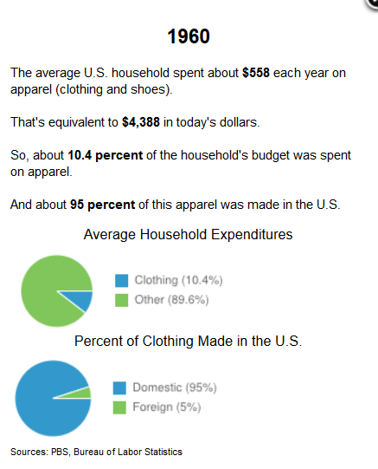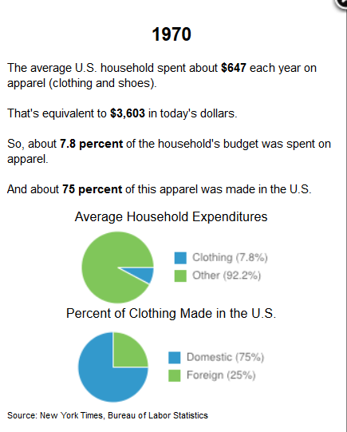
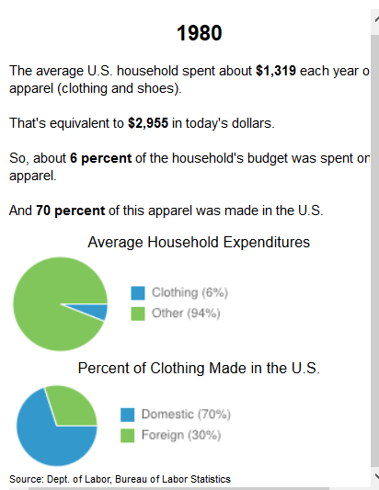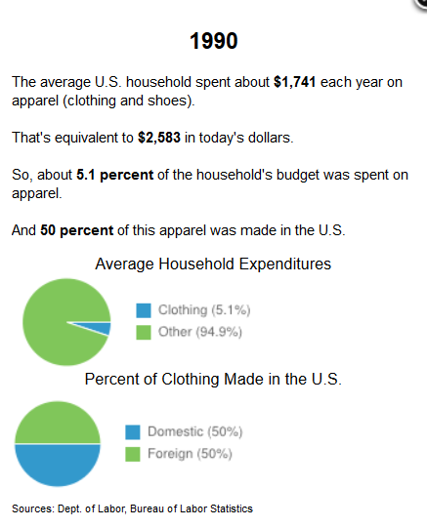

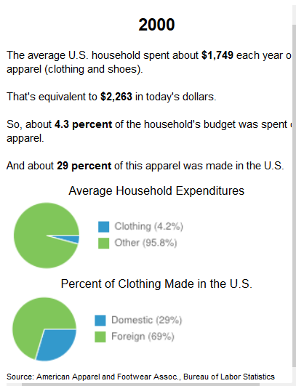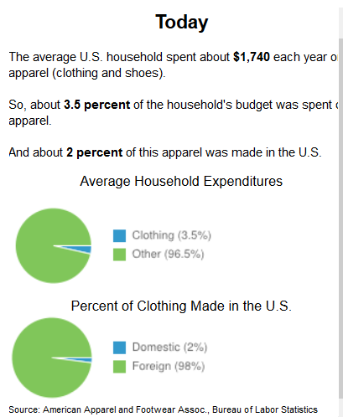

Step 5 Data
Note: Some of the same data is duplicated in the sentences and the charts and tables to give exposure to reading data from different sources. There is table data available on the websites from the U.S. Bureau of Labor Statistics.
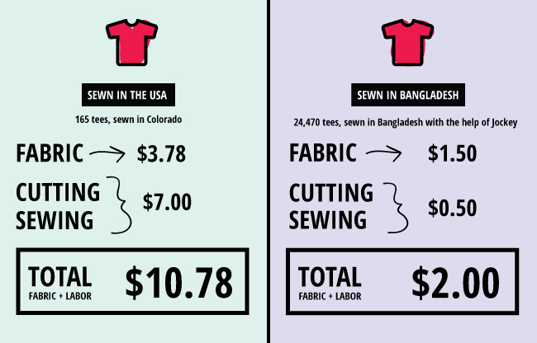

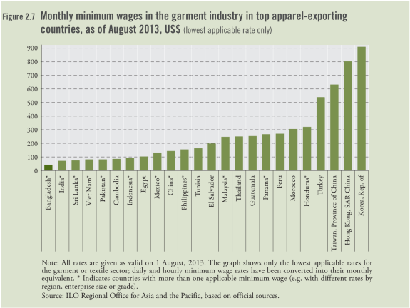
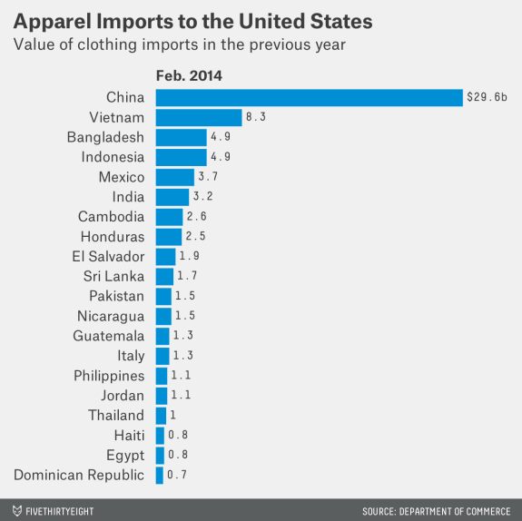

Sentence Strips to cut out
The United States exported $5.8 billion worth of apparel in the 12 months leading to February 2014, according to the Department of Commerce’s Office of Textiles and Apparel.
The United States imported $80 billion worth of apparel in the 12 months leading to February 2014, according to the Department of Commerce’s Office of Textiles and Apparel
The global apparel market is valued at 3 trillion dollars and accounts for 2 percent of the world's Gross Domestic Product (GDP). The fashion industry includes many sub industries, such as menswear, womenswear and sportswear.

Apparel manufacturing - number of people employed around the world
- 14.5 million in 1990
- 13.1 million in 1995
- 13.0 million in 2000
- 24.8 million in 2014

Textiles - number of people employed around the world
- 19.7 million in 1990
- 16.8 million in 1995
- 13.5 million in 2000
- 33.0 million in 2014
In the United States 232,000 of the 1.8 million are employed in manufacturing textiles for apparel and other fashion items.
Between 1990 and 2011, about 750,000 apparel manufacturing jobs in the U.S. disappeared according to the Bureau of Labor Statistics.
The United States has a population of roughly 323.2 million people. The labor force is made up of 161 million people. The employment in the fashion industry (all parts) is 1.8 million.
In the United States the average annual wage in fashion is $26,440 for textile bleaching and dyeing machine operators. This comes to $2,203 per month.
In the United States, 143,000 people of the 1.8 million are employed in the apparel manufacturing industry.
In the United States the average annual wage is $34,110 per year or $2,843 per month for all fashion jobs.
In the United States the average wage for tailors, dressmakers and sewers is $27,510 per year, or $2,293 per month.
There are 4 million people in the garment industry in Bangladesh, double from ten years ago in 2003.
The average U.S. Garment worker makes about 38 times the wage of his or her counterpart in Bangladesh.
The U.S. apparel market (buyers) is the largest in the world, comprising about 28% of the world total.
In 1980, about 70% of the clothing Americans bought was still made domestically.
By the 1980’s a few retail stores, like Gap, Inc. and J.C. Penney continued to design and sell clothes, but started to have them made in factories overseas, where the work was done for a fraction of the cost.
By 2003, Gap was ordering its clothes from more than 1,200 different factories in 42 countries.
In the mid-1970’s large textile mills and factories began to open in China and other developing countries in Asia and Latin America.
The Chinese, Asian, and Latin American mills and factories were able to offer cheap labor and raw materials, and to manufacture huge orders quickly.
In 2012, President Obama, through the departments of Commerce and Labor launched the “Make It in America” challenge. $40 million was offered in grants to applicants who came up with proposals to manufacture in America.
Cotton is cultivated in around 80 countries.
China is the world’s largest producer of cotton, but uses most of their own crop.
The United States is the leading exporter of cotton.
The world produces around 25 million tons of cotton every year. Six countries - China, Brazil, India, Pakistan, the USA and Uzbekistan - account for more than 80% of total production.
China has become a major purchaser of raw cotton, with imports of 3.2 million tons in 2006, mainly from the United States.
An estimated 60% of cotton fiber is used as yarn and threads in a wide range of clothing, most notably in shirts, T-shirts and jeans, but also in coats, jackets, underwear and foundation garments.

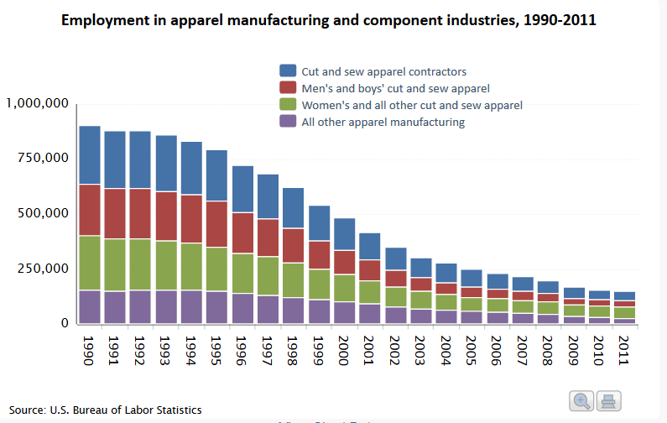
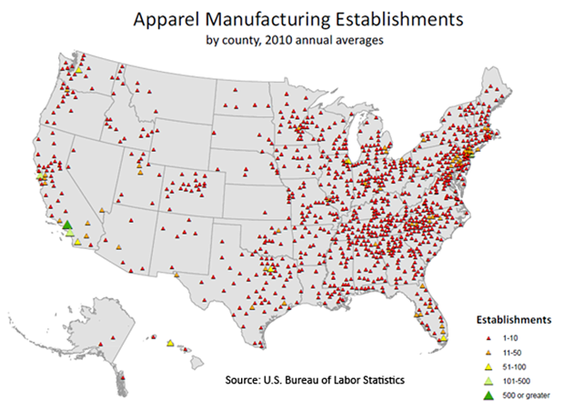
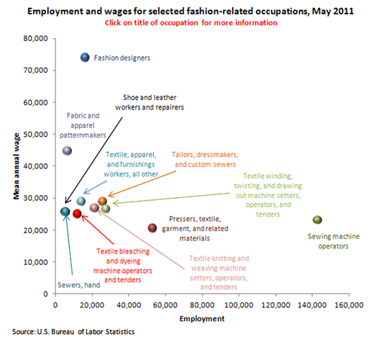

Sources
Blumberg, A. (Producer) & Davis, J. (Director). (Dec 2, 2013) Money Makes a T-Shirt. (2013) NPR. Retrieved July, 2016. http://apps.npr.org/tshirt/#/title
Chalabi, M. (April 23, 2014) Where the U.S. Gets Its Clothing, One Year After the Bangladesh Factory Collapse. Retrieved July, 2016 http://fivethirtyeight.com/datalab/where-the-u-s-gets-its-clothing-one-year-after-the-bangladesh-factory-collapse/
Fashion United. (2016) Global fashion industry statistics – International apparel. https://fashionunited.com/global-fashion-industry-statistics
Glenn, K. (2014). Why Does American-Made Clothing Cost More? Retrieved July, 2016
http://images.elephantjournal.com/wp-content/uploads/2014/02/Cost-Comparison.jpg
Natural Fibres, Cotton (2009) Discover Natural Fibres. Retrieved July, 2013 from http://www.naturalfibres2009.org/en/fibres/cotton.html
U.S. Bureau of Labor Statistics. Retrieved July, 2013 http://www.bls.gov/spotlight/2012/fashion/

Google Link:
https://docs.google.com/document/d/1gN0nHvW-db_C64VWandaGgzdDvh730gBVBZd-K3kZsw/edit?usp=sharing

