Common Hormone treatments used in large animal medicine:

**Trade Name**: Fertiline

**Drug Name:** Gonadorelin Acetate (Gonadotropin Releasing Hormone)

**Indicated for use** mainly in cattle to aid in reproductive management and in the treatment of cystic ovaries in bovine. Also effective in bovine synchronization programs.

**Contraindications**: Not to be used in Food animals meant for slaughter. Withdrawal time is 7 days after last treatment.

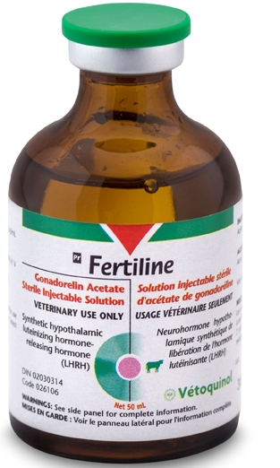

**Drug Name: Progesterone 5%**

**Progesterone 5% Indications:**

Hormone for use in Cattle, Swine, Horses, Goats and Sheep experiencing habitual abortions, threatened abortion, nymphomania, sterility, mammary underdevelopment and for oestrous control. To be administered intramuscularly only.

**Contraindications**: Not for use in Lactating animals as hormone is passed into milk. Not for use in animals meant for slaughter for meat.

**Withdrawal:** 10 days after last treatment

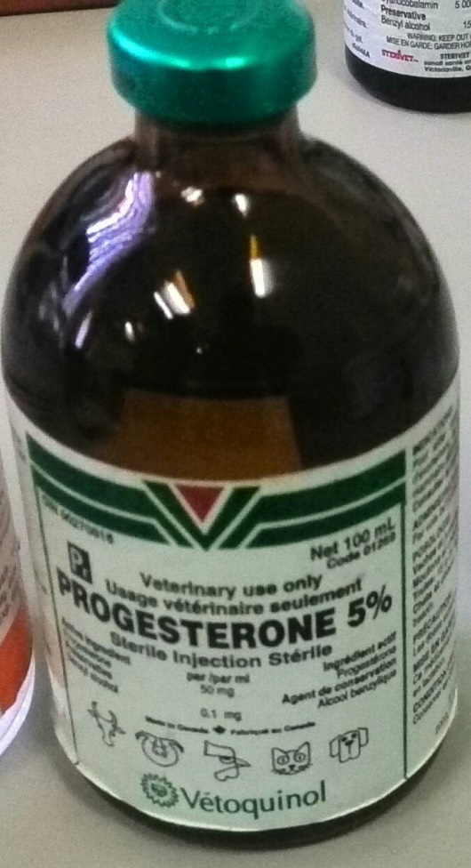

**Trade Name**: Lutalyse

**Drug Name**: Dinoprost Tromethamine

**Indications** forintramuscular use for estrus synchronization, treatment of unobserved estrus and chronic endometritis in cattle; for abortion of feedlot and other non-lactating cattle; for parturition induction in swine; and for controlling the timing of estrus in estrous cycling mares and clinically anestrous mares that have a corpus luteum**.**

**CONTRA-INDICATIONS:** For subcutaneous use only in the equine and intramuscular use only in the bovine and porcine. Not to be administered intravenously.

**Withdrawal period**: No Withdrawal time is noted for dairy milk or meat carded for human consumption however drug should not be used in horses meant for consumption.

