HOOF MAINTENANCE TOOLS | Instrument | Indications for use | Directions | Photos
 | Rasp | Overgrown or uneven hooves | Use like a file but be careful as it can remove skin | 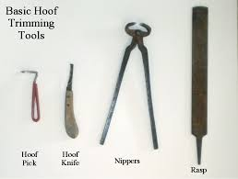  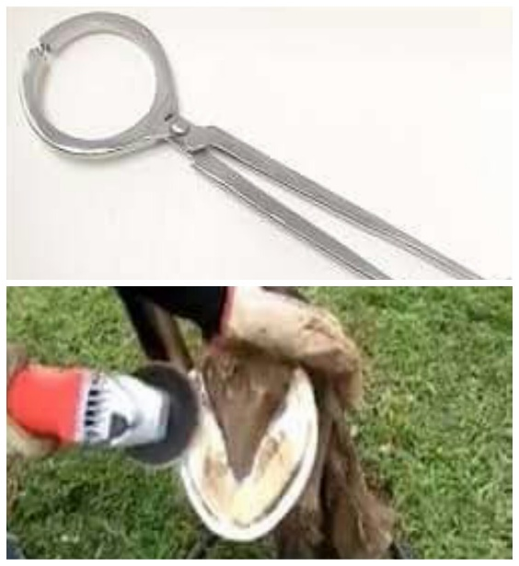
 | Hoof knife and sharpener | When there is loose dried out sole and or frog. Or even in the case if abscesses. | Fit curve to the curve of your hand; there are special ones for right/left handers
 | Hoof tester | https://youtu.be/eK81NatuGlU
 | Hoof pick | When it’s necessary to clean debris from the bottom of the hoof. | https://youtu.be/3NESd0rmP6E
 | Chainsaw | Hoof trimming | https://youtu.be/flPcbuqm-LE

