TOOLS FOR RESTRAINT | Instrument | Indications for Use | Directions | Photo
 | Halter | Animal needs to be handled- controlling the head makes this easier | “The part that draws goes under the jaws” leaving the upper part to behind the poll and ears. The lead is placed on the left. | 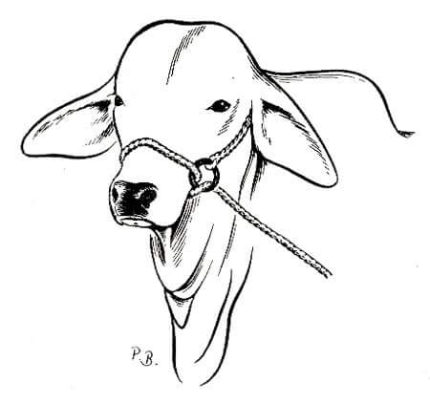
 | Twitch | Horse needs to be calmed or distracted to facilitate the completion of some activity that may be unpleasant. | https://youtu.be/78yK3c4tNuM  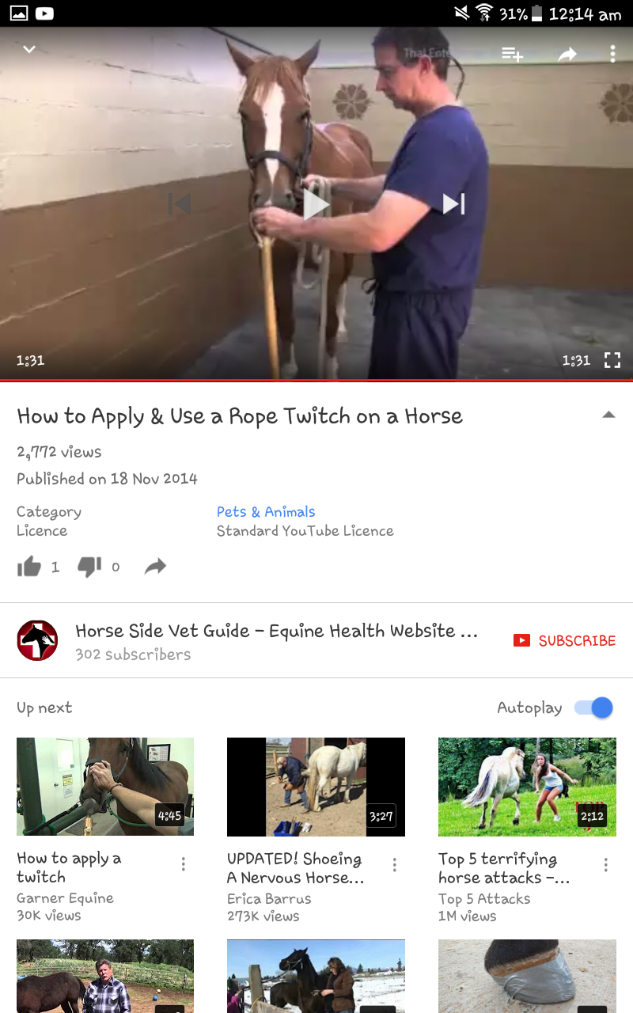
 | Hog snare | Restraint of large pigs. | Animal mouths the cable loop when it is dangled in front of them. Loop is then pushed to the commisure of its lips and tightened | 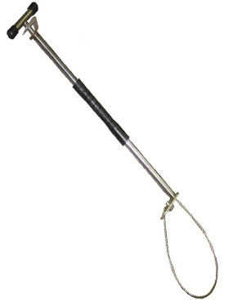
 | Electric goad/cattle prod | When a stubborn animal refuses to move. | The end of the baton with the electrode is placed on the animal for no more than 2 seconds to convey a mild shock and prompt movement | 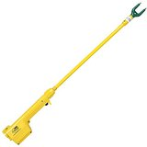
 | Nose lead | 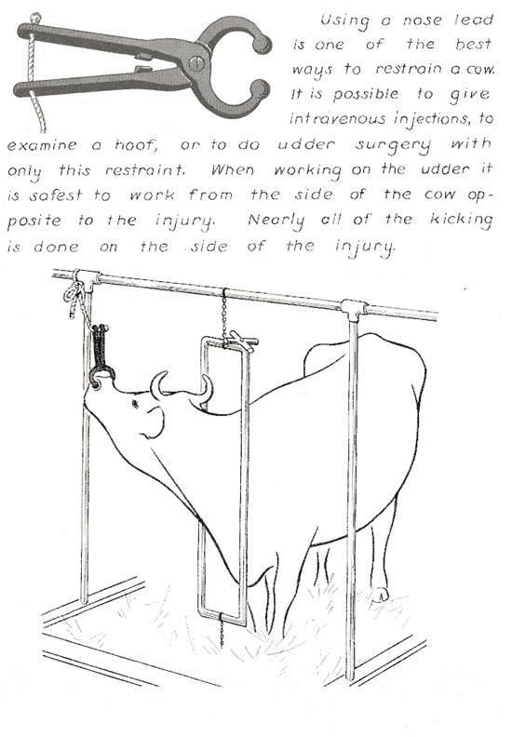
 | Nose ring | When it is necessary to restrain a powerful bull | Applied through the nasal septum about 1cm back from the nostrils after the punch has created a hole. The portion outside the nostrils should be able to accommodate a rope or chain | 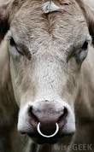
 | Punch | Application of a nose ring | Pierces the nasal septum after spot is first tested with fingers | 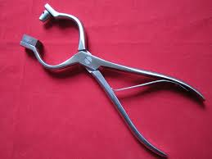
 | Mouth gag | https://wikivet.mediacore.tv/media/cow_examinationwmv  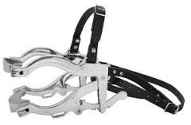  Haussman mouth gag for horses
 | Anti-kicking devices | When it is necessary to prevent an animal from kicking | Metal bars are clamped around the animals flank | 