Manure Scoring
Manure scoring can help evaluate how well the ration is balanced for protein, fiber, and carbohydrates. It can also assess if the cows are digesting the feed correctly and if water intake is appropriate. This tool is helpful in evaluating pasture-based diets as the manure gives a good indication of whether too much protein is being supplemented, too much forage is being fed in the barn, or whether the rumen bugs are utilizing grain for energy.
Once again, this system uses a score of "1" to "5," with "1" being very liquid and "5" being very stiff. In practical use, a score of "1" would slide off your boot, a score of "3" would stick to your boot, and a score of "5" would bounce off your boot (Cow comfort [Online], DeLaval Global). Refer to photos below for more information.

Score 1
Manure is runny with a consistency of pea soup (see Figure 1). The manure may arc from the rump of the cow. Excess protein or lack of fiber can lead to this consistency, typical of early spring pasture-based diets. If Score 1 continues past early spring, there may be too much protein being supplemented in the barn. Cows with diarrhea or Johne’s disease will also score in this category.
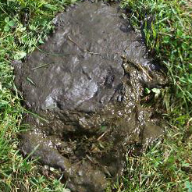
Figure 1. Photo credit: Robert DeClue, USDA Natural Resources Conservation Service.

Score 2
Manure is runny and does not form a distinct pile, rather it splatters when it hits the ground or concrete (see Figure 2). This is typical of cows on pasture after the spring flush and if little supplemental forage is fed in the barn. If seen in full stored forage confinement feeding, the cows may lack adequate fiber in their diet and have acidosis.
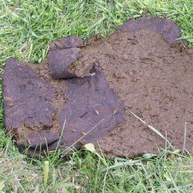
Figure 2. Photo credit: Robert DeClue, USDA Natural Resources Conservation Service.

Score 3
Manure has the appearance of pudding, and will form a pile with concentric rings around a small depression in the middle (see Figure 3). It makes a plopping sound when it hits the floor or ground and sticks to shoes, pasture sticks, and the flanks of cows that lay in it. Cows fed pasture, some stored forage, and adequate energy without extra protein will attain this manure score. Cows on stored forages in the winter with properly balanced grain mix, will also produce this kind of manure. Score 3 is optimal.
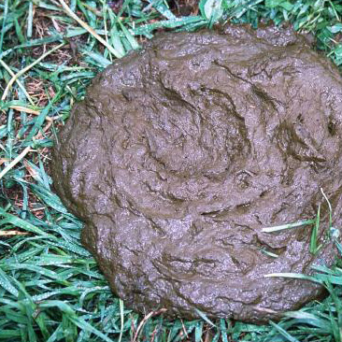
Figure 3. Photo credit: USDA Natural Resources Conservation Service Photo Gallery.

Score 4
Manure is considerably thicker and will make a taller pile (see Figure 4). It will stick to your shoe, but is not as easily wiped off as with Score 3 manure. This is more typical of dry cows, older heifers, and any group of animals fed low-quality forages. It may indicate a lack of protein in the diet.
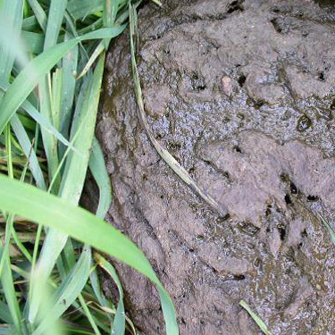
Figure 4. Photo credit: Robert DeClue, USDA Natural Resources Conservation Service.

Score 5
Manure is stiff, firm, and possibly in the shape of a ball (see Figure 5). This indicates extremely low quality forage, a digestive blockage, or dehydration. If you feed relatively good-quality forage and see manure of this consistency, you need to call a veterinarian because death of the animal is possible due to digestive blockage or dehydration.
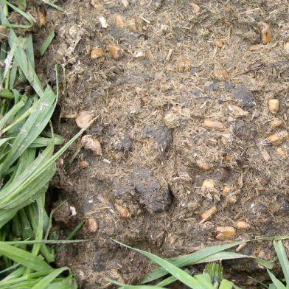
Figure 5. Photo credit: Robert DeClue, USDA Natural Resources Conservation Service.
If you are willing to feel manure for texture and consistency, you can score it by hand. The following guidelines provide a reference for this examination.
- Score 1: Manure feels like a creamy homogenous mixture. There are no visible undigested food particles.
- Score 2: Manure feels like a creamy homogenous mixture. There are a few visible undigested food particles.
- Score 3: Manure does not feel homogeneous. Some undigested particles are visible. When you squeeze the manure in your hand, some undigested fibers will stick to your fingers.
- Score 4: Undigested food particles are clearly visible and are larger than in Score 3. When you squeeze the manure in your hand, a ball of undigested food will remain.
- Score 5: Larger food particles are clearly visible in the manure and it is easy to distinguish the undigested components of the feed ration (Karreman, 2007).

Source: http://articles.extension.org/pages/68571/managing-dairy-nutrition-for-the-organic-herd:-assessing-the-feeding-program

