**AURICULOPALPEBRAL NERVE BLOCK IN CATTLE:**

**ABOUT THE AURICULOPALPEBRAL NERVE:**

Anatomy: The eyelids are innervated by the auriculopalpebral nerve. The nerve is a motor branch of the facial nerve supplying to the orbicularis occuli muscle of the eye lid and therefore, the block produces akinesia only. The nerve runs from the base of the ear along the facial crest, past and ventral to the eye giving of its branches on the way. The auriculopalpebral nerve supplies to the orbicularis occuli muscles, which is one of the branches of the facial nerve and motor to the eyelid and auricular muscle.

**USES OF THE AURICULOPALPEBRAL NERVE BLOCK:**

* It is mostly used in large animals for examination of the eye, in blepharospasm and for removal of foreign bodies.
* Also used for surgeries related to eyelid (entropion, ectropion and prolapse of 3rd eyelid).
* To avoid the blinking reflex of the eye lid to examine and treat the eye.
* To relieve the spasm of the eyelids following injury and to use in conjunction with Peterson’s block, during surgical treatment of squamous cell carcinoma of eye, removal of foreign body from the cornea and sub-conjunctival injections.

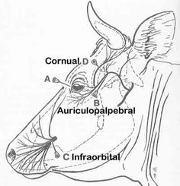

FIGURE 1: DIAGRAM SHOWING THE AURICULOPALPEBRAL BRANCH OF THE FACIAL NERVE.

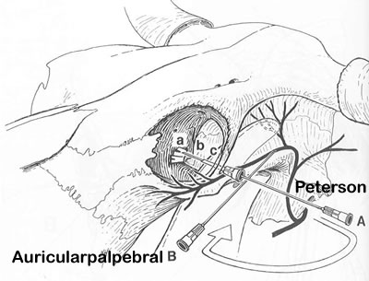

FIGURE 2: DIAGRAM SHOWING THE DIRECTION OF INSERTION OF THE NEEDLE INTO THE BRANCHES OF THE FACIAL NERVE TO ACHIEVE THE AURICULOPALPEBRAL NERVE BLOCK.

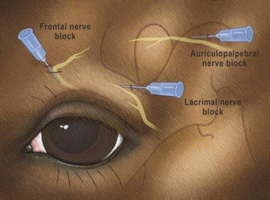

FIGURE 3: PICTURE DIAGRAM VISUALIZING THE AURICULOPALPEBRAL NERVE BLOCK.

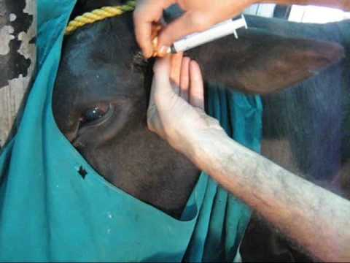

FIGURE 4: PICTURE SHOWING ADMINISTRATION OF THE AURICULOPALPEBRAL NERVE BLOCK.

**PROCEDURE OF THE AURICULOPALPEBRAL NERVE BLOCK:**

1. This nerve block was successfully administered at 3:32 p.m.
2. The site was located, which is directly at a point midway between the imaginary line drawn from the lateral canthus of the eye and the temporal.
3. In the bovine, a 22- gauge, 1.5 inch needle is inserted subcutaneously at a point midway between the imaginary line drawn from the lateral canthus of the eye and the temporal fossa.
4. The syringe is attached, and aspirated. Once all goes correctly, the 10 ml of anaesthetic, containing 5 ml 2% Lidocaine and 5 ml saline is subfacially injected.
5. After administration, the area is gently massaged.

**SIGNS OF A SUCCESSFUL AURICULOPALPEBRAL NERVE BLOCK:**

Akinesia of the orbicularis occuli of the eyelid. This nerve block has a duration of 45 minutes.

**COMPLICATIONS OF THE AURICULOPALPEBRAL NERVE BLOCK:**

1) Orbital hemorrhage

2) Penetration of the globe

3) Optic nerve injury

**PRECAUTIONARY MEASURES:**

If procedures are to be performed on the peri-ocular structures or the globe of the eye, a sensory block should be used also.