**CORNUAL NERVE BLOCK IN CATTLE:**

**ABOUT THE CORNUAL NERVE:**

Anatomy: The Cornual nerve is a sensory nerve supplying to the horn core and skin around its base. The cornual nerve is a branch of lacrimal nerve, which is a division of the ophthalmic branch of trigeminal nerve. The cornual nerve emerges behind the orbit and ascends along frontal crest and is placed relatively superficial in the upper third covered by skin and the thin layer of the frontalis muscle. The caudal part of the nerve also has close association with the superficial temporal artery.

**USES OF THE CORNUAL NERVE BLOCK:**

* The cornual nerve block is used for desensitizing the horn core in cattle. The horn and the skin around the base of the horn, containing the germinal epithelial cells, are innervated by the corneal branch of the lacrimal nerve. Dehorning or disbudding is the process of removing or stopping the growth of the[horns](http://en.wikipedia.org/wiki/Horn_%28anatomy%29) of [livestock](http://en.wikipedia.org/wiki/Livestock).

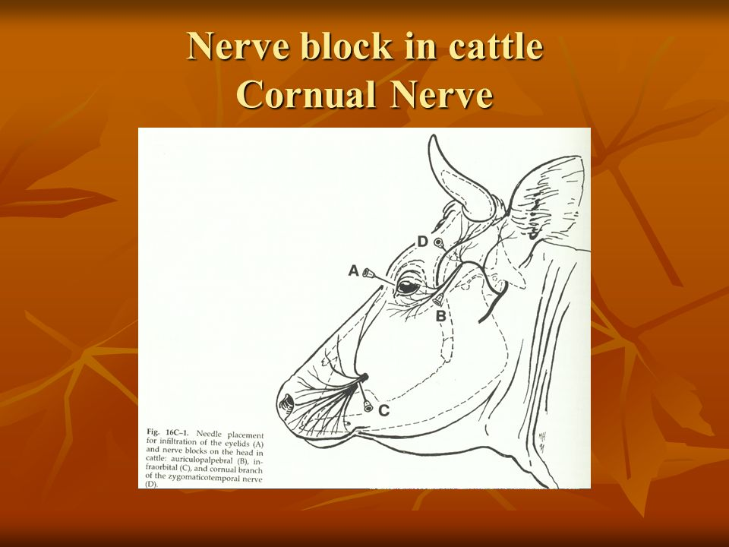

FIGURE 1: DIAGRAM SHOWING THE NEEDLE PLACEMENT FOR THE CORNUAL NERVE BLOCK (D)

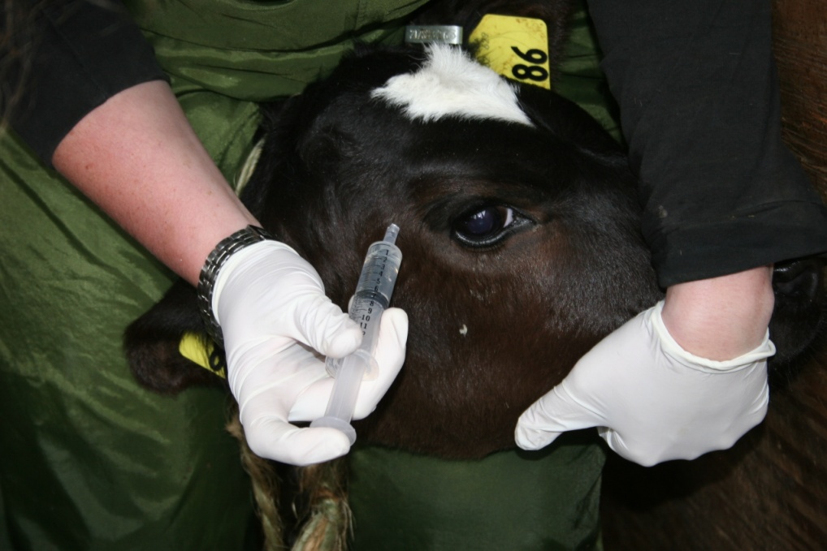

FIGURE 2: PICTURE DEMONSTRATING THE CORNUAL NERVE BLOCK BEING PERFORMED.

**PROCEDURE OF THE CORNUAL NERVE BLOCK:**

1. This nerve block was performed at 3:35 p.m.
2. The anatomical location was palpated, along the saggital crest.
3. Next, a 20 gauge, 1.5 inch needle was inserted into the upper third of the temporal ridge and about 2.5 cm below the base of the horn, to a depth of 0.7 to 1.0 cm. The nerve may be palpable, between the frontalis and temporal muscles, about half way from the lateral canthus of the eye to a point about 3cm below the lateral base of the horn.
4. In large bulls the needle should be inserted to about 2.5 cm deep. Aspirate to check that the needle is not placed intravascularly.
5. Finally, the 10 ml mixture of [lidocaine](http://wildpro.twycrosszoo.org/S/00Chem/ChComplex/Lignocaine.htm) 2% and saline in a 1:1 ratio was administered, and the area was massaged after.

**SIGNS OF A SUCCESSFUL CORNUAL NERVE BLOCK:**

A blink response should be noted during drug administration; drooping of the upper eyelid is a good early sign of correct anaesthesia. The duration of this nerve block is 45 minutes.

**COMPLICATIONS OF THE CORNUAL NERVE BLOCK:**

1) Failure may occur if the anesthetic solution is injected too deeply, into the temporal muscle aponeurosis.

2) Injection under the skin at the horn base may be difficult as the skin is tightly applied to the skull in this area.

**PRECAUTIONARY MEASURES:**

 In large individuals with well developed horns make a second injection about 1 cm caudal to the first injection, to block the posterior division of the nerve.