Possible Complications

1. Pain

* Animals should be monitored during and after the procedure for signs of unnecessary pain, such as vocalization, reluctance to move, and failure to nurse. Such animals should be treated with a systemic analgesic such as flunixin melamine. Severe pain warrants the attention of a veterinarian.

1. Haemorrhage

* Observe calves closely for one hour following dehorning.
* The risk of haemorrhage is greatly increased in older calves
* Wound powder may be applied to the surface of the horn bud after dehorning
* Note: avoid powder use if the sinus cavity is exposed

► Dehorning: Dairy&rsquo;s Dark Secret VIDEO:[ http://www.youtube.com/verify_age?next_url=%2Fwatch%3Ffeature%3Dplayer_embedded%26v%3D8nGMgHyzHcA ]
Many people are surprised to learn that nearly all cows used for milk are born with tissue that will develop into horns. That&rsquo;s because most farmers remove the sensitive horn tissue or the horns themselves from the cows&rsquo; skulls using searing-hot irons, caustic chemicals, blades, or hand saws.Animals often struggle violently and have to be restrained manually or in a head bail (a metal apparatus for restraining a cow by the neck) during the painful dehorning process, which is frequently performed without anesthetics or painkillers and results in severe pain that lasts for hours and can become chronic.This procedure is extremely traumatic to young calves, who are often just a few weeks old when their horn buds are burned or cut out of their heads. Older cows fare even worse. Dehorning in mature cattle usually requires amputation of the horn, which has already attached itself to the skull. Tools used for this procedure include saws, sharp wires, or gruesome guillotine dehorners, which also slice off the surrounding skin. Horn removal in older animals can lead to post-operative problems of hemorrhage, tissue necrosis, bone fracture, sinusitis, and even death. The wound caused by this amputation can take three months or more to heal.Farmers are fully aware that dehorning is painful, and it is up to the industry to phase out this excruciating mutilation. One simple solution is to breed for naturally hornless cows. A single gene determines whether or not a cow will have horns, and this approach has proved effective in the beef industry.    




Follow me on my journey for the animals : 
Tumblr :    http://jotter-journal.tumblr.com/
Twitter :    https://twitter.com/#!/Jotter_Journal
                                                      With Love, Jotter-Journal


1. Horn Regrowth

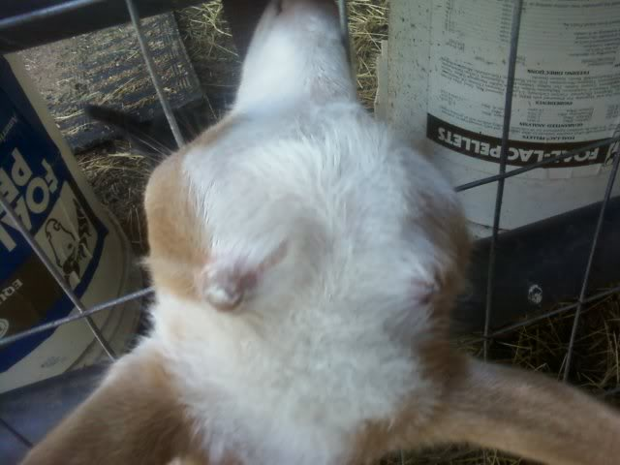

1. Infection / Sinusitis

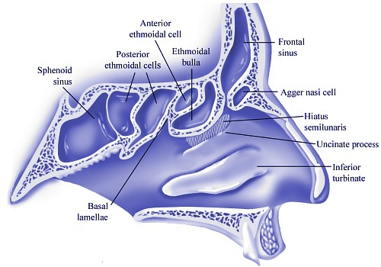

Leaving the wound open for a very short period of time can lead to infections as bacteria would be able to enter. Signs of infection are redness, swelling and discharge.

1. Potential decreased weight gain following dehorning of older calves due to pain and stress

* Calves should be dehorned as young as possible to minimize stress.
* Use of local and systemic analgesics is recommended.

1. Tetanus

* The use of tetanus antitoxin should be considered, and calves should be vaccinated for tetanus.

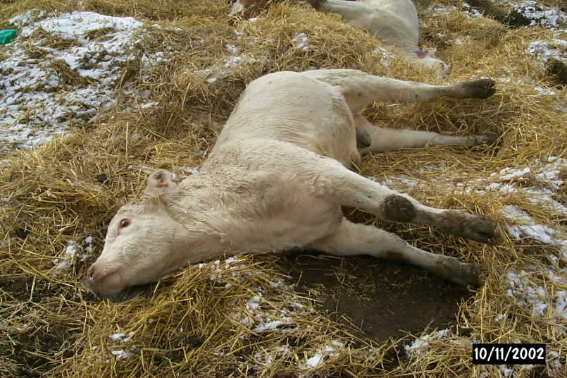

Picture above showing a calf with tetanus

7.Bovine papilloma virus (warts)

* Dehorning instruments can provide a fomite for transmission of the papilloma virus, and should be disinfected between calves. This can be achieved by maintaining a bucket of disinfectant for rinsing between animals.

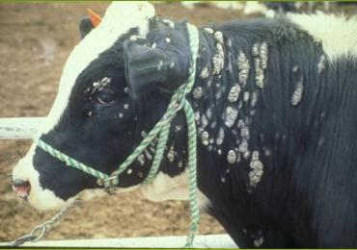

Picture showing warts and papilloma on the skin of a cow

8.Flystrike

* Dehorning method that leave an open wound should NOT but used during fly season. Paste and hot dehorning are acceptable any time of year.
* The use of a fly repellant may be warranted.