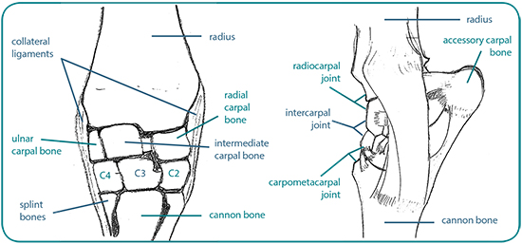

**Procedure:**

There are 3 joints within the carpus: The radiocarpal joint (isolated), the Intercarpal joint and the carpometacarpal joint (communicate so 1 block blocks both).

CARPAL JOINT

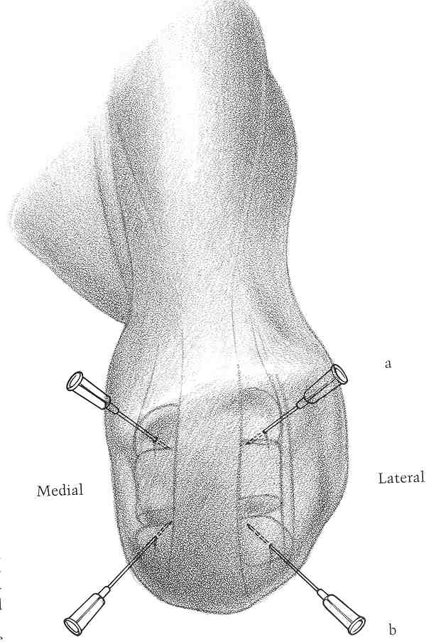

Extensor Carpi Radialis Tendon

*Radiocarpal Joint*

* With the carpus flexed, inject dorsally into the indentation on the medial or lateral side of the extensor carpi radialis tendon (with the distal radius dorsally and the proximal radial/intermediate central bone distally.

*Intercarpal Joint*

* The procedure is the same as above with the distal radial/intermediate carpal bone dorsally and the proximal border of the 3rd carpal bone distally.

Laterally:

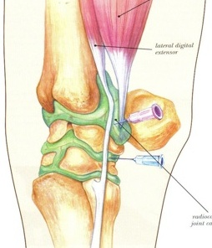

This allows for blocking to be done on a weight-bearing limb

* Palpate the notch created by the ulnaris lateralis tendon and the lateral digital extensor tendon
* Insert the needle into the small depressions immediately distal to this notch