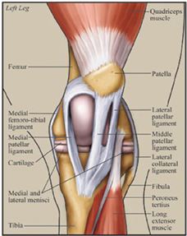

**Procedure**

STIFLE JOINT

There are 3 sites:

*Medial Femoral-Tibial*

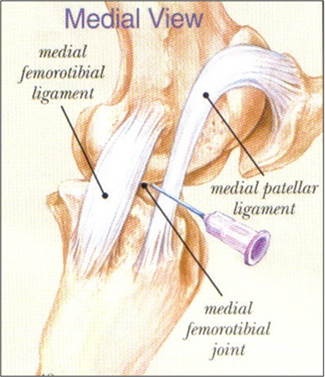

* Insert the needle between the medial patellar ligament and the medial collateral ligament, just proximal to the tibial tuberosity
* Avoid blood vessels

*Femoral-Patellar*

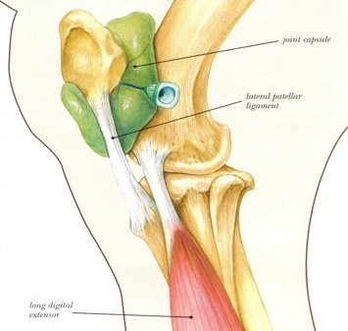

* Insert the needle between the medial and middle patellar ligament, proximal to the tibial tuberosity and angle upwards towards the supra-patellar process

*Lateral Femoral-Tibial*

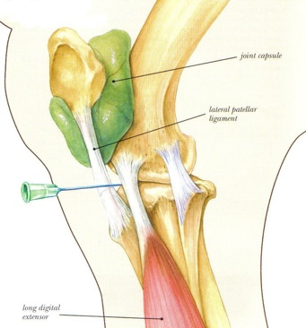

* Insert the needle caudal to the lateral collateral ligament and proximal to the proximal-lateral edge of the tibia

**NB// There is some degree of communication between the:**

* **Femoral-patellar and medial femoral-tibial joints**
* **Femoral-patellar and lateral femoral-tibial joints**
* **Medial femoral-tibial and lateral femoral-tibia joints**

**This means that a more specific location for lameness could possibly be determined!**