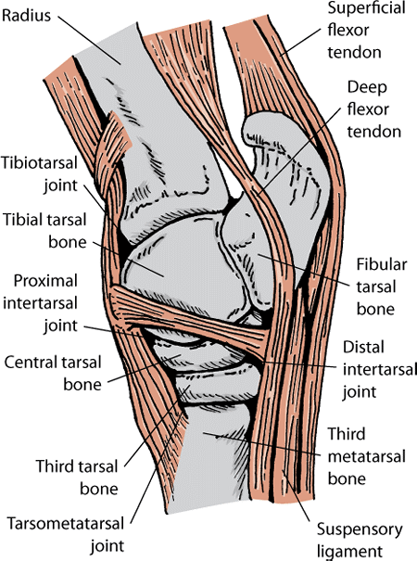

**Procedure:**

TARSAL (HOCK) JOINT

There are 3 joints involved here: The Tibiotarsal joint, the Proximal Intertarsal joint, the Distal Intertarsal Joint and the Tarsometatarsal joint.

*Tibiotarsal & Proximal Intertarsal Joint*

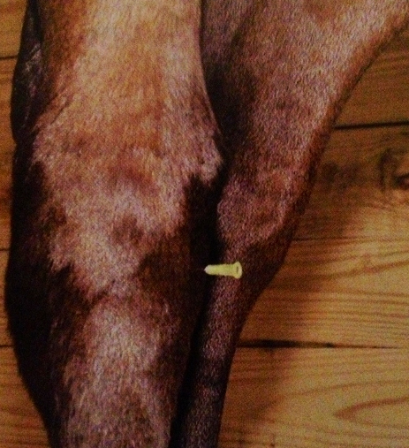

* Insert the needle directly into the joint pouch on the dorsomedial aspect
* Be aware off the saphenous vein and avoid it
* The Tibiotarsal joint and the Proximal inter-tarsal joint are blocked due to communication

*Distal Intertarsal Joint (DIT)*

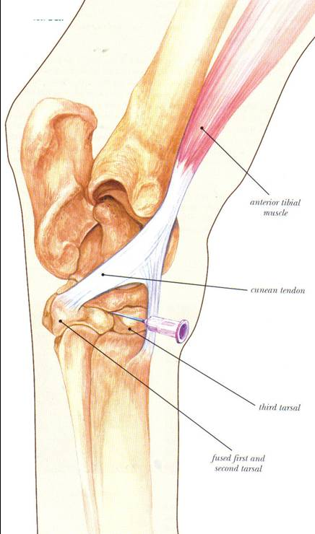

* Insert the needle on the medial aspect into the T-shaped gap formed by the junction of the fused 1st and 2nd tarsal bone, the 3rd tarsal bone and the central tarsal bone (immediately distal to the cuneal tendon

*Tarsometatarsal Joint (TMT)*

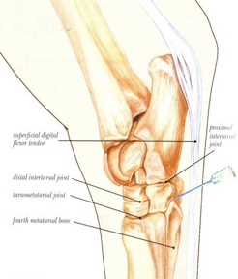

* Insert the needle on the plantar-lateral aspect of the hock immediately above the head of the lateral splint bone and angle it dorsomedially and distally.

**NB// In some cases the DIT may communicate with the TMT, in some the DIT may communicate with the joint proximally and in others it may be isolated.**