**PALMAR/PLANTAR DIGITAL NERVE AND RING BLOCK**

|  |  |  |  |  |  |  |
| --- | --- | --- | --- | --- | --- | --- |
| **NERVE AFFECTED** | **NEEDLE** | **VOLUME** | **TECHNIQUE** | **POSITION OF LIMB** | **ONSET OF ACTION** | **STRUCTURES BLOCKED** |
| -Palmar/plantar digital nerve  -dorsal branches of the digital nerve | -25 gauge, ¾ inch  -25 gauge, 5/8 inch | 1.5-2 cc | -Complete Palmar Digital nerve block as described  - Insert needle through PD site and place a subcutaneous line of anaesthetic agent proximal to the coronet band that extends dorsally.  -Extend the ring   by replacing the needle through the anesthetized skin until it goes 2/3’s of the way around the pastern. | flexed | 10-15 minutes | -All of structures with PD  -P 2, 3  -Pastern Joint  -Coffin Joint  -Entire corium  -Dorsal branch of the suspensory ligament  -Extensor tendon insertion  -Entire foot |

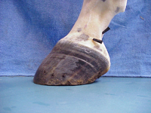 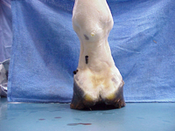

1. Lateral view 2) palmar/plantar view