**LOW 4 POINT NERVE BLOCK**

|  |  |  |  |  |  |
| --- | --- | --- | --- | --- | --- |
| **NERVE AFFECTED** | **NEEDLE** | **VOLUME** | **ONSET OF ACTION** | **TECHNIQUE** | **STRUCTURES BLOCKED** |
| -lateral & medial palmar nerves  - lateral & medial palmar metacarpal nerves | 22gx1” needle  25gx5/8” needle | 2-3ml | 10-15 minutes | 1.    Ensure adequate restraint of horse to do this procedure with the foot on the ground.   2.   Palpate DDFT and the SL.  Avoid digital sheath by measuring a hand’s breadth above fetlock joint.   3.   Insert needle parallel to the ground and perpendicular to the skin   between the DDFT and the SL.  (22gx1” needle)   4.   Insert needle to the hub, check for blood and deposit 2-3mL      anaesthetic.  This will anesthetize the medial branch.  Withdraw    the needle until it is subcutaneous on the lateral side and deposit    2-3mL.   5.   Palpate the bell (button) of Metacarpal/metatarsal bone    4.  Insert needle distal to bell of     splint bone, pointing slightly upwards.  (25gx5/8” needle)   Check     for blood and inject 2-3mL anaesthetic.  Support hub of needle    with one hand and inject with the other.  Repeat on medial     aspect of limb. | All structure of previous block (all of structures distal to the location of nerve block)  Navicular structures  Soft tissue structures of pastern and foot  Sole, Laminae  Three phalanges  Coffin and Pastern and **Fetlock joint**  Distal Digital tendon Sheath |

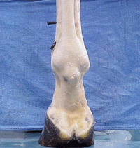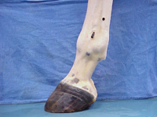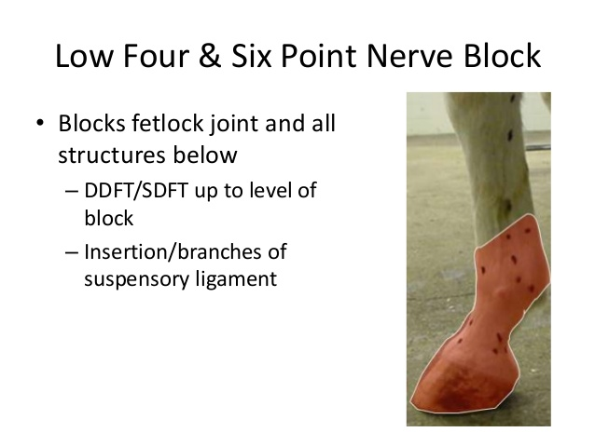

1)Palmar view 2)lateral view 3)areas affected

