**NERVE BLOCKS IN HORSES**

**Introduction**

Perineural anesthesia of regions of the equine limb is commonly performed to facilitate

standing surgery and wound exploration, to temporarily ameliorate pain and to

diagnose lameness.

The proper use of diagnostic anesthesia to localize the source of pain in a lame horse is

an essential skill for the equine practitioner. Diagnostic anesthesia should be performed

with minimal risk of injury to horse or people and in a manner that allows for accurate interpretation of the patient’s response to the procedure. Subsequent decisions

regarding diagnostic imaging, treatment, aftercare and prognosis are all predicated

upon the presumed anatomic source of pain.

**Safety**

Proper technique when performing diagnostic anesthesia minimizes risk of injury to the

horse, the veterinarian and those handling the patient. Examples of physical restraint

options, in ascending order of severity, which can be useful when performing diagnostic

anesthesia include:

* sensory distraction (touch, sound, taste, visual)
* skin twitch
* leg up
* lip twitch
* mouth chain
* nose chain
* gum chain
* single leg hobble

When attempting hind limb injection in a fractious patient, one can consider attaching a

short extension set to the needle prior to insertion of the needle. This action facilitates

subsequent injection of anesthetic solution without requiring further manipulation of the

needle hub.

Chemical restraint, when necessary, can be achieved without masking signs of

lameness via intravenous injection of one to two milligrams of detomidine hydrochloride.

However, one must remember that a small, but significant, percentage of horses

sedated with alpha 2 adrenergic agonists will respond suddenly and violently to noxious

stimuli. Before administering any sedative, the author always informs the owner/agent

that sedatives are considered forbidden substances in competition horses.

**Equipment**

• Sterile disposable needles

1. -smallest gauge possible

2. -big enough for synovial fluid

3. -big enough not to break

• Gloves

1. -exam

2. -sterile

• Local anesthetics

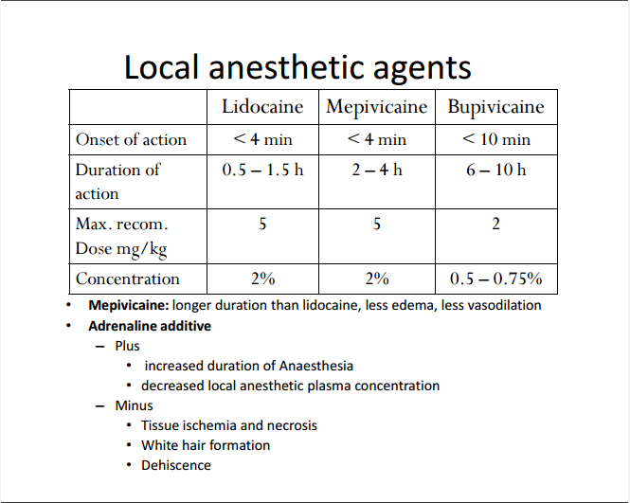

**Site Preparation**

While the risk of infection subsequent to perineural injection is relatively low, infection

can and does occur. Therefore, it is prudent for both clinical and medicolegal reasons to

perform appropriate site preparation prior to injection. Furthermore, the risk of

inadvertent injection into a synovial cavity (joint or tendon sheath) is often present

when performing perineural injections. The consequences of such infections can be

severe.

For most perineural injections, the author simply wipes the site clean with 70%

isopropyl alcohol-soaked swabs. When administering blocks in close proximity to

synovial cavities, the author performs a site prep using 7.5% povidone iodine scrub

followed by an isopropyl alcohol rinse or have a scrub prepared with either betadine or chlorhexidine.

Specific blocks close to synovial cavities include:

* low palmar nerve block (fetlock palmar pouches)
* lateral palmar nerve block distal to accessory carpal bone (carpal canal)
* high plantar nerve block (tarsometatarsal joint and tarsal sheath)

Clipping may be necessary in some cases to facilitate accurate palpation of anatomic

landmarks. We obtain permission from the owner or designated agent to clip the

injection area prior to clipping a competition horse for nerve block.

**Procedures**

Needle choice, volume and choice of anesthetic agents and injection techniques for

perineural anesthesia may vary among equine practitioners. The author’s preferences

are as follows:

* Regarding choice of anesthetic agent, three drugs are commonly used: 2%

mepivacaine hydrochloride, 2 % lidocaine and 0.5% bupivicaine. Bupivicaine has

been reported to possibly cause chondrocyte toxicity. Duration of action with

mepivacaine (90 to 120 minutes) is greater than that of lidocaine (30 to 45

minutes). Before performing the procedure, the author always informs the owner/agent that localanesthetics are considered forbidden substances in many competition horses.

* A thorough knowledge of the anatomy at and around the injection site is

essential, as nerve block accuracy depends on appreciation of nearby anatomic

landmarks. Insertion of the needle should be swift with the needle detached

from the syringe. The author uses non-locking syringes onto which a needle can

be easily slipped on and off. This technique avoids the potential problem of

creating unnecessary discomfort for the horse at the injection site should the

syringe be used inadvertently as a lever. If repeated needle placement is

necessary, a new needle should be used every time.

* Finally, the volume of anesthetic agent injected should be the minimum amount

that the veterinarian considers to be effective. Injecting excessive volumes of

anesthetic agents risks diffusion of the drug into neural tissue unassociated with

the intended target(s) and, as such, easily leads to false positive results

.

* The author first examines the horse in motion three minutes after injection and

then every three minutes up to a total of 15 minutes or ablation of lameness. In

the author’s opinion, whether or not to walk the horse while waiting to assess

the block is irrelevant to the interpretation of the nerve block’s effect.