**CASTRATION TECHNIQUES**

**CRYPTORCHIDS**

**LAPAROTOMY**

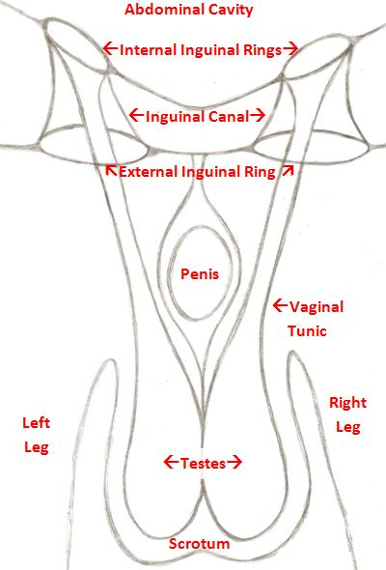

**LAPAROTOMY** is the surgical opening of the abdomen under general anaesthesia by a number of surgical approaches including an inguinal approach with or without retrieval of the inguinal extension of the gubernaculum testis, a parainguinal approach (to the side of the inguinal ring), or, less commonly, a flank approach.

The inguinal and parainguinal approaches involve the incising of the skin, and blunt dissection down to the inguinal ring. The vaginal process, epididymis and/or scrotal ligament will be identified, the vaginal process opened, and the retained testis exteriorized and emasculated. If these structures are not identified, deeper dissection will be required. Special attention to the closure of the incision will be required since the intestine can eviscerate through the open vaginal process.

1. 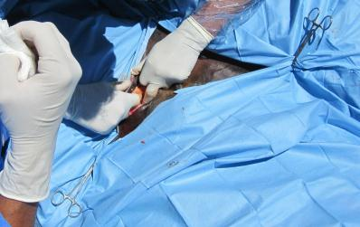Palpate the external inguinal ring, just to be sure that the testis is not inguinal and to identify the incision site.

Figure 1: Draping

1. Make an incision directly over the external inguinal ring and parallel to it.  The incision should be about 1½ times the length of the palpable slit that is the external ring and should be extended no deeper than the dermis. The remaining dissection to find the external inguinal ring is done bluntly with the fingers.  Injury to large vessels in this region will make visualization very difficult.  As the external inguinal ring is dissected out, the assistant uses fingers or retractors to open the incision and allow visualization.  A large self-retaining retractor can be used, but is less adaptable than an assistant.

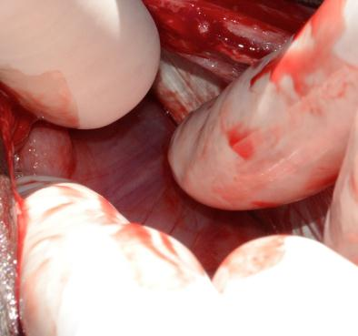

Figure 2: Identifying the landmark vessels

1. The loose areolar connective tissue is bluntly dissected until the white, fibrous external inguinal ring is exposed.  A white finger-like projection coming up from the interior of the ring indicates an incomplete cryptorchid covered by the vaginal process.  If this is the case, the white membrane (vaginal process) is opened with scissors and the epididymis is pulled into the incision and used as a handle to deliver the testis from the abdomen, as described below.
2. More commonly, a group of very thin vessels will be seen going from the surrounding fascia, over the edge of the external inguinal ring and down into the inguinal canal.  These vessels may fan out along the entire length of the canal or be in a more discrete bundle.  They indicate the tissue that would become the scrotal ligament in a normally descended testis.  They should be grasped together, making a bundle.
3. 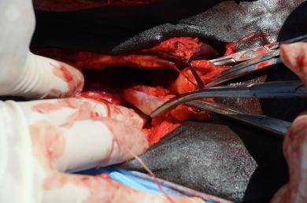Carefully place traction on the bundled vessels (scrotal ligament) to evert the vaginal process through the internal inguinal ring (vaginal ring) and into the inguinal canal.  The vaginal process is conical and the tip can be visualized as a small white structure as it passes out of the external inguinal ring.  Palpation with an index finger during traction, will establish that the base of the cone is deep inside the inguinal canal.  This structure will be more or less easy to mobilize in different horses.

Figure 3: Gathering The Vessels

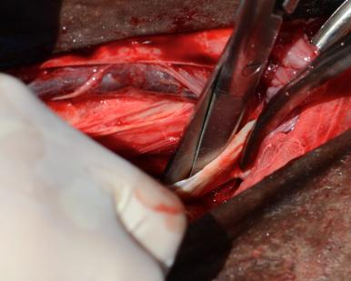

1. Once the vaginal process is identified, it is opened with scissors or the point of a scalpel.  Immediately inside the tip of the vaginal process is the ligament of the tail of the epididymis (remnant of the embryonic gubernaculum).  This structure is grasped and used to deliver the epididymis through the inguinal canal and into the incision.  Firm pressure is required to do this, but it is important not to break and lose the ligament or the epididymis.

Figure 4: Opening the Vaginal Process

1. 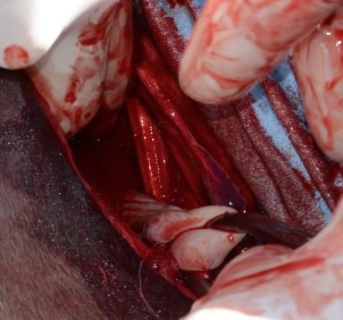Using the epididymal structures as a guide and handle traction in placed on the abdominal testis.   The object is to deliver the testis through the smallest hole in the vaginal process and without disrupting the internal inguinal ring.  A combination of traction, massage with an index finger, and occasionally stretching the vaginal process will deliver nearly every testis, with some patience.
2. Once the testis appears through the external inguinal ring, its vessels are ligated as one unit with 2 or 3 Vicryl and cut, along with the vas deferens.  The cryptorchid testis and the epididymis are removed and the contralateral testis is castrated.

Figure 6: Delivering the Tail of the Epididymis

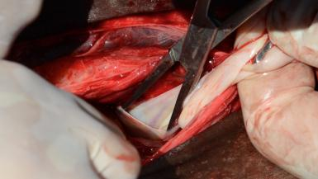

Figure 7: Bluntly opening the Incision in the Vaginal Process

1. 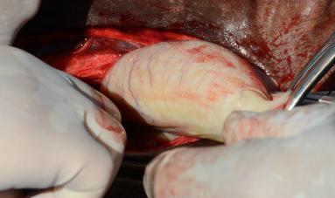If only minor stretching of the vaginal process is required to remove the cryptorchid testis and the internal inguinal ring was not invaded, the incision is left open to heal by second intention and no further suturing is required.  If the testis was larger and more difficult to deliver the inguinal canal can be closed with 2 or 3 Vicryl, by placing one or a few cruciate or simple interrupted stitches across the inguinal canal.

Figure 8: Delivering the Testis

1. Because the inguinal canal in the horse is long and runs up the body wall, the internal inguinal ring cannot be readily identified for suturing.  So it is difficult to do a firm closure of the canal if the internal ring has been opened significantly.  Further, any suturing in this area should be done with care, due to the large vessels that lay in the fascia around the inguinal canal.  If there is concern about the integrity of the closure and possible evisceration, the incision should be tightly packed with a sterile towel and the skin closed in a simple continuous pattern, over the towel.  Then in 48-72 hours the sutures and towel are removed.  At this time swelling caused by the towel will have closed the canal and granulation has started.  This generally requires a second, though brief, anesthesia.

**NOTES**

* IF the vessels indicating the scrotal ligament cannot be identified; IF the landmarks are broken while attempting to exert traction; or IF the testis is too large to be delivered through the internal inguinal ring: a parainguinal incision can be made, allowing the surgeon to enter the abdomen through a very small incision just next to the inguinal canal.
* To utilize the parainguinal incision the assistant retracts the existing skin incision cranially and medially.  In this region the internal abdominal oblique muscle is thin, but strong and fibrous.  The surgeon selects a site a few inches medial and parallel to the external inguinal ring.  A small stab incision is made just though the external muscle sheath.  This is extended into the abdomen by using a blunt instrument, such as the tip of Mayo scissors.  The instrument is opened, stretching the incision so that the surgeon can stick two or three fingers into the abdomen.
* Since the majority of abdominal testes are just next to the internal inguinal ring, the surgeon sweeps laterally and deep to the body wall incision, to palpate and grasp the testis, epididymis, or vas deferens and deliver the testis from the abdomen.  The vessels are ligated and cut as above.  Closure of the parainguinal incision with sutures in the internal abdominal oblique is a simple matter and very strong.  No towel packing or removal is necessary.  The skin incision is left open to heal by second intention.
* In the rare instances in which the abdominal testis cannot be found via the small parainguinal incision described above, the surgeon simply extends the incision made bluntly in the abdominal wall, and, with a sterile sleeve, can explore the entire abdomen, following the decent of the testis from the dorsal body wall.  Again, the incision, just large enough to permit the surgeon’s arm is easy to close, once the testis is found and removed.