**CASTRATION TECHNIQUES**

**CRYPTORCHIDS**

**LAPARASCOPY**

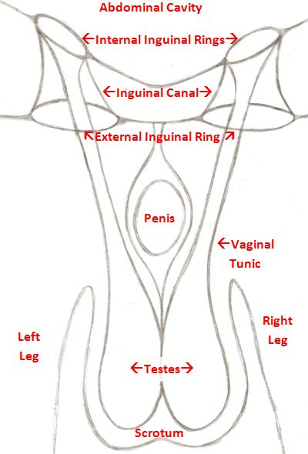

**LAPAROSCOPY** is an endoscopic procedure where a small, fiber-optic, video camera and surgical instruments are introduced into the abdomen through a small incision. This permits the observation of the inside of the abdomen and allows for the performance of abdominal surgeries without a large incision into the abdominal cavity. The main advantages are the small incisions, minimal postoperative pain and the fact that the horse can return to exercise very quickly. Laparoscopy can be used to remove retained abdominal testes in horses. Depending on the horse's temperament and on the surgeon's preference, the laparoscopic surgery will be performed in a standing position or laying down under general anaesthesia.

Standing Laparoscopy

This is performed under local anaesthesia and tranquilization with the horse restrained in a set of stocks. It is relatively painless and minimally invasive. After sedation of the horse, local anaesthetics are injected to deaden nerve sensation to the flank area and three 1-cm incisions are made through the muscle layers of the flank into the abdominal cavity. These incisions are for the insertion of the laparoscopic camera and surgical instruments. During the procedure, carbon dioxide gas is used to inflate the abdominal cavity to allow for better visualization. Under laparoscopic guidance, the testis is ligated, emasculated and removed.

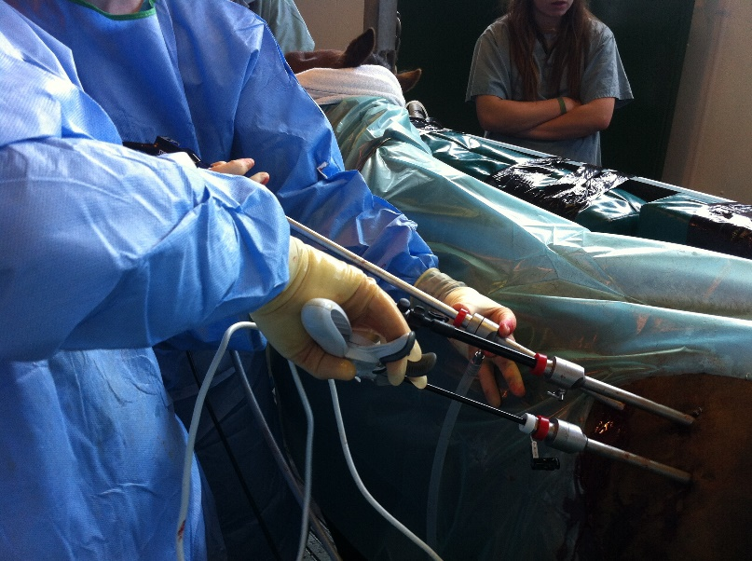

General Anaesthesia Laparoscopy

This involves the administration of general anaesthesia and placing the horse in dorsal recumbency (on its back). Once an adequate plain of anaesthesia is reached, small incisions are made in the abdominal wall. As in the standing laparoscopic procedure, the abdomen is inflated and the retained testis located and removed. The small incisions are closed and the horse recovered from anaesthesia. Both laparoscopic methods involve minimal invasion and pain but require more extensive equipment and specialized training to perform than open surgical procedures.

