PRE-OPERATIVE CONSIDERATIONS FOR CASTRATION
- History

- Physical Exam
- Distance – Body Condition Score, Presence of testicles, noticeable lesions, temperament of the horse, etc.
- Hands-on – TPR, palpation, presence of hernias, etc.
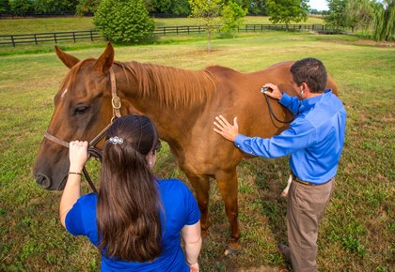

- Restraint
- Standing – limited to open castrations (may have a twitch on hand for additional restraint to the halter and lead rope)
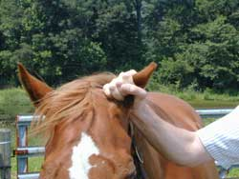
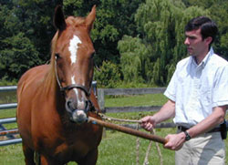

- Recumbent – general anesthesia required (need a suitable grassy area). Towel or padding under head. Tie up upper hind leg to shoulder, using a quick-release knot:
Drugs
IV via catheter : Ketamine (+/- butorphanol & diazepam)
Thiopentone +/- GCE
+/- LA (lidocaine) into the testicle to be removed las
Maintain using top up dose
Antibiotic – Procaine penicillin (IM)
Analgesia – Phenylbutazone, Flunixin meglumine
Tetanus prophylaxis – toxoid + antitoxin

