***CASLICK’S (PNEUMOVAGINA REPAIR)***

When air enters the vagina it can bring in dirt, bacteria, and other debris. It is this contamination that can lead to vaginitis (inflammation of the vagina), cervicitis (inflammation of the cervix), and metritis (inflammation of the uterus). The first barrier that protects the uterus from the outside world is the vulva. A defect in the vulva can allow contamination to enter the vagina. Abnormalities in the vulva can be from either previous trauma or deviations from normal anatomy. The second protective barrier is the cervix. The cervix is a circumferential muscular structure and in essence represents the junction between the vagina and uterus. During the heat period, the cervix is relaxed, allowing sperm to enter the uterus; in non-heat periods or during pregnancy, the cervix should remain tightly closed, protecting the uterus or developing fetus. Wind-sucking can lead to chronic inflammatory states in the vagina, cervix, and potentially the uterus that can reduce fertility. Wind-sucking during pregnancy can lead to abnormalities in the developing fetus or even abortion.

**Reasons**

- Prevents involuntary aspiration of air into the vagina.

**Causes**

-Poor conformation

-Injury,breeding, foaling

**Horses that need Caslick**

- Old thin mares with sunken perineal region.

-Racing mares that aspirate air

-Breeding mares Mares foaling

**Drugs**

-Tranquilize or sedate (if necessary)-zylazine,detomadine,fomifidine

-Local anaesthetic: Vulva region -lidocaine

**Advantages**

* Simple, standing procedure.
* Relatively cheap.

**Disadvantages**

* The Caslick's operation requires repeated opening and repair for breeding and parturition.
* Repetition of the procedure, particularly with excessive removal of labial tissue, can   →   excessive scarring, loss of labial tissue and plasticity, and eventual failure of the technique  *(fig 1)*

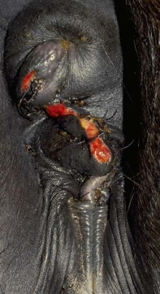

* Fig.1 Vulva: conformation 02 - after Pouret and Caslick operation

### Complications

* Excessive removal of labial tissue.
* Excessive closure of vulval cleft.
* Failure to perform episiotomy prior to foaling can result in serious perivulvar trauma.
* Interference with stallion's penis during breeding   →   inability to achieve [intromission](https://www.vetstream.com/equis/Content/Disease/dis00270.asp) or trauma to penis

### Reasons for treatment failure

* Incorrect diagnosis.
* Poor success in those mares requiring perineal [reconstruction](https://www.vetstream.com/equis/Content/Technique/teq00247.asp)  .
* Incorrect technique with poor or inadequate length of apposition.

**CALCULATING CASLICK’S INDEX**

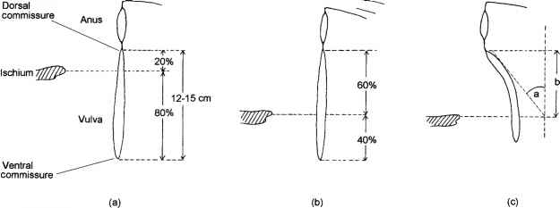

Lateral view of the anatomical arrangement of the anus, pelvic floor and vulva in three types of mare to illustrate: (a) good conformation; (b) poor conformation; (c) very poor conformation (Caslick operation is required). The likelihood of requiring a Caslick operation is indicated by the Caslick index, length of vulva above ischial arch (cm) angle “a” of declination away from the vertical distance “b”.

Type I mare: Caslick index < 50 - Caslick operation is not required. Type II mare: Caslick index 50-150 - Caslick operation may be required later in life. Type III mare: Caslick index > 150 -Caslick operation is required immediately.

