PROSTHETIC LARYNGOPLASTY
(TIE BACK)

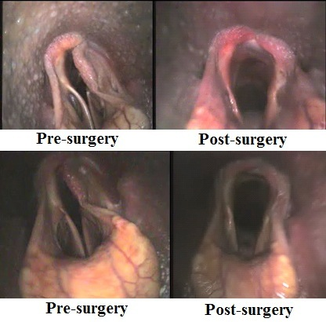

Locating the Prosthesis Site
- Make an 8-10cm incision immediately ventral and parallel to the linguofacial vein extending rostrally from the point at which the vein crosses the sternomandibularis muscle
- Incise the subcutaneous tissue to expose between the omohyoideus muscle and the vein
- Cut the fascia in the center of the incision leaving 3-4mm next to the vein for closure (beware of the linguofacial nerve)
- Conduct haemostasis
- Bluntly dissect the fascia around the larynx until the muscular process of the arytenoid cartilage, the median ridge of the cricoid cartilage and the caudal border of the cricoid cartilage can be palpated
- Place Sauerbruch retractors in the incision beneath the vein and the sternomandibularis muscle to elevate them from the larynx dorsally and laterally
- Visualize the cricoid cartilage and the thyropharyngeus and cricopharyngeus muscles
- Transect any fascia inhibiting mobility and vision
- Split the septum between the thyropharyngeus and cricopharyngeus longitudinally to expose the shiny white cartilage of the apex of the muscular process
- Repose the retractor and beware of the thyrolaryngeal vascular pedicle and cranial thyroid veins

Placing the Prosthesis
- The prosthesis is first placed through the cricoid cartilage by depressing the soft tissues on the caudodorsal aspect of the cartilage and palpating the caudal notch of the cricoid cartilage
- The needle is walked off the back of the cartilage next to the notch just lateral to the midline and passed under the cartilage for approximately 1.5cm
- Keep the needle close to the inner surface of the cartilage to avoid penetration of the underlying laryngeal mucosa
- The needle is then forced through the cricoid cartilage (roll the needle holders and drive the needle along its circular arc to avoid breaking or bending)
- Pass the needle in a craniomedial direction with the point emerging 4-5mm caudal and lateral to the midline ridge of the cricoid cartilage (beware and avoid the oesophagus and carotid artery)
- The ends are brought out of the incision and the needle removed once the prosthesis is positioned

Securing the Prosthesis
- The suture is pulled back and forth gently to ensure engagement with cricoid cartilage
- Use curved forceps to grasp both ends of the prosthesis and pull them forward so they are adjacent to the muscular process
- A trocar point needle is put on the needle and retractors moved cranially to pass the needle through the muscular process in a medial to lateral direction just cranial to the apex
- Remove the needle and pull the prosthesis gently through the muscular process to ensure it will slide when tension is applied
- Tie the ends under tension positioning the index finger against the larynx to ensure alignment with the original pull of the cricoarytenoideus dorsalis muscle
- Close the incision with braided polyester suture (clamp the first throw of the knot to avoid slippage as this suture type has poor knot security)

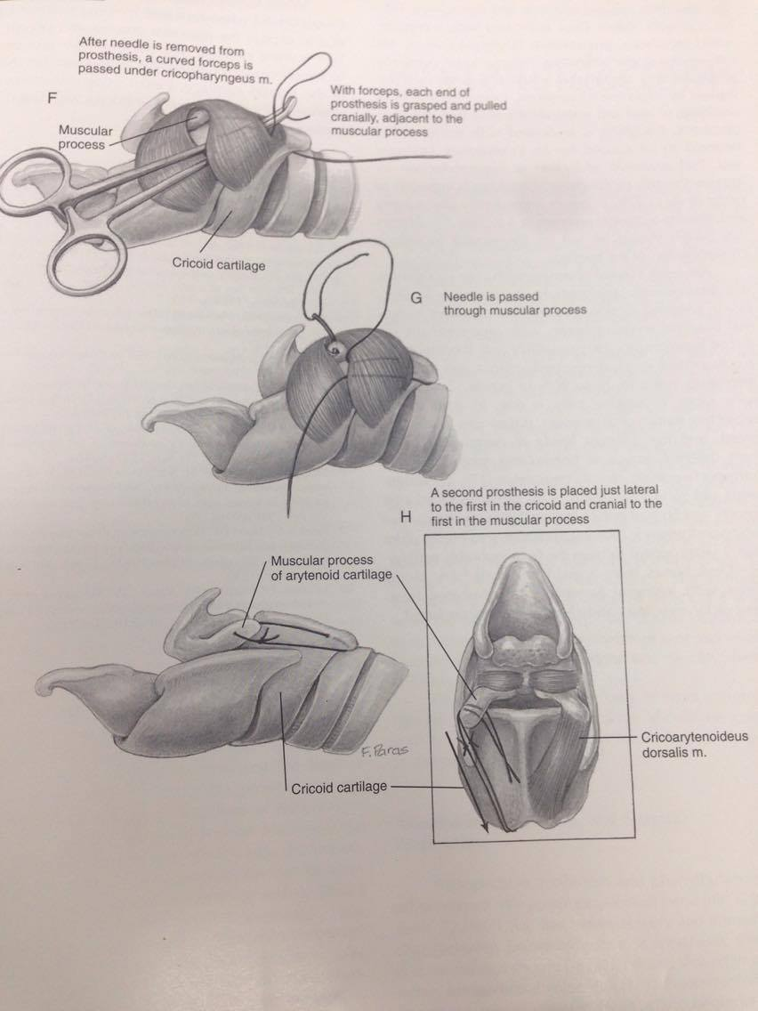

Sacculectomy
- After completion, the horse is positioned in dorsal recumbency
- Enter the lumen of the larynx and examine the mucosa over the cricoid cartilage to determine if the prosthesis penetrated it
- If it has, although rare, the prosthesis can be removed and replaced or the mucosa can be incised under the exposed prosthesis allowing it to be buried in the correct position next to the crcoid cartilage
- Lavage and close the incised mucosa with several interrupted sutures of size 3-0 absorbable synthetic suture material
- Perform the Sacculectomy

