What is Colic?   
  
The term "colic" means only "pain in the abdomen" or "pain in the belly". There are many causes for such pain, ranging from the mild and inconsequential to the life-threatening or fatal. One of the problems with equine colic is that it can be very difficult in the early stages to distinguish the mild from the potentially fatal. This is why all cases of abdominal pain should be taken seriously right from the onset.

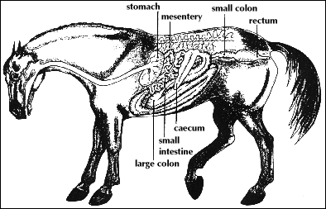

Reference: <http://www.equusite.com/articles/health/healthColicFacts.shtml>