**Colic: Causes and Symptoms**

**Colic is defined as any abdominal pain although horse owners typically refer to colic as problems with the gastro-intestinal tract. The causes of colic are numerous, but generally they are related to the anatomy and the microflora of the horse's gastrointestinal tract. Some more common causes of colic include:**

* High grain based diets/Low forage diets
* Moldy/Tainted feed
* Abrupt change in feed
* Parasite infestation
* Lack of water consumption leading to impaction colics
* Sand ingestion
* Long term use of NSAIDS
* Stress
* Dental problems

Impaction: a blockage formed by something the horse has ingested

NSAID: non-steroidal anti-inflammatory drug

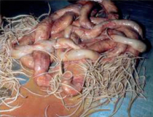  
*Parasites, such as strongyles can be a common cause of colic. It is important*

*to practice a deworming routine to prevent parasites in equines.*

Antibiotics may lead to colic because they alter the microbial population in the gut, which in turn affects starch digestion. Dental problems may cause colic if the horse is unable to chew its food sufficiently. Older horses fed coarse hay are at greater risk of impaction colic.   
Signs of colic include:

* Pawing
* Rolling
* Bloating
* Sweating
* Distress
* Uneasiness
* Loss of interest in food and water
* Peculiar postures (sitting, stretching)
* Absence of gut sounds

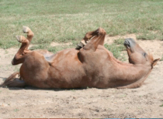  
*Photo of horse rolling due to colic.*

A colicky foal may not show typical signs of colic. Instead, they may lay on their back with their legs tucked. The foal owner or manager needs to be on alert for any abnormal foal behavior.

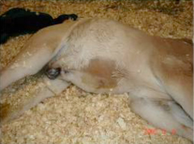  
*This foal has a distended abdomen due to gas.*  
*Source: Dr. Judy Marteniuk, Michigan State University*

Reference: <http://www.myhorseuniversity.com/resources/eTips/January_2010/Didyouknow>