INTRA-OPERATIVE PROCEDURES FOR CASTRATION IN THE CAPRINE SPECIES
Castration is the process by which the testes, epididymides and a portion of each spermatic cord are removed from a buck thereby making him a wether. This removal may be immediate as with the knife method, or may take several weeks as with the emasculatome or elastrator methods.
Castration should take place at the youngest age possible since the stress of castration can adversely affect growth in older animals and the chances of complications increase. Buck kids can be castrated as soon as the testicles descend into the scrotum (this can be from a few days of age to a week or more). Castration may be performed by one of three methods - the knife method, emasculatome method or elastrator method.

1) Knife Method:
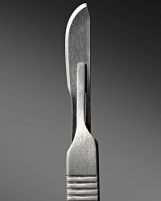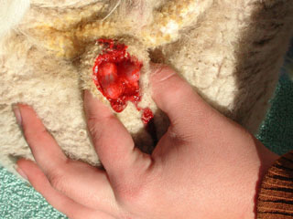
Cutting with a knife is the most reliable and least expensive method of castration.
Materials needed include: a sharp knife or scalpel, soap and water, disinfectant, syringes and tetanus antitoxin. The kid is often held by an assistant who grasps the kid's hind and front legs of the same side with each hand. The kid usually has its back to the assistant.
Method:
1. Begin by washing your hands and instruments (knife or scalpel) thoroughly with soap and water and then disinfectant. Next, wash the scrotum and disinfect.
2. Push the testes up out of the way and cut off the lower 1/3 of the scrotum with a cut parallel to the ground. The testes should now be visible.
3. Using your fingers, grasp one of the testis and pull downward. The testes are slick and difficult to hold onto, so grasp firmly. Do not to allow the testis or spermatic cord go back up into the scrotum once you have touched it as this will increase chances of infection.
  - In young kids (less than 4 or 5 weeks) pull down firmly, but steadily until the cord breaks.
  - In older kids or adults, instead of pulling the cord, use the knife or scalpel to sever the cord. Do not cut the cord cleanly, instead scrape it until it abrades through. Because the spermatic cord contains many blood vessels, a clean cut could cause excessive blood loss.
4. If a segment of the spermatic cord is protruding below the cut scrotum, it must be removed. If left exposed, it will act as a wick to pull bacteria into the body cavity and cause infection. Pull it free or abrade it with the knife.
5. Apply antiseptic to the castration site and administer an injection of tetanus antitoxin.
Note: Kids with a scrotal hernia should not be castrated by the cutting method. Care should be taken not to excite kids before or immediately after castration. A disadvantage can be possible hemorrhage that can become extensive, if mis-managed, while using this method.

2) Emasculatome Method:
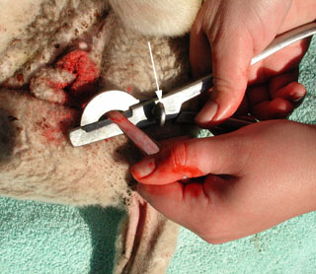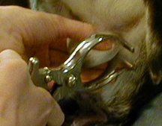
The emasculatome or Burdizzo method involves an instrument (emasculatome) which crushes the spermatic cord, thus destroying the blood supply for the testes. Without this blood supply, the tissues eventually atrophy even though the scrotum (cod) will be visible for the animal's lifetime. This method is known as a "bloodless" method since no cutting is done and when done properly the skin is not even broken. Care must be taken to be sure that both cords have been properly crushed.
Method:
1. Since it is possible for the emasculatome to break the skin, it doesn't hurt to wash and disinfect it.
2. Have an assistant hold the kid as described above.
3. Wash the upper portion of the scrotum (near to where it attaches to the body) and disinfect.
4. Grasp the scrotum in one hand and manipulate until you have the testes down into the scrotum and the spermatic cord between your fingers. Place the jaws of the emasculatome onto the upper scrotum, just below the rudimentary teats. Position the jaws so that about two-thirds of the scrotum is crushed when the jaws are closed. Leave the instrument closed for 15 to 20 seconds. Open the jaws and move the instrument about 1/2 inch lower and crush the other side of the scrotum.
Note: The spermatic cord is very elusive when you try to crush it. Be sure that you feel it within the jaws of the emasculatome before and after the jaws are closed.
A possible disadvantage could be breaking the skin with the corners of the emasculatome. Examine each kid carefully after castration. If the skin is broken, apply an antiseptic and give the kid an injection of tetanus antitoxin.
3) Elastrator Method:
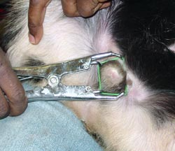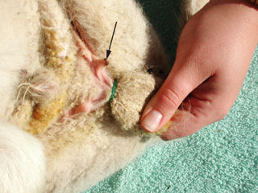
This method involves cutting off the blood supply to the testes with a heavy rubber band or ring. In 10 to 14 days, the scrotum and testes will slough off. This method is most effective for young animals whose scrotal tissues have not yet become well developed.
Materials needed include an elastrator (instrument used to apply the bands) and castrating bands or rings (Purchase these from a livestock supply company. Do not use household rubber bands!). It is not necessary to disinfect the elastrator or rings since this method is bloodless.

Method:
1. Restrain the animal as described previously.
2. Place a rubber ring on the prongs of the elastrator. Turn the elastrator so that the prongs face the kid's body. Expand the ring by squeezing the elastrator and place over the scrotum and testes. Position it as close to the kid's body as possible without interfering with the rudimentary teats.
3. Manipulate the scrotum until you are certain that both testes are descended below the ring.
4. Press the trigger lever, displacing the ring from the prongs, thereby positioning the ring. Note: Be sure that both testes are below the ring! If they are not, cut the ring and start over.
5. Administer an injection of tetanus antitoxin. Even though this is a bloodless procedure, the tetanus organism can gain entry through the irritated tissue around the rubber ring.
The main disadvantage of this method is the fact that the animals would be in prolonged periods of pain and discomfort due to the gradual restriction of the castrating bands. It is however a beneficial method in that it is not open and sever hemorrhaging should not be an issue.
SUMMARY:
Castration can be performed by one of three methods. Kids should be castrated as young as possible to avoid disruptions in growth performance and other possible complications. Tetanus antitoxin injections are recommended in conjunction with castration procedures to avoid tetanus or lock jaw. Post-operative care usually involves regular inspections of the site after the procedure is performed, and the administration of antibiotic and anti-miaisis sprays as needed.

