Pre-operative management

Anti-inflammatory/ analgesic therapy

The disease process and degree of

invasiveness determined usually the

degree of anti-inflammatory therapy

required. Flunixin meglumine (1 mg/kg IV)

was immediately used before eye

enucleation procedure which was

performed in twelve of the examined cases

(eleven cattle and one goat).

Antibiotic therapy

Broad spectrum systemic antibiotic

therapy was required in all cases especially

in those cases in which eye enucleation was

performed.

Surgical site preparation

The hair around the eye was clipped and

the skin was disinfected with betadine, the

ear was draped and the lateral portion of

the halter was covered to decrease

contamination to the surgical site. Saline

solution rinse was used rather than

antiseptic scrubs to prevent irritation and

damage to the cornea and an ophthalmic

ointment was placed on the cornea prior to

aseptic preparation to further protect the

cornea from damage in cases other than

enucleation.

Surgical manipulation

Surgical manipulation varied according to

the animal health condition and severity of

the condition.

- In one buffalo, which was suffering a

corneal foreign body, the foreign body

(wooden piece) was extracted through the

entrance opening of the foreign body at the

level of the limbus using a mosquito artery

forceps. The wound was very small and

was left opened.

**PRE-OPERATIVE CARE FOR EXENTERATION OF THE EYE:**

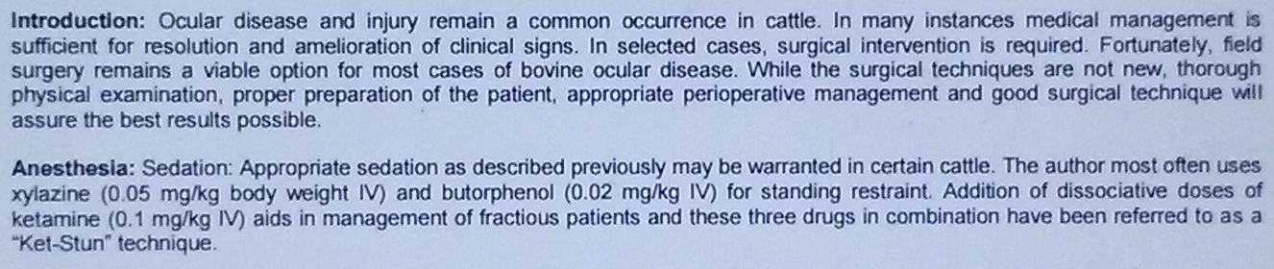

**NERVE BLOCKS:**



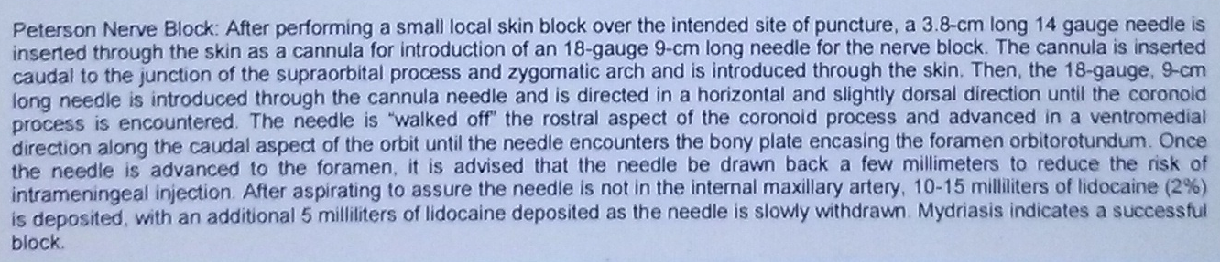

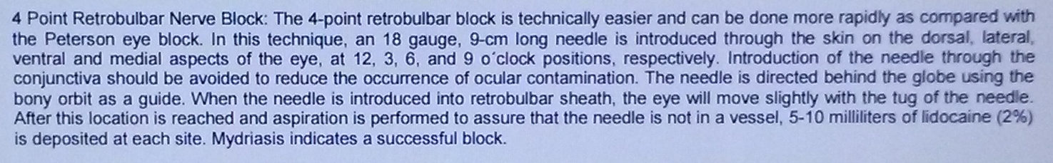

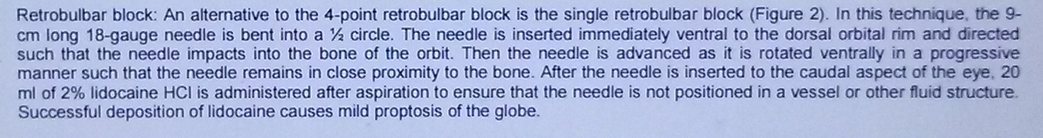



**PRECAUTIONARY MEASURES:**



**PERI-OPERATIVELY:**

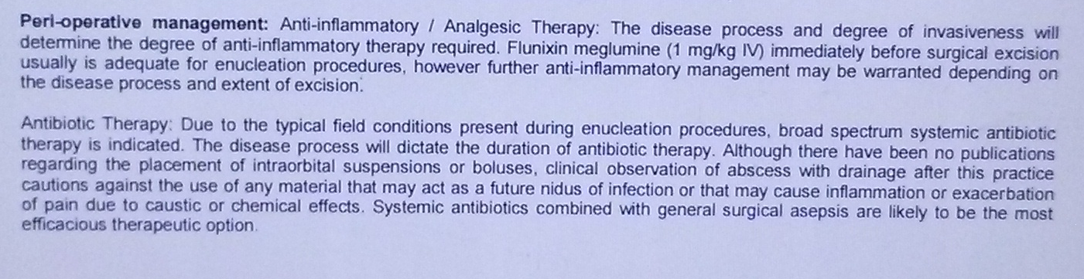

**SURGICAL PREPARATION:**

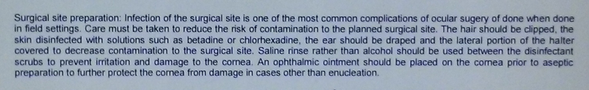

Pre-operative management

Anti-inflammatory/ analgesic therapy

The disease process and degree of

invasiveness determined usually the

degree of anti-inflammatory therapy

required. Flunixin meglumine (1 mg/kg IV)

was immediately used before eye

enucleation procedure which was

performed in twelve of the examined cases

(eleven cattle and one goat).

Antibiotic therapy

Broad spectrum systemic antibiotic

therapy was required in all cases especially

in those cases in which eye enucleation was

performed.

Surgical site preparation

The hair around the eye was clipped and

the skin was disinfected with betadine, the

ear was draped and the lateral portion of

the halter was covered to decrease

contamination to the surgical site. Saline

solution rinse was used rather than

antiseptic scrubs to prevent irritation and

damage to the cornea and an ophthalmic

ointment was placed on the cornea prior to

aseptic preparation to further protect the

cornea from damage in cases other than

enucleation.

Surgical manipulation

Surgical manipulation varied according to

the animal health condition and severity of

the condition.

- In one buffalo, which was suffering a

corneal foreign body, the foreign body

(wooden piece) was extracted through the

entrance opening of the foreign body at the

level of the limbus using a mosquito artery

forceps. The wound was very small and

was left opened.