**The Peterson’s Nerve Block**

The peterson’s nerve block is performed to block the occulomoter, abducens, trochlear and 3 branches of the trigeminal nerve, this can stop eye movements and reduce sensory to the eye and surrounding tissues- it does not eliminate the blink reflex.

The area should have gross contamination removed and swabbed with alcohol. A 14G or 18G cerebrospinal fluid collection needle can be used or a 18G 5inch needle.

The point of injection is the notch formed by the supraorbital process and the zygomatic arch and the apparent point at which the coronoid process should be.

As the needle is inserted small quantities of the anesthetic should also be injected to allow desensitization of the tissues. The needle is directed until it touches the coronoid process as which point the need should be “walked” forward rostrally until it moves just off the coronoid process and slightly advanced. At this point the needle is in the pterygopalatine fossa where the anesthetic can be injected. Aspirate and inject a volume of between 7- 15ml of anesthetic.

Effects should be seen in 10 to 15 minutes.

Complications include apnea and death if improperly performed.

**Auriculopalpebral Nerve Block**

This blocks the auriculopapebral nerve which causes stops movement of eyelid. This can stop the blink reflex as such it is commonly used with the peterson’s block. This nerve block does not reduce sensory to the area.

The needle is inserted 5-7cm caudal to the supraorbital process at the base of ear at the end of the zygomatic arch. The nerve should run just at this point just below the skin.

10-15ml of anesthetic can be inserted at this point to desensitize the nerve.

Effects should be seen in 10-15 minutes.

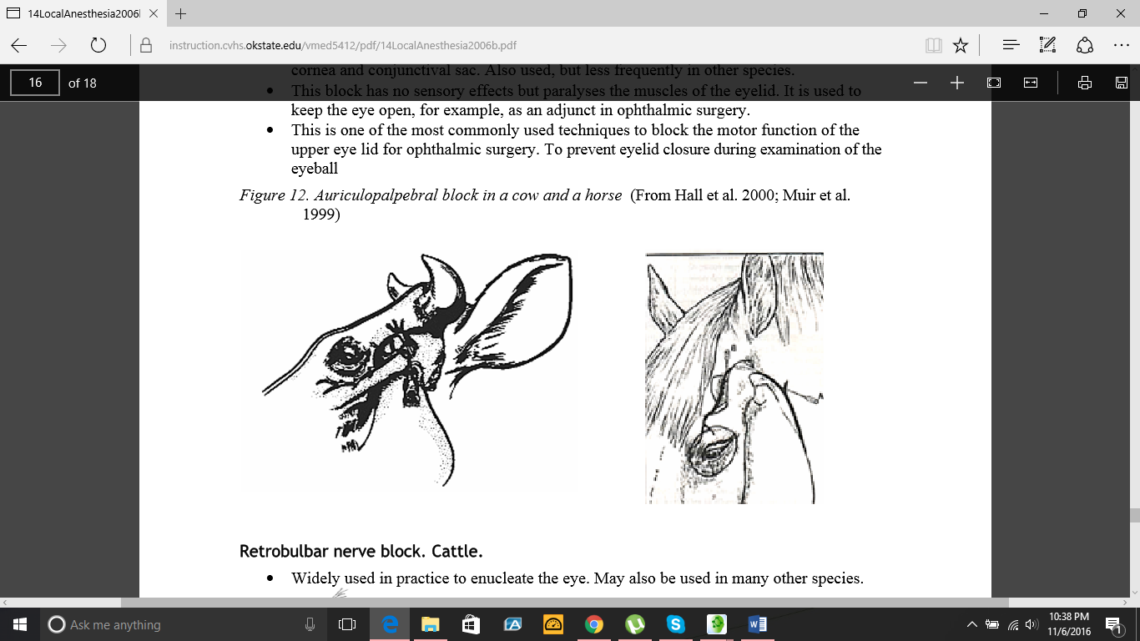

Lidocaine is a commonly used anesthetic for nerve blocks. The toxic dose is 8 – 10mg/kg in large animals (the toxic dose is significantly lowered in calves, kids and other small animals- 2mg/kg in cats.).

The peterson’s block is useful as it blocks a number of nerves simultaneously thus decreasing the quantity of lidocaine that needs to be injected thus reducing the chances of causing systemic toxicity.