THE DUTCH 5 STEP METHOD
(Manual)
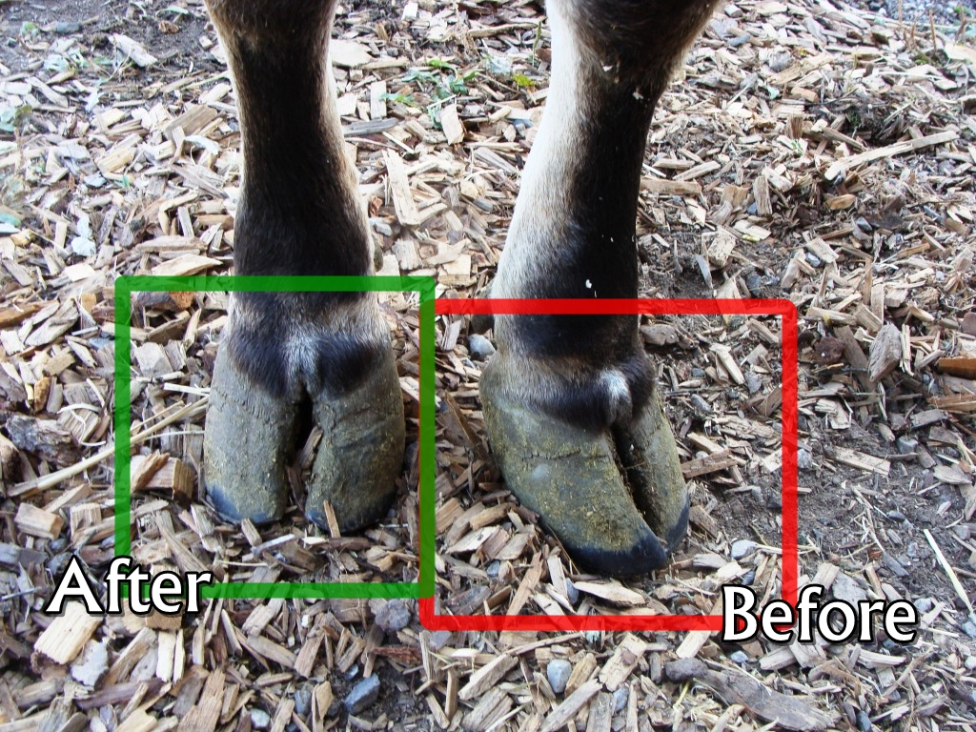

- Trim toe length to approximately 7.5cm (appropriate length in average Holstein) and correct toe angle
- Measure from front wall just below hairline to toe tip and cut perpendicular to the sole using pincers (squares the toe)
- For hind feet, start with medial claw while for fore feet start with lateral claw
- In severely overgrown toes this may not be possible and trimming should be done to lower level for later repetition of the procedure to allow for a gradual return to normal conformation (otherwise this may cause a drastic shift in balance for the cow and cause further injury)

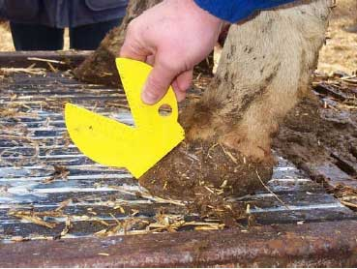

- Match the untrimmed claw

- REMODELLING - Dish the soles
- Trim the soles using a hoof knife such that the lateral surface is flattened and the medial surfaces are made concave around the axial groove (using a hoof knife trim 1/3 off the weight bearing claw and ¼ off the other)
- The knife is stroked down the claw and away from the operator with the foot resting on the operator’s knee for stabilization
- Be careful not to cut too deep i.e. just until the white line becomes visible (noted by excessive softness distinguishable from the rest of the sole)
- Measure the level of the sole using a flat surface (eg. Hoof knife handle) to ensure each claw is flat and even with the other)

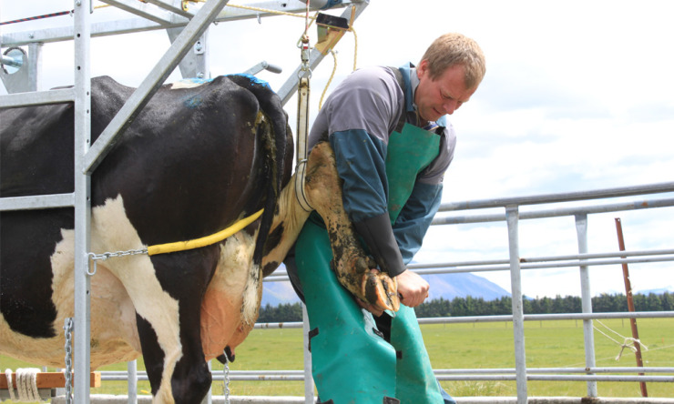

- Relieve weight off painful claw
- Any pathology must be attended to now
- Trim around abscesses (drain afterwards and treat appropriately) and lesions

- Remove loose/under-run horn and hard ridges
- Using a rasp shave down the sole until smooth

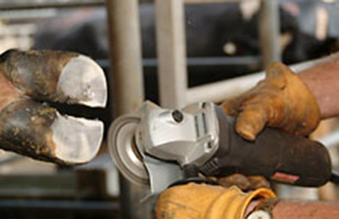

Bear the following 5 principles in mind:
- Correct toe overgrowth to correct toe angle
- Spare the heel, leave sole thickness
- Allow the walls to bear most of the weight, taking weight off the sole ulcer site
- Remove weight from the painful claws
- Remove dead/diseased horn

** Begin with the weight bearing/overgrown claw (usually has more pathology and is bigger)
** Spare the heel
** Power tools such as the Merlin and Grinders may be used in steps 3, 4 and 5

