Digit amputation

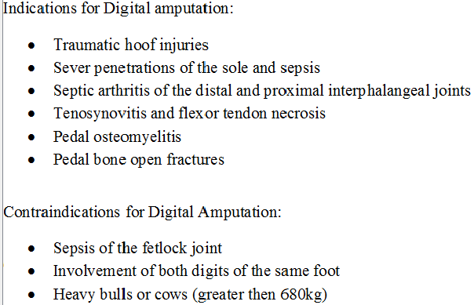

**-** Low amputations are done when only the coffin joint and distal phalanx are diseased.

* + This amputation is directed through the middle phalanx.
* High amputation is used in cases with involvement of the coffin joint, distal phalanx, pastern joint, and middle phalanx.
  + This amputation is directed through the junction of the middle and distal third of the proximal phalanx.

There are 3 methods that can be done

1. Disarticulation through the distal interphalangeal joint
2. Amputation through proximal phalanx 2
3. Amputation through distal phalanx 1

Anesthesia is most easily performed by intravenous infiltration of lidocaine distal to a tourniquet on the metatarsus or metacarpus. Lidocaine without epinephrine, 20 to 30 ml, is infused using a butterfly catheter (19 g, 15 to 25 cm). Any accessible vein will result in complete anesthesia of both digits after a few minutes. If no vein can be found, regional perfusion above the intended surgical site is an alternative. The distal limb is scrubbed and disinfected as for any surgery but usually not shaven as the hair is typically very short or absent.

After aseptic preparation, a skin incision is made in the interdigital space and then beginning about 2 cm proximal to the interdigital cleft angling upward to a point on the lateral or medial side of the leg even with the distal margin of the accessory digit or dewclaw. All soft tissues can be sharply incised along the line of the skin incision. Obstetrical wire is then placed between the digits and the distal end of the first phalanx cut. If the cut misses this landmark and a portion of the second phalanx remains proximal to the cut it should be removed. If the articular surface of the first phalanx is intact it should be roughened with a knife.

The digit may be amputated by sharp dissection to disarticulate the proximal interphalangeal joint.

After determining that all diseased tissue is removed, the surface of the wound is covered with an antiseptic or antibiotic dressing and a bandage applied to control hemorrhage. The bandage should be removed or changed in about 1 week if there was no need for maintaining drainage of septic regions proximal to the incision. If a tendon resection is performed the bandage should be removed in 2 or 3 days. Depending on the environment the cow must live in after surgery either no bandage is placed after the first one is removed or a light wrap to minimize painful contact with environmental objects

After amputation, it is evident that sepsis extends proximally along the deep flexor tendon it should be resected. A 3 cm incision parallel to the path of the tendon is made over the affected branch of the flexor tendons beginning just proximal to the accessory digit. There is strong fascia surrounding the sheath of the combined superficial and deep flexor tendons. In fact the superficial flexor tendon forms a tube around the deep at this level. Sharp dissection oriented along the skin incision through the superficial flexor tendon will reveal the deep flexor tendon. The deep flexor tendon is grasped with a strong instrument such as a dental extractor or exteriorized with the aid of curved hemostats. There may be adhesions of the deep flexor tendon to surrounding structures at the level of the distal transaction which require sharp dissection. In some cases the tendon will simply be pulled to the outside from the proximal incision. The deep flexor tendon is transected at the most proximal exposed part and surgical drainage tubing placed through its original course to exit at the distal incision. It may be knotted into a loop or each end affixed by suture. One or 2 skin sutures are placed in the proximal incision. Systemic antibiotics are routinely given for 5 days. The drainage tubing is removed in 2 weeks.